Wireframe

Parkinson’s Disease prediction

**Version 1.0**

**Date of Revision 08 May 2022**

# Homepage

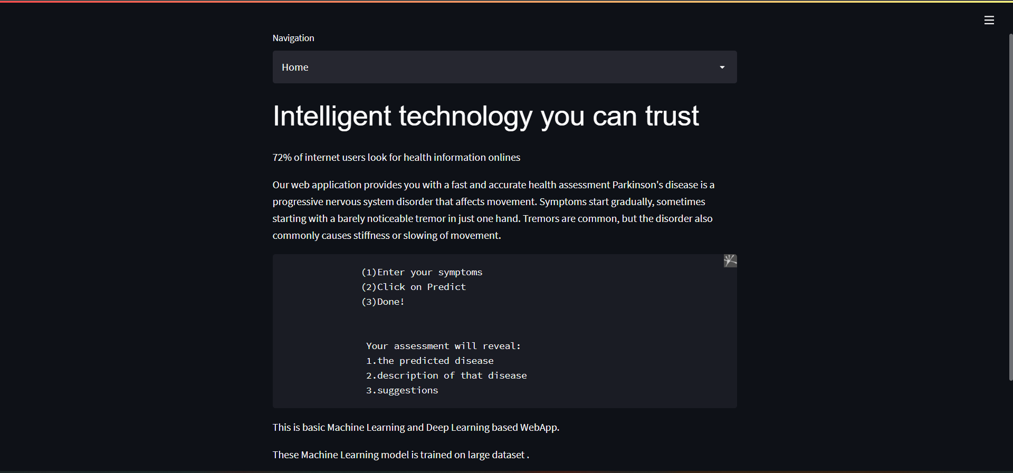

From the Homepage user can have an overvieew of the webapp. In addition, can explore further more.

# Checkup Page

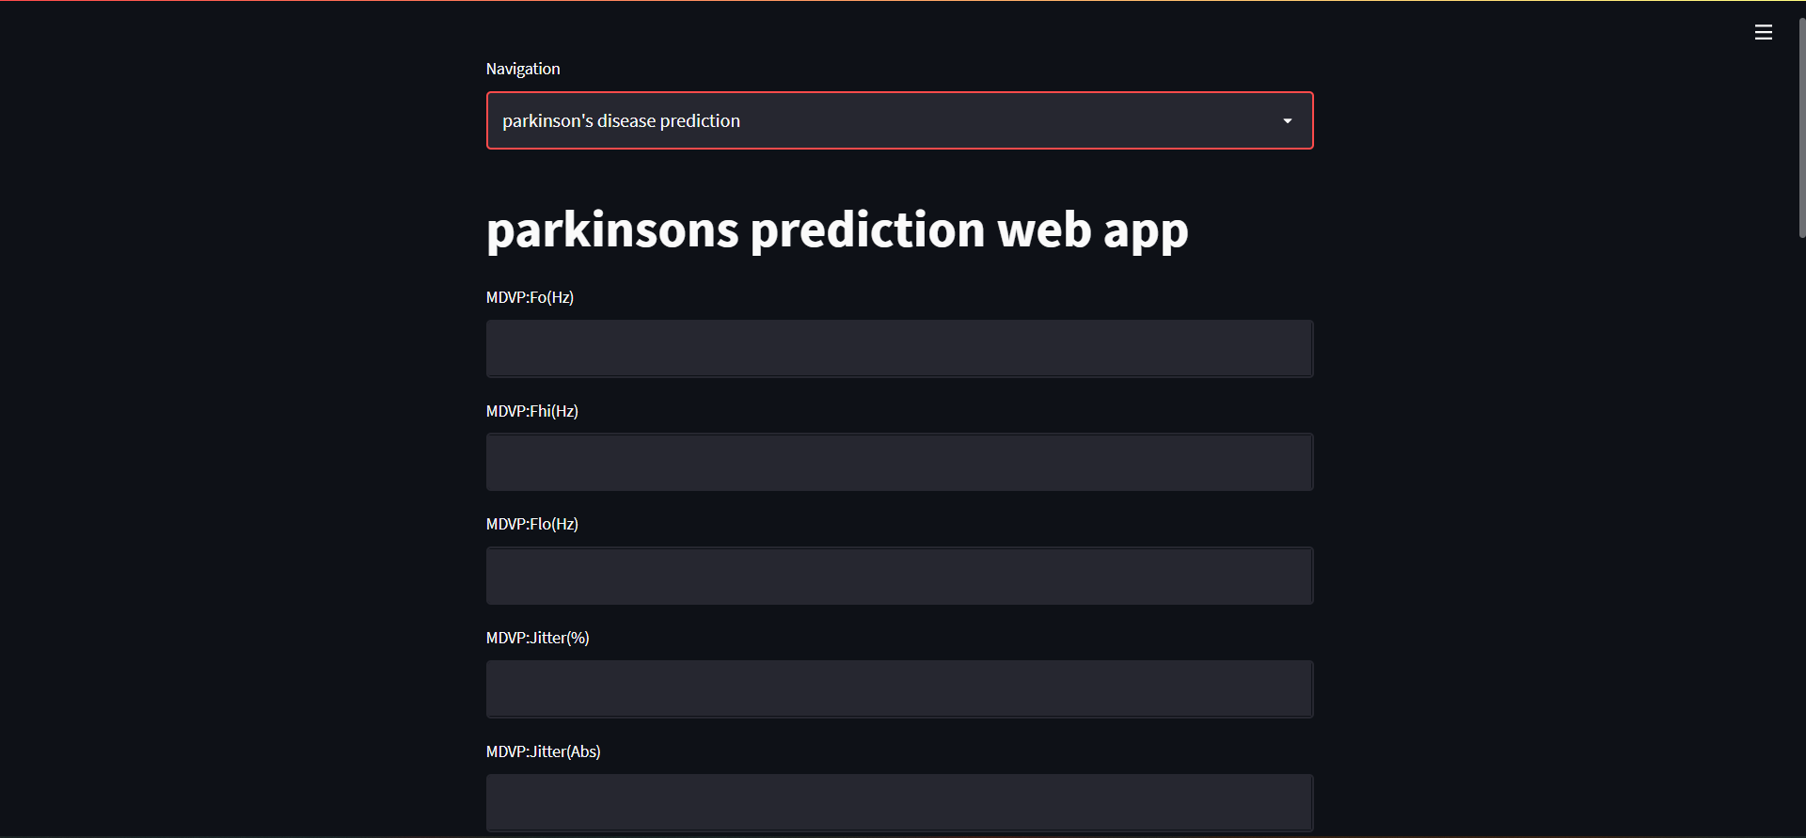

From the Home page User can click on the navigation bar and check their disease

By clicking the test result button the machine will predict wheteher the person has parkinson’s disease or not.