Data mapper static web app documentation

GUI with drawable elements
Requirements:-
- Container with draggable input/output structure boxes
- Mechanism to specify input/output files(XML)
- Parse files into structure.
- Identify leaf elements
- Mechanism to connect leaf elements from input to output
Incorporated tools/libraries:-
- Brackets
- bootstrap
- jQuery/jQeury-ui
- jsPlumb
- backboneJS

Incorporating d3
- Started with a bar chart using file loading
The containers are to include node elements read by an XML parsing logic, so basically, when an XML file is selected, each container will be appended by text objects and the leaf nodes will be additionally appended with an SVG circle on the right of inputs and on the left of outputs.

- Implemented draggable nodes
When a circle is dragged, a line should be extended with the drag and when it is dropped on a leaf node of the opposite container, it should connect with the circle of the dropped node.
- Implemented draggable containers
Added all the lines to the input container(to make it easier to control them) and updated the line ends during the drag. The drag used “d3.event.dx” and “d3.event.dy” which incremented the current position attributes of the container. When the input was dragged, the target ends (x2 and y2) of the lines were decremented and when the output was dragged, the raget ends were incremented.

Adding Backbone to the project

The models of the app are as follows:
- Operator – The container/operator box with a collection of nodes. Direct mappings are considered to be connected to an operator called “direct”.
- Container(extending Operator) – Input/output containers
- Node – The elements of the container. A node has a text, a text type, node type(object, array or leaf) and a type(input or output) which decides the placement of anchor.
- Anchor – The arrow heads that are assigned to leaf nodes. Anchors of type output are draggable while the others are not.
- Connector – The line that connects nodes through anchors. Each connector has a source node, source container, target node and target container.
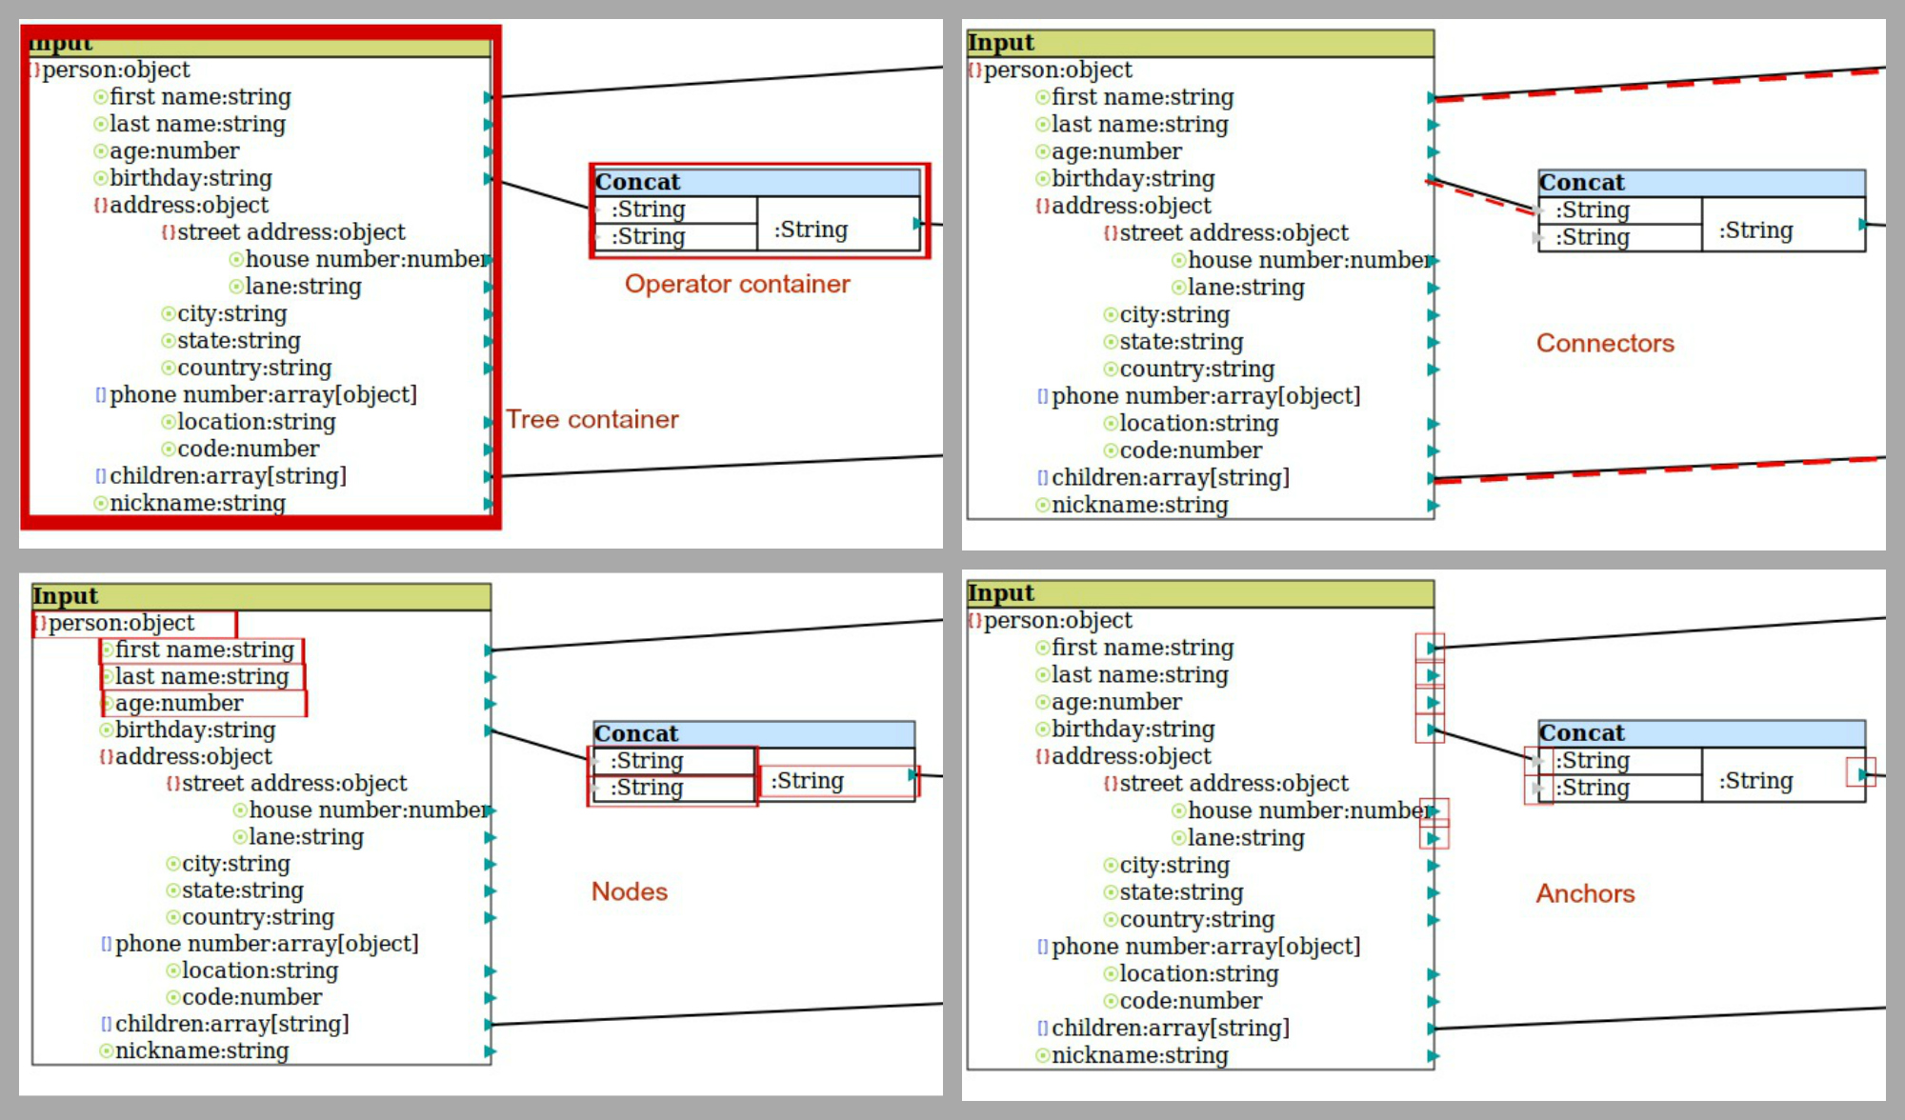

The collections of the app:
- Operators – a collection of all the operators. The drawContainer function is responsible for drawing a container with the specified input count and output count on the canvas.
- Connectors – a collection of all the connectors added to the app. The functions include findFromSource and findFromTarget which intakes a node and returns the connectors which have the specified node as the source or target respectively.
- Nodelist – each container has a collection of nodes. The functions include getNodeFromDOMObject which returns the node in the collection when the DOM object is specified.

Views initialize the app itself and the important functionalities. Some of the highlighting views are:
- Canvas - The app is initiated by the CanvasView which initializes the required views and models of the app.
- LoadFile – The file handling is managed by the LoadFileView which reads the specified file and draws the tree structure in the container.
- OperatorPanel – This view is responsible for binding events to operator addition.

The mappings
At the event of calculating the mappings, the app outputs four arrays:
- Variable list – an array of nodes. The id of the node in the array is used for the adjacency list.
- Operators – a list of operators in the model, including direct operators.
- Input adjacency list – each entry of the array corresponds to each operator and the inputs connected to the operator. Assumed that each node has only one input.
[input-nodes-of-op1, input-nodes-of-op2, ….] → [2, 3] , [1, 2] …..
- Output adjacency list – each entry of the array corresponds to each operator and the outputs connected to the operator. Assumed that each node can have multiple outputs, which is again an array.
[ [output-nodes-of-op1, output-nodes-of-op2, …... ] → [ [9], [10, 11] ] , [ [7, 8], [10] ]….

