# To add a new article:-

1. Make a copy of “sample_page.php “ (It is better to edit in a local machine so download it)
2. Rename the file according to the article title by replacing the spaces with the underscore (“_”)
   * Eg:- If title is ‘True Sound’, the file name must be “true_sound.php”
3. After editing the file, upload it to the “articles” folder.
4. Upload the images to the “images” folder inside the articles folder.

# To edit a file(article):-

The page <http://www.spiritwolfsound.com/articles/sample_page.php> contains a sample with examples.

Once you make a copy of the sample page and rename it, open it in a text editor (I suggest notepad or Context – don’t use MS word)

First of all, scroll to the end of the file to find the following piece of code.

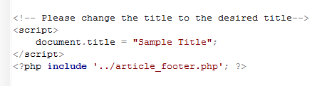

Replace the “Sample Title” with your desired article title.

Then the second step.

In your file you will see two lines as

<!-- START CONTENT -->

<!-- END OF CONTENT -->

(those are comments, so they do not affect the content)

Whatever content you add must be added in the middle of it, so you can start by deleting everything in the middle. (Better to keep a backup of sample_page to refer to when needed. You can just copy and paste the desired elements from it)

Now we’re going to learn just a little bit of html.

HTML is a language that can display content in web. Just like English uses words and sentences, HTML uses elements, which are enclosed within tags.

(closing tag is the same as starting but with additional “/”)

<element_tag> content </element_tag>

eg:- <h1> Heading </h1>

<p> Paragraph </p>

<img src=”image_souce”> (image_source is the image file location)

<hr> (Horizontal line)

<br> (Line break)

(img, hr and br are special cases with no closing tag)

Note:- Your image_source should always be “./images/image_file_name”. Refer sample page for examples.

## Headings :-

Headings are depicted withing <h1></h1> tags and there are multiple heading types. As the sample page depicts,

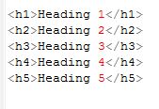 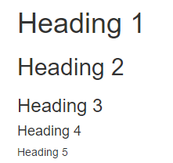

I have defined custom headings for you, which you can use to change alignment.

class="center-heading" for center aligned headings

class="right-heading" for right aligned headings

class="left-heading" for left aligned headings(left align is default)

Eg:-

<h1 class="center-heading">Center aligned heading 1</h1>

<h2 class="right-heading">Right aligned heading 2</h2>

## Paragraphs:-

Use tags <p> </p> to enclose paragraphs.

Eg:-

<p> Paragraph content </p>

## Images:-

I have defined certain custom image properties to make it easy. The “alt” property defines a text that will be displayed if the browser fails to load the image.

### Full size images:-

The following is the general image tag and the dimensions are not specified, therefore the image will be displayed in full size.

<img src="./images/sampleimage.jpg" alt="spirit sound" >

### Custom sized images

The following has the “width” and “height” attributes specified, which determines the width and height of the image. The image will be stretched or compressed if the dimensions are not in proper ratio.

<img src="./images/filename.jpg" alt="alttext" width="100" height="300" >

### Aligned images

Although tag <img> is independently used for images, I have enclosed it inside <p> to make the alignments easy.

Similar to heading, the classes “center-image”, “right-image” and “left-image” are used inside <p> to define alignment.

Eg:-



### Inline images

Inline images are a bit tricky, but possible.

For that a new tag is introduced the <div> tags, which stand for divisions. And (according to bootstrap) a division is always made up of 12 segments when it is defined so.

Simply put, if you want to add inline images, just find in sample, copy and paste the following piece of code in the desired place.

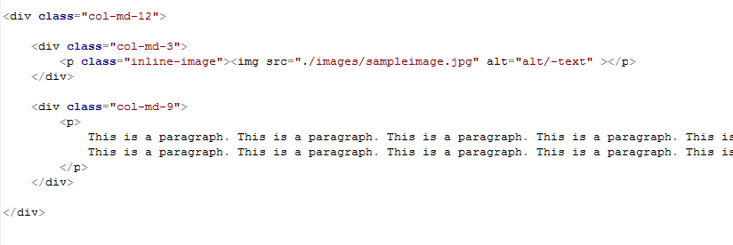

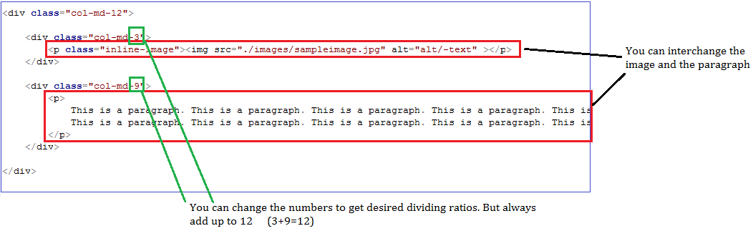

You can have multiple divisions too but always, the division ratios must add up to 12. The following will give you an idea.

