# Hybrid App Development

# Practical 1

## Ionic 4-Create and build first project or application (Android and iOS)

Hybrid App Development helps to deploy the code on different platforms using one source code.

Ionic is open source framework used for developing mobile applications. It provides tools and services for building Mobile UI with native look.

## Commands to setup Ionic project:

1. Npm install –g ionic Cordova
2. Ionic start hello_world blank

(blank is the template, hello_world folder will be created)

1. cd hello_world
2. Ionic serve
3. Ionic Cordova build android –
4. Now to run the ionic Cordova app on android, we type

Ionic Cordova run android

If we have our phone connected to the machine, then we need to turn on the USB debugging under the Developer settings. This will export the app and will be viewable in your phone.

Another way is to run by setting up an emulator in the Android Studio.

## Screenshots of the steps:

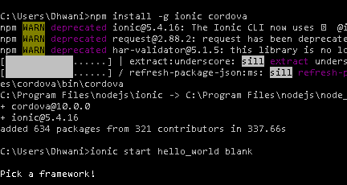

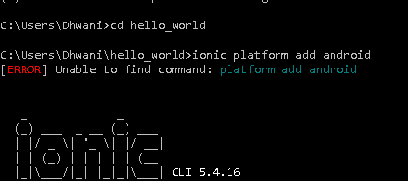

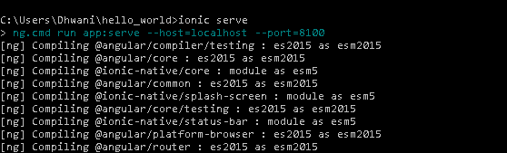

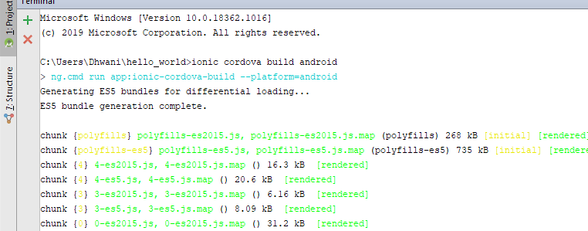

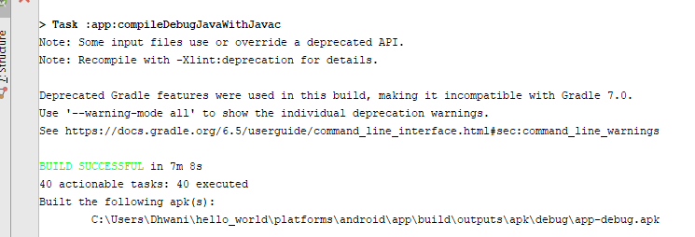

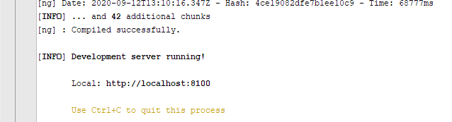

## Screenshot of code and output:

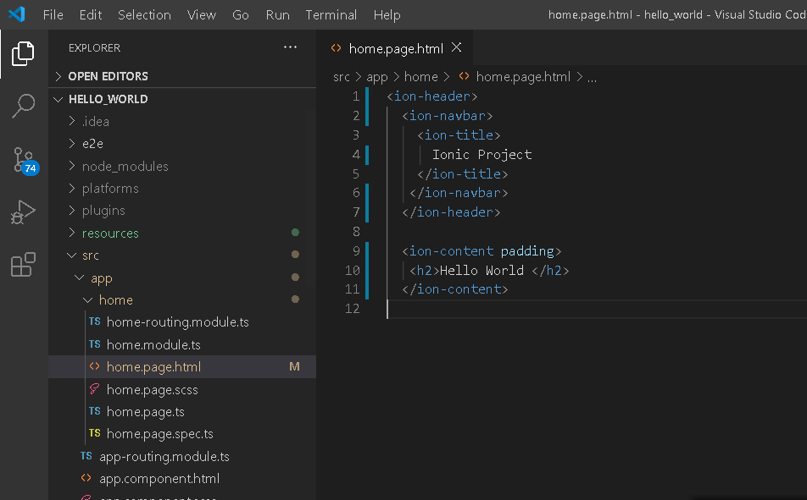

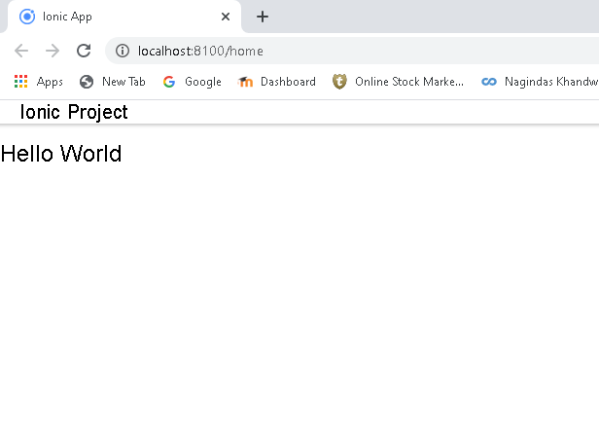

## Output on Android device:

