**TUTORIAL 1**

1.Design and Document Test Case for a Downloaded Sample Project.

● Test case Instagram login page.



TC_01:-

Step 1:- To check login page Functionality and features

Step 2:- Enter valid Username and password.

Step 3:- To click on Next Button.

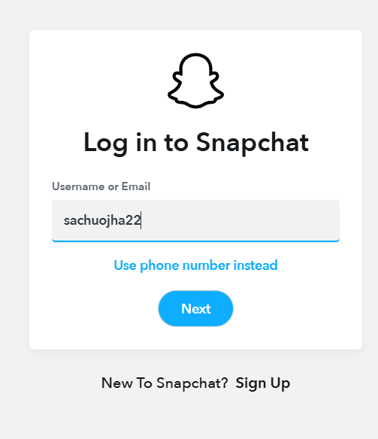 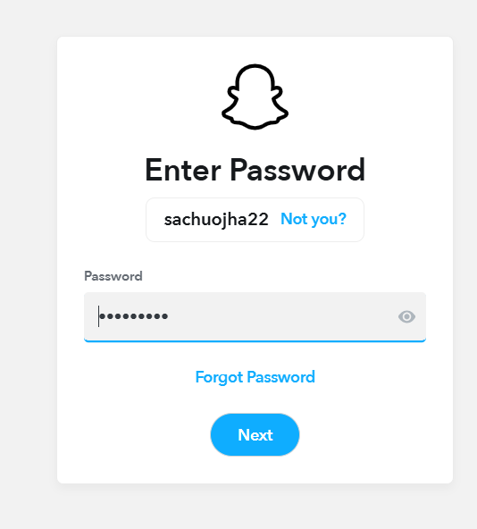 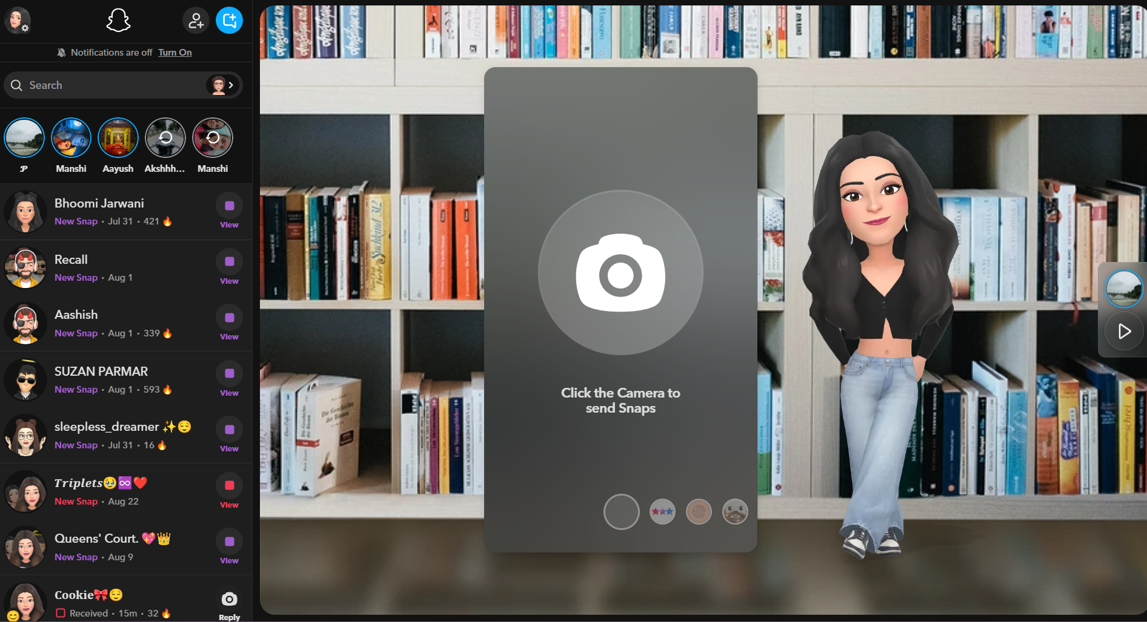

Excepted Result:- user login and redirected to homepage.

Actual Result:- user logged successfully.

Status:- Pass

Comments:- working as expected.

TC_02:-

Step 1:- Enter invalid username.

Step 2:- Enter valid password.

Step 3:- To click on Next button.

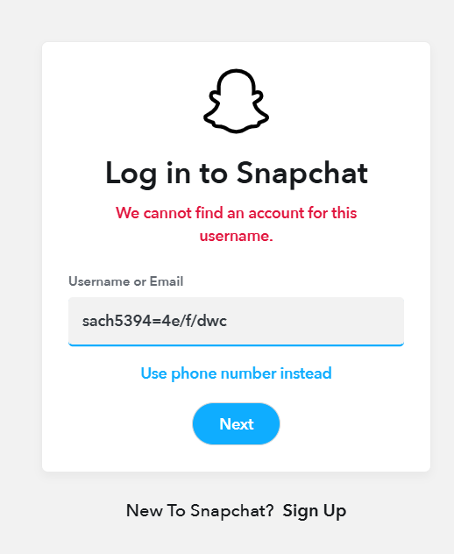

Expected Result:- Error message: username not found.

Actual Result:- Error message not shown.

Status:- Fail

Comments:- Username validation issue.

TC_03:-

Step 1:- Leave both fields blank.

Step 2:- Click Next.

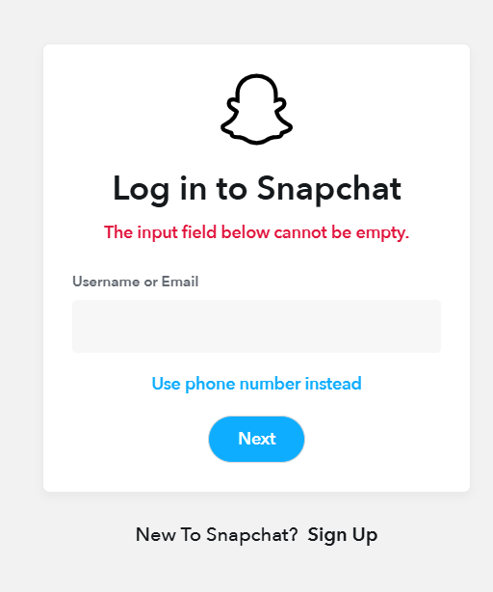

Expected Result:- Next button should be disabled.

Actual Result:- Next button still active.

Status:- Fail

Comments:- Input field cannot be empty.

TC_04:-

Step 1:- Enter valid username.

Step 2:- Enter invalid password.

Step 3:- To click on Next button.

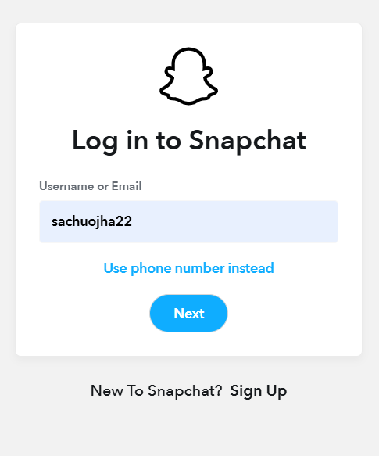 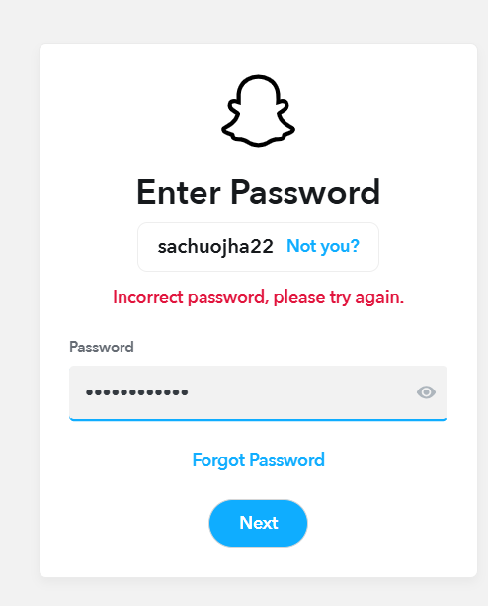

Expected Result:- Error message: Incorrect password.

Actual Result:- Correct error message displayed.

Status:- Pass

Comments:--Error handled properly.

TC_05:-

Step 1:- Enter special characters in both fields.

Step 2:- Click Next.

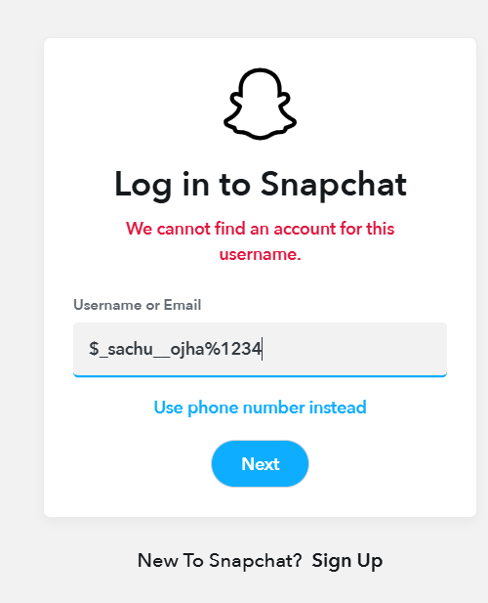 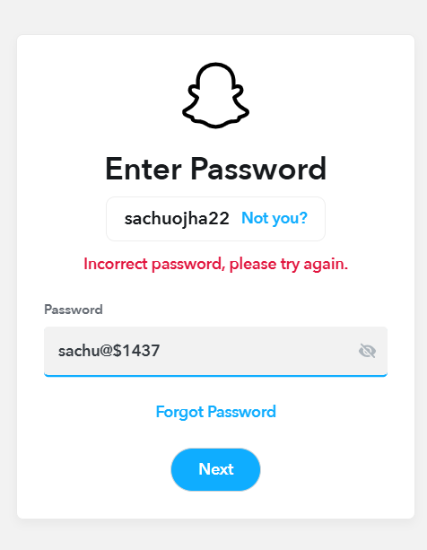

Expected Result:- Username and password is masked as $symbol.

Actual Result:- Next button is working.

Status:- Fail

Comments:- Field making is not working.

TC_06:-

Step1:- Click “Forgot password?”

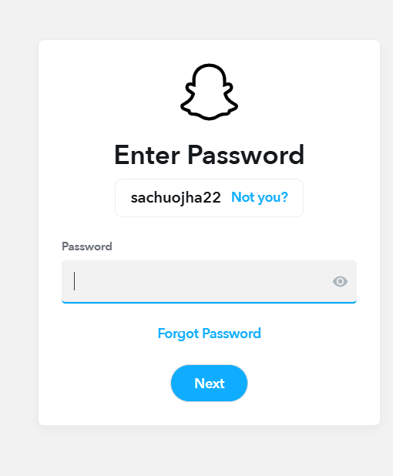 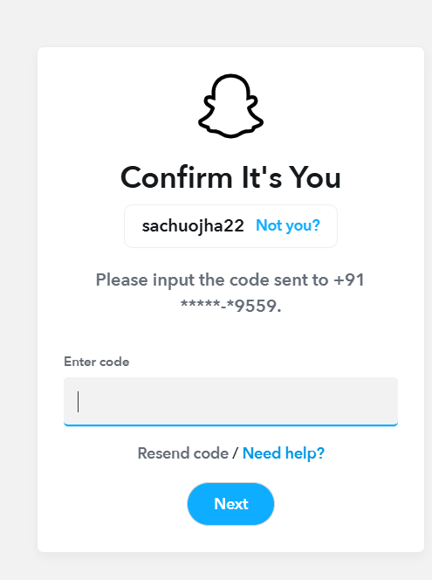

Expected Result:- Redirects to password reset page.

Actual Result:- Password Change page open

Status:- Pass

Comments:- Input is working.

TC_07:-

Step 1:- Enter registered phone number.

Step 2:- Enter correct password.

Step 3:- Click Next.

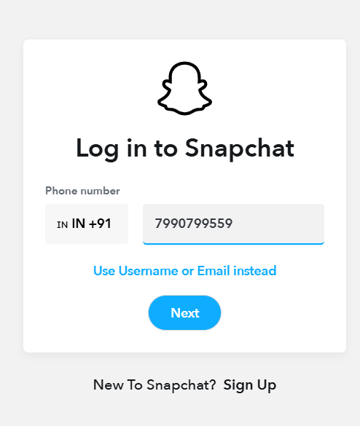 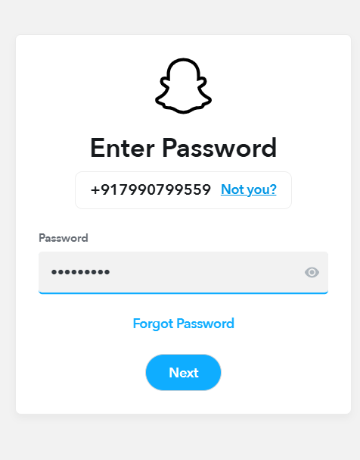

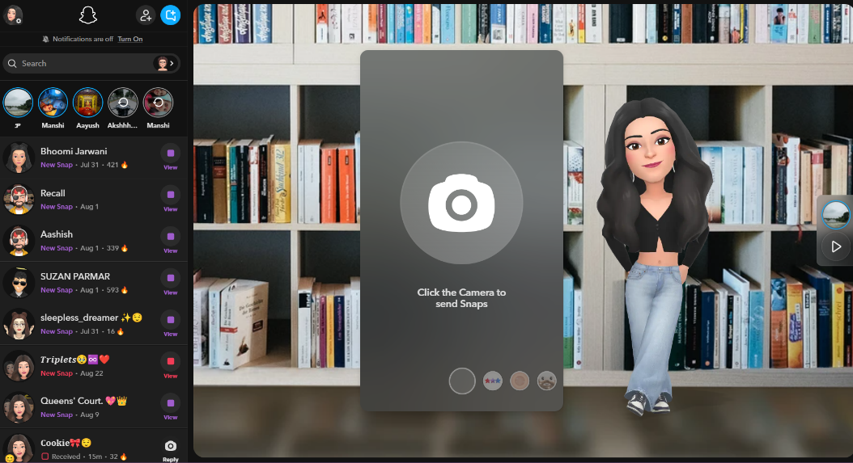

Expected Result:- User logged in successfully.

Actual Result:- User logged in successfully.

Status:- Pass

Comments:- login works fine.

TC_08:-

Step 1:- Enter email instead of username.

Step 2:- Enter valid password.

Step 3:- Click Next.

