**Architecture Diagram of StockListing App**

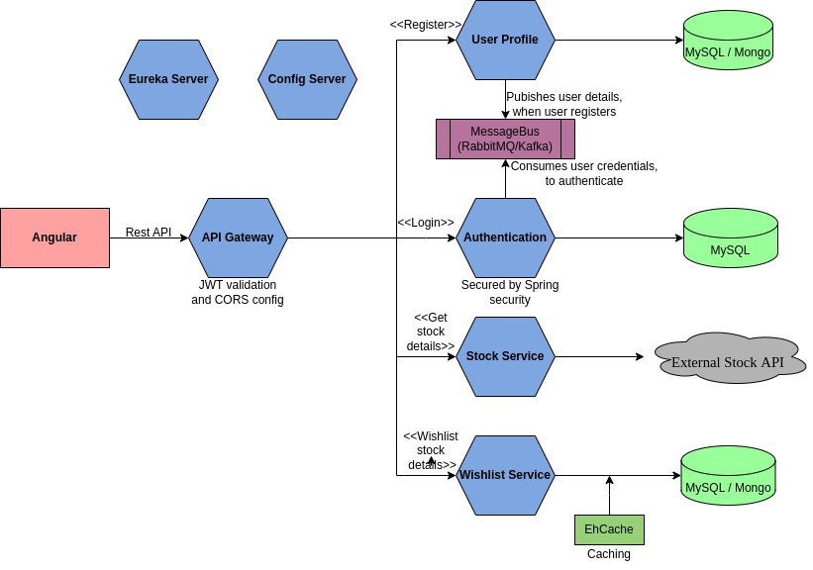

**Frontend Spring**Boot

**DB**

REST API

API Gateway



AWS Lambda