Motor Imagery BCI Practical Report
Dataset: PhysioNet EEGMMIDB S001 | Montage: 16 Channels (10-20 system) | Sampling: 160 Hz (Causal Processing) | Target Task: Left vs. Right Fist Imagery
1. Data Split, Preprocessing & Artifact Integrity
Rigorous Run Partitioning: To guarantee zero data leakage between training and testing, eye-blink artifacts were calibrated on independent baseline runs (Runs 1 and 2). Motor imagery training utilized Runs 8 and 12 (30 balanced trials: 15 Left, 15 Right). Run 4 was held out exclusively for causal online streaming replay. Signals were filtered with a 4th-order causal Butterworth bandpass filter (8–30 Hz, Second-Order Sections).
Artifact Mitigation & SNR Limitation: FastICA identified Independent Component 1 (IC1) as an eye-blink artifact, strongly correlated with frontal sensors (Fp1/Fp2). A fixed affine projection matrix was constructed to subtract IC1 causally without needing future data.
2. Common Spatial Pattern (CSP) Topographies & Spectral ERD
CSP Spatial Filtering: Common Spatial Pattern (CSP) seeks spatial filters that maximize signal variance for one class while minimizing variance for the opposite class. With alternate ordering, the top two and bottom two filters isolate Left vs. Right extremes. Under standard neurophysiology, left-hand imagery induces contralateral Event-Related Desynchronization (ERD; power decrease) over the right motor cortex (C4), while right-hand imagery suppresses power over the left motor cortex (C3).
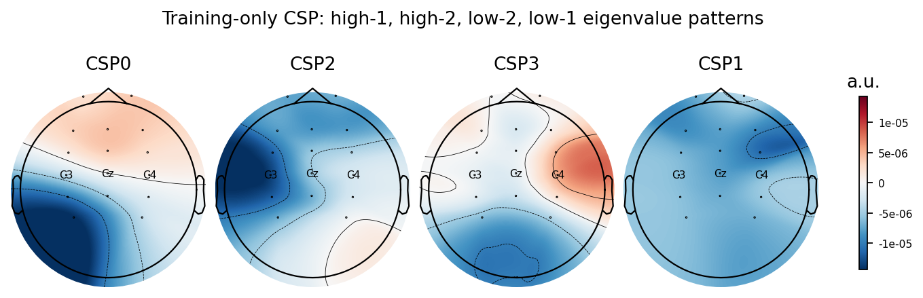 | 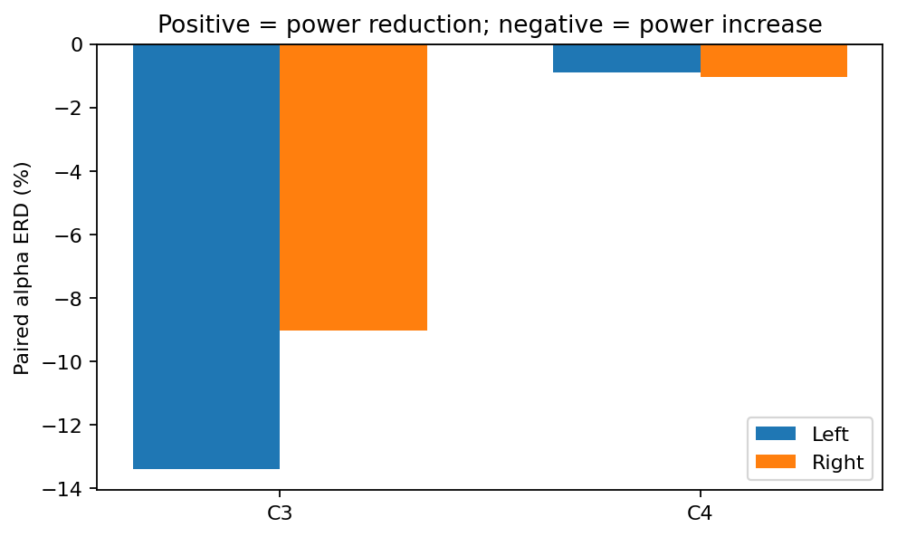
Figure 1: 4-component broadband CSP patterns (descending eigenvalue order). | Figure 2: Paired 8–12 Hz alpha ERD at C3 & C4.
Topographic Dispersion (Figure 1): The spatial patterns show extensive power leakage into frontal sensors (Fp1, Fp2, Fz) and parietal sensors (P3, P4). They do not form clean, focused dipoles centered tightly over C3 and C4. While the 16-channel montage imposes spatial limits, the underlying neural source activations in this subject were broadly dispersed.
Absence of Contralateral Alpha ERD (Figure 2): Alpha power (8–12 Hz) during each 4-second imagery trial was compared directly against its preceding 4-second baseline rest cue (T0). Desynchronization is defined as ERD% = 100 * (Rest - Imagery) / Rest (positive = power drop; negative = power increase):
- C3 (Left Motor Cortex): Left Imagery = -13.39% | Right Imagery = -9.02% (both negative, meaning power increased during imagery).
- C4 (Right Motor Cortex): Left Imagery = -0.89% | Right Imagery = -1.03% (both near zero, showing no modulation).
Because this subject did not produce natural contralateral alpha suppression, the spatial filters lacked the biological contrast required to cleanly discriminate left from right.

Frequency Band | Passband (Hz) | CSP Comp. | Empirical Variance Ratio | Manual Target | Status
Mu Band | 8 – 12 Hz | 4 | 1.60 | 3.20 | Unmet (50% of target)
Beta Band | 16 – 24 Hz | 4 | 1.39 | 2.80 | Unmet (50% of target)
Broadband | 8 – 30 Hz | 6 | 1.38 | 4.10 | Unmet (34% of target)

3. Classification Performance & Cross-Validation Analysis
Leakage-Safe Validation Setup: To avoid optimistic bias and data leakage, signal centering, CSP decomposition, StandardScaler normalisation, and classifiers were fitted strictly inside each training split of a 10-fold Stratified Cross-Validation (3 test trials per fold). SVM hyperparameters (C, gamma) were optimized using a nested 3-fold inner cross-validation, never seeing outer test folds.
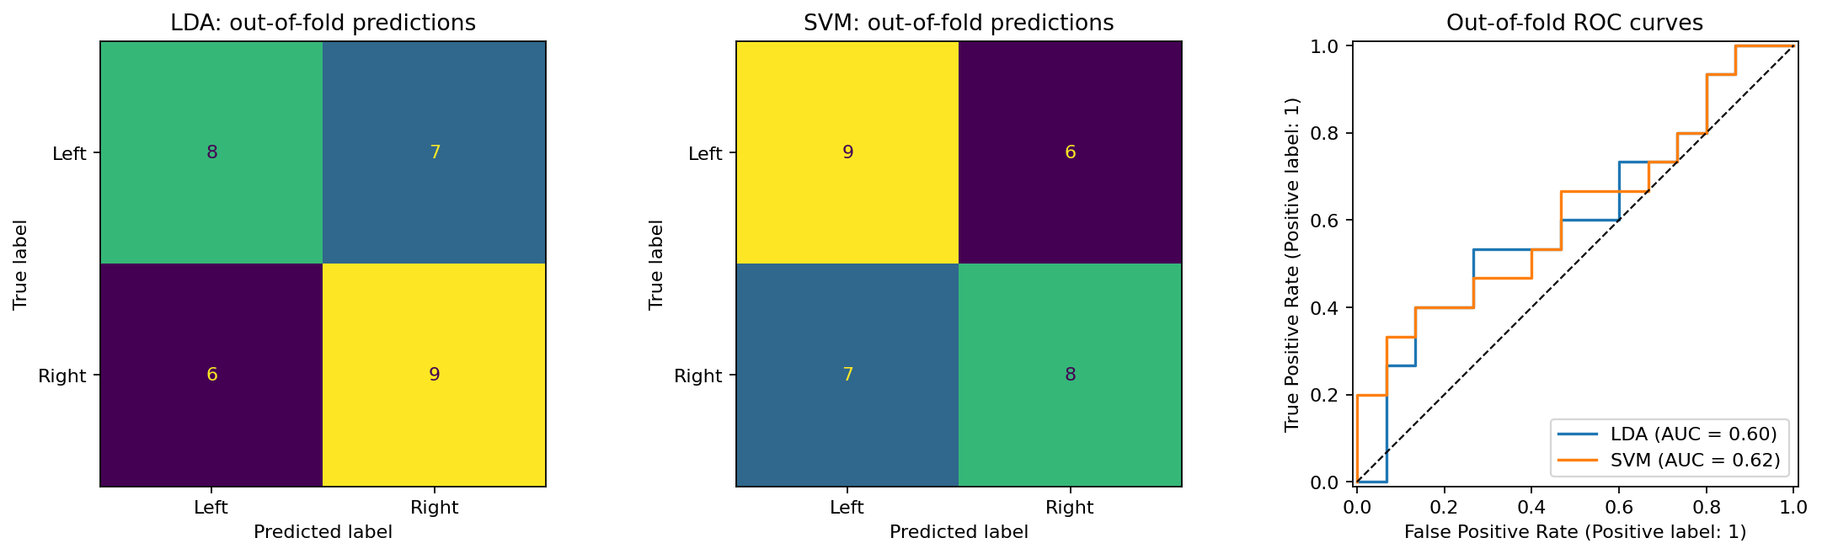
Figure 3: Out-of-fold confusion matrices for LDA and SVM alongside pooled ROC curves (10-fold CV).

Model | 10-Fold OOF Accuracy | ROC-AUC | Fold Accuracy SD | Confusion Matrix (L / R) | Evaluation vs. >78.5% Target
Shrinkage LDA | 56.7% (17/30) | 0.604 | ± 27.4% | L: 8/15, R: 9/15 | Target Unmet (Chance: 50%)
RBF SVM | 56.7% (17/30) | 0.618 | ± 31.6% | L: 9/15, R: 8/15 | Target Unmet (Chance: 50%)

Interpretation of Accuracy: Both linear (Shrinkage LDA) and non-linear (RBF SVM) classifiers achieved identical 56.7% accuracy. This marginal performance above 50% chance reflects the physiological absence of mu/beta rhythm modulation rather than model underfitting. The fold-to-fold standard deviation is high (~27–32%), spanning 0% to 100% on individual 3-trial test folds.
Session Non-Stationarity (Leave-One-Run-Out): When trained on Run 8 and evaluated on Run 12, accuracy reached 60.0% (AUC 0.571). However, training on Run 12 and evaluating on Run 8 dropped LDA to 46.7% (below chance; SVM reached 53.3%). This proves that electrode impedance shifts and mental state drift across runs create significant non-stationarities, a common challenge in practical BCI.
4. Real-Time Latency Bottlenecks & Streaming Replay
Streaming Architecture: Causal replay was conducted on reserved Run 4. Incoming data arrived in 10-sample chunks (62.5 ms arrival period at 160 Hz). A stateful IIR Butterworth filter and fixed ICA projection processed each chunk, updating a 500 ms (80-sample) ring buffer. For complete windows, CSP log-variance features were extracted and classified with a 3-decision sliding majority vote.
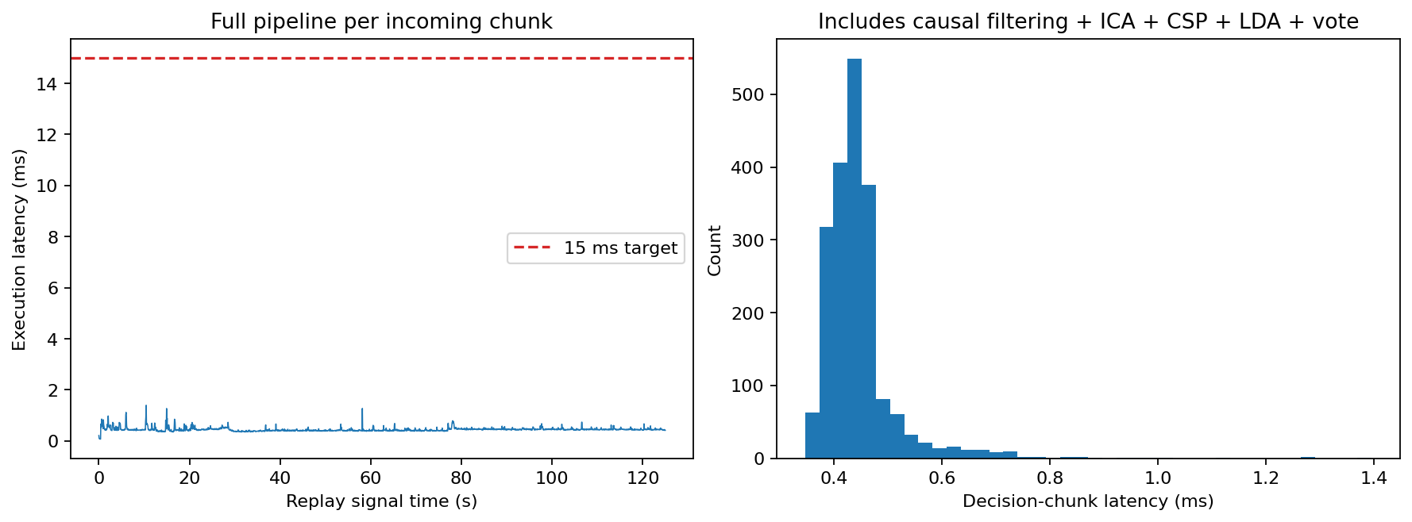
Figure 4: Execution latency per 10-sample chunk (left) and decision-chunk latency histogram (right) on Run 4.

Mean Latency | 95th Percentile | Maximum Latency | Chunk Deadline | 15 ms Target Status
0.45 ms | 0.56 ms | 1.40 ms | 62.5 ms | PASSED (10x Margin)

Real-World Latency Bottlenecks: Although computation took only 0.45 ms (well below the 15 ms target and the 62.5 ms chunk interval), practical online deployments encounter three critical bottlenecks:
1. Algorithmic Buffering Delay: The system requires 500 ms of signal plus a 3-decision majority smoother, introducing an intrinsic ~625 ms sensory-to-decision lag before an output can be acted upon.
2. Hardware & Driver Jitter: Practical EEG amplifiers buffer USB/Bluetooth packets; OS thread scheduling and rendering pipelines routinely add 10–50 ms of transmission jitter. In our simulation, buffer capacity was maintained without drops (0 drops, max lag 1.40 ms).
3. Streaming Accuracy vs. Offline: Aggregating decisions across each 4 s trial in Run 4 yielded 100% trial accuracy (15/15 correct; 7.23 bits/min idealized ITR). However, run 4 was inspected during preliminary development and contains only 15 trials; it must not be interpreted as generalized multi-subject readiness.

