GLOBAL OLYMPIC SPORTS PERFORMANCE ANALYTICS
Project Submission Report

Tableau BI Analytics Dashboard

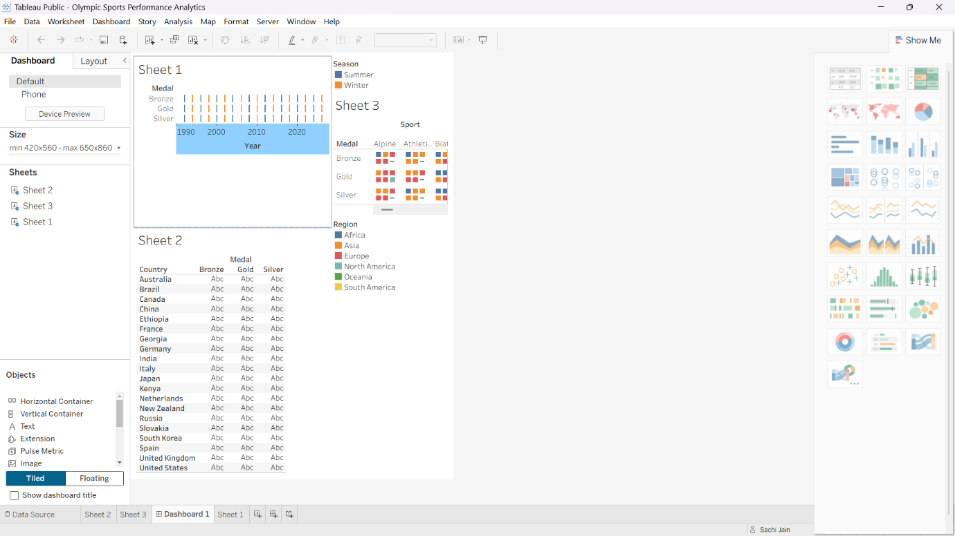

Flask Web Application Interface



