# Linux Basic Admin Tasks

Prepared by: Sachin  
Date: 03-Aug-2025

## 1. Creating and Renaming Files/Directories

Commands:  
mkdir test_dir  
cd test_dir  
pwd  
touch example.txt  
mv example.txt renamed_example.txt  
ls  
  
Explanation:  
- mkdir: Creates a new directory.  
- cd: Changes to the directory.  
- pwd: Prints current directory path.  
- touch: Creates an empty file.  
- mv: Renames the file.  
- ls: Lists files in the directory.

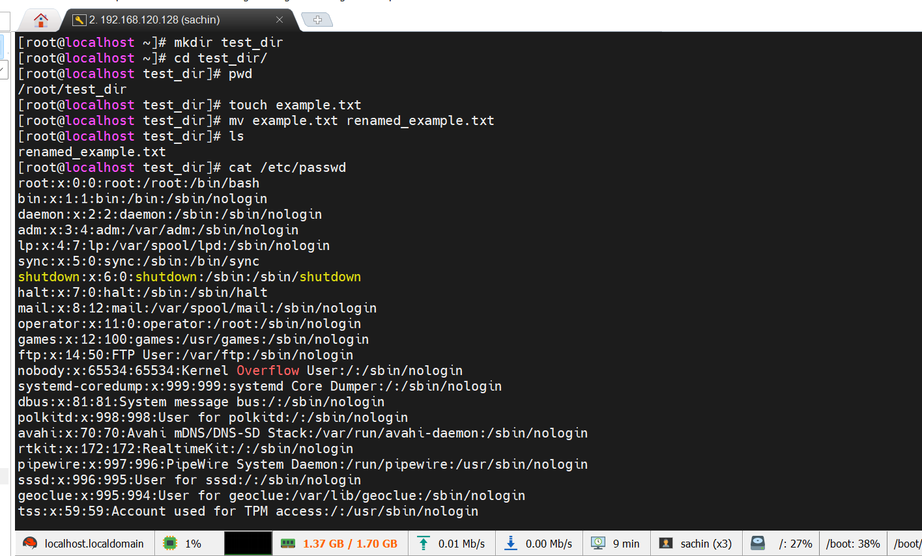

## 2. Viewing File Contents

Commands:  
cat /etc/passwd  
head -n 5 /etc/passwd  
tail -n 5 /etc/passwd  
  
Explanation:  
- cat: Displays file contents.  
- head: Shows first 5 lines.  
- tail: Shows last 5 lines.

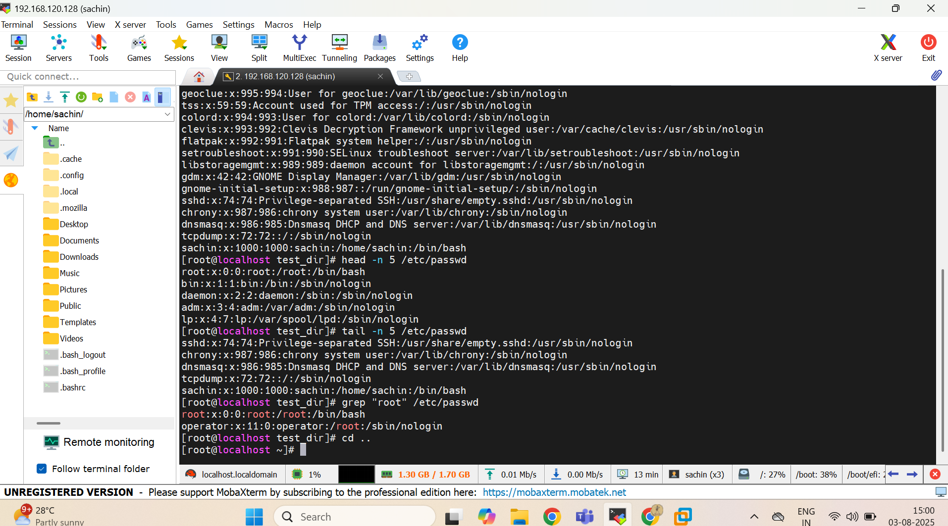

## 3. Searching for Patterns

Command:  
grep "root" /etc/passwd  
  
Explanation:  
- grep: Searches for "root" in /etc/passwd.



## 4. Zipping and Unzipping

Commands:  
tar -czvf test_dir.tar.gz test_dir  
mkdir unzipped_dir  
tar -xzvf test_dir.tar.gz -C unzipped_dir  
  
Explanation:  
- tar -czvf: Compresses the directory.  
- mkdir: Creates new directory.  
- tar -xzvf: Extracts files to directory.

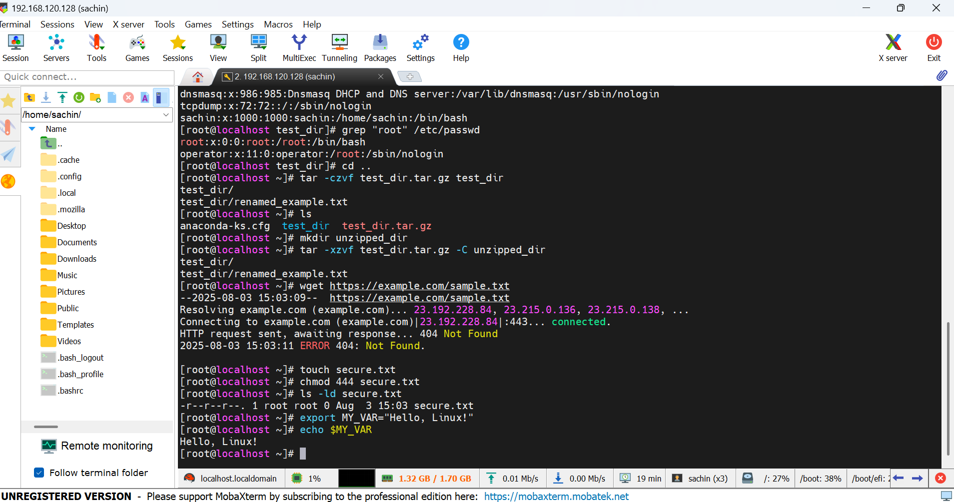

## 5. Downloading Files

Command:  
wget https://example.com/sample.txt  
  
Explanation:  
- wget: Downloads file from URL.



## 6. Changing Permissions

Commands:  
touch secure.txt  
chmod 444 secure.txt  
ls -ld secure.txt  
  
Explanation:  
- touch: Creates a file.  
- chmod 444: Makes it read-only for everyone.  
- ls -ld: Displays file permissions.



## 7. Working with Environment Variables

Commands:  
export MY_VAR="Hello, Linux!"  
echo $MY_VAR  
  
Explanation:  
- export: Sets environment variable.  
- echo: Displays variable value.



## 8. Full Command History

Command:  
history  
  
Explanation:  
- history: Shows the list of previously run commands.

