User Interface Design

Saachin SR

230701273

CSE-‘C’

Lab 4: Create a prototype with familiar and unfamilair navigation elements evaluate ease of use with different user groups.

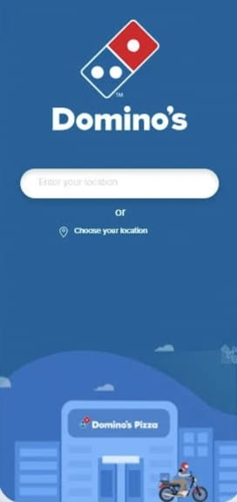

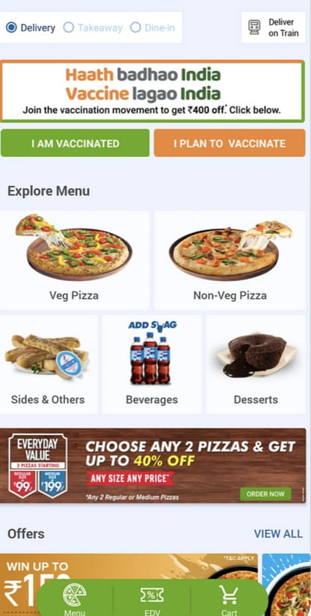

Here familiar icon is the cart located bottom navigation bar, commonly used to navigate to the main or home screen of an app. The cart icon also located to its right where the users can view selected items before making purchase. It is commonly used in e-commerce and food-ordering apps.

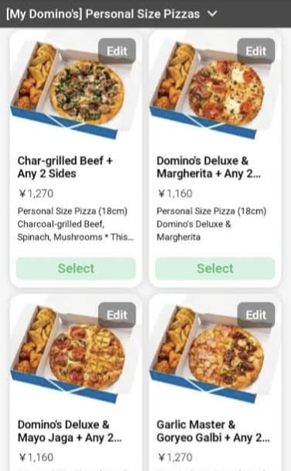

Also clicking the options pizzas, burgers and shakes helps the users to view them all these are familiar icons.