# USER INTERFACE AND DESIGN

Saachin SR

230701273

CSE-‘C’

# Lab Experiment 6

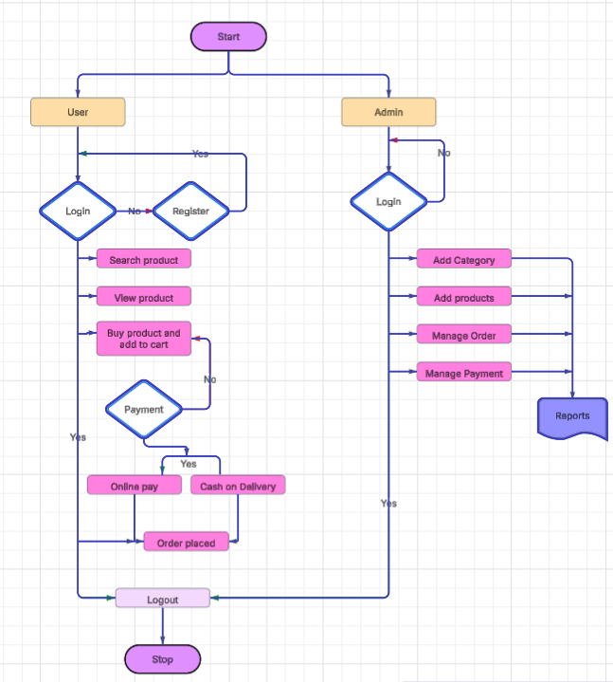

## Simulating the Lifecycle Stages for UI Design using the RAD Model and Developing an Interactive Interface using Axure RP

## 1. Aim

To demonstrate the lifecycle stages of User Interface (UI) design using the Rapid Application Development (RAD) model and to develop a small interactive interface using Axure RP.

## 2. Tools Required

Software: Axure RP (https://www.axure.com/)

## 3. Overview of RAD Model

The RAD model emphasizes quick development and frequent iteration. It consists of four main phases:

- Requirements Planning

- User Design

- Construction

- Cutover

## 4. Procedure

### Phase 1: Requirements Planning

Identify Key Features:

* • Navigation: Home, Product Categories, Product Details, Cart, Checkout, Order Confirmation, Order History.
* • User Actions: Browsing, Searching, Adding to Cart, Checkout, Tracking Orders.

Create a Requirements Document:

* • List all features and functionalities.
* • Document user stories and use cases.

### Phase 2: User Design

1. Install and Launch Axure RP: Download and install Axure RP from its official site.

2. Create a New Project: Navigate to File → New and name the project (e.g., "Shopping App Interface").

3. Create Wireframes: Design wireframes for:

* • Home Page  
  • Product Categories  
  • Product Listings  
  • Product Details  
  • Cart  
  • Checkout  
  • Order Confirmation  
  • Order History

4. Add Interactions: Use the Properties panel to add interactions such as OnClick navigation.

5. Create Masters: Design reusable components like headers and footers.

6. Add Annotations: Document the purpose and functionality of each element through the Notes panel.

### Phase 3: Construction

1. Develop Interactive Prototypes: Add transitions, dynamic panels (e.g., carousels, pop-ups), and simulate real-time user interaction.

2. Test and Iterate: Use the Preview function to review. Collect feedback and adjust designs accordingly.

### Phase 4: Cutover

1. Finalize and Export: Finalize all designs and interactions. Export the prototype as an HTML file or upload it to Axure Cloud for sharing.

2. User Training and Support: Conduct training sessions to demonstrate the UI. Provide supporting documentation and help users troubleshoot.

## 5. Conclusion

By following the RAD model and using Axure RP, a functional and user-friendly interactive interface can be rapidly designed and iterated based on user feedback, ensuring better usability and quicker development cycles.