Below is the website I created in wix.com, I want similar

**Home Page**

Requirement: 1 pic(yet to decide) and some lines of description(yet to finalise)



2. Service Page

Requirement: 1-3pic(yet to decide) and some lines of description(yet to finalise)



3. Contact

Requirement: 1 pic and Contact form like this, need to connect to my gmail ID or business ID(yet to decide)

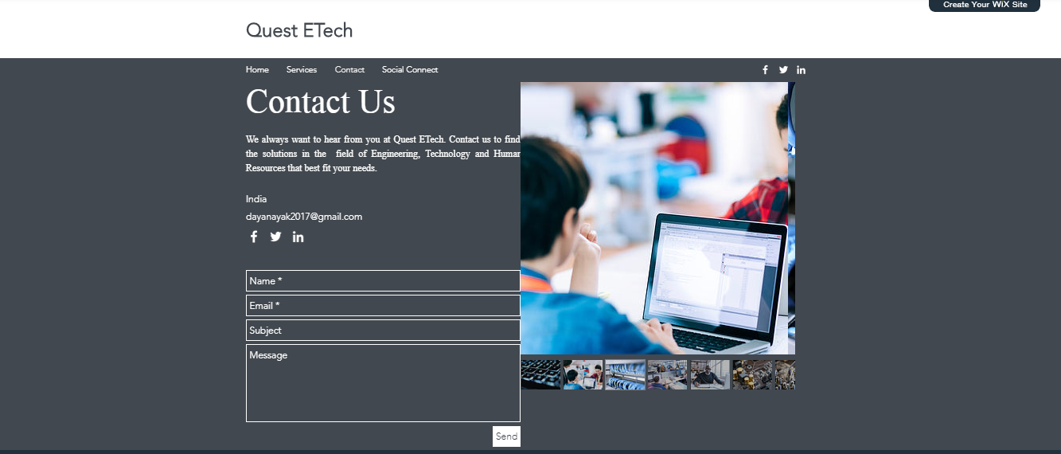

4. Social Connect

Requirement: 1 pic(need to select) plus description. Also at the bottom of this people should be able to post comments, which will get posted once I approved it. As of now only 4 buttons

