SALES KPI POWER BI PROJECT
27 Business KPIs Built with DAX

Prepared by: Sachin Gupta
Aspiring Data Analyst | Advanced Excel · Power BI · SQL · Python
Tool: Power BI Desktop | Data: Ecommerce_Sales_Data.xlsx (2,500 orders)

Project Overview
This project was built to practice designing and calculating business KPIs from scratch in Power BI using DAX. The core deliverable is a bank of 27 KPIs covering sales, profitability, orders, customers, discounts, order fulfillment, and time intelligence. A simple supporting dashboard was also built on the side for extra Power BI practice — it is not the main focus of this project.
Project type | KPI design practice (27 KPIs) + a practice analytical dashboard
Tool | Power BI Desktop
Data source | Ecommerce_Sales_Data.xlsx — sheet "Sales_Data"
Rows / Columns | 2,500 orders x 31 columns
Report pages | All KPI's, Page 3 (cover), DAShBOARD
File | KPI_s_Project.pbix

Data Model
Fact table: Sales_Data (2,500 rows, 31 columns), loaded from the Excel workbook via Power Query. Columns:
Order ID, Order Date, Customer ID, Customer Name, Customer Age, City, State, Zone,
Category, Product, SKU, Quantity, Unit Price, Gross Sales, Coupon Code, Discount Amount,
GST Rate %, Net Sales, GST Amount, Payment Mode, Order Status, Sales Channel,
Sales Employee, Delivery Partner, Delivery Days, Customer Rating, COGS, Profit,
Profit Margin %, Shiping Charges, Invoice Amount
Supporting tables:
- Date — a calendar/date table used for all time-intelligence measures (MTD, QTD, YTD, YoY, running total)
- DateTableTemplate_* / LocalDateTable_* — Power BI's auto date/time tables
Measure table: "All Measure" — a dedicated table holding all 28 DAX measures. 27 of them are surfaced as KPI cards across the report; one is an internal helper measure used inside another KPI.

The 27 KPIs (with DAX)
All formulas below are copied exactly as authored in the .pbix file's data model.

1. Sales & Profitability
KPI | DAX Formula
Total Sales | SUM(Sales_Data[Net Sales])
Gross Sales | SUM(Sales_Data[Gross Sales])
Total Profit | SUM(Sales_Data[Profit])
Profit Margin% | DIVIDE([Total Profit],[Total Sales])
Total COGS | SUM(Sales_Data[COGS])

2. Orders & Customers
KPI | DAX Formula
Total Orders | DISTINCTCOUNT(Sales_Data[Order ID])
Total Customers | DISTINCTCOUNT(Sales_Data[Customer ID])
Average order value | DIVIDE([Total Sales],[Total Orders])

3. Discounts, GST & Shipping
KPI | DAX Formula
Total Discount | SUM(Sales_Data[Discount Amount])
Discount% | DIVIDE([Total Discount],[Gross Sales])
Total GST | SUM(Sales_Data[GST Amount])
Total Shippimg | SUM(Sales_Data[Shiping Charges])

4. Order Fulfillment
KPI | DAX Formula
Deliverd Orders | CALCULATE( [Total Orders],Sales_Data[Order Status]= "Delivered")
Returnd Orders | CALCULATE( [Total Orders],Sales_Data[Order Status]= "Returned")
Cancelled Orders | CALCULATE( [Total Orders],Sales_Data[Order Status]= "Cancelled")
Delivery Success Rate% | DIVIDE([Deliverd Orders],[Total Orders])
Return Rate% | DIVIDE([Returnd Orders],[Total Orders])
Cancellation Rate % | DIVIDE([Cancelled Orders],[Total Orders])

5. Time Intelligence
KPI | DAX Formula
Sales MTD | TOTALMTD([Total Sales],'Date'[Date])
Sales QTD | TOTALQTD([Total Sales],'Date'[Date])
Sales YTD | TOTALYTD([Total Sales],'Date'[Date])
Profit YTD | TOTALYTD([Total Profit],'Date'[Date])

6. Year-over-Year Growth
KPI | DAX Formula
Previous year Sales | CALCULATE([Total Sales],DATEADD('Date'[Date],-1,YEAR))
Previous Year Profit | CALCULATE([Total Profit],SAMEPERIODLASTYEAR('Date'[Date]))
YoY Sales Growth% | DIVIDE([Total Sales]-[previois year sales],[previois year sales])
YoY Profit Growth% | DIVIDE([Total Profit]-[Previous Year Profit],[Previous Year Profit])

7. Running Total
KPI | DAX Formula
Running Total Sales | CALCULATE([Total Sales],FILTER(ALLSELECTED('Date'[Date]),'Date'[Date]<=MAX('Date'[Date])))
Helper measure: previois year sales = CALCULATE([Total Sales],SAMEPERIODLASTYEAR('Date'[Date])) — an internal support measure (not shown as its own card) used inside YoY Sales Growth%. It brings the total measure count in the model to 28, with 27 exposed as KPI cards.

Report Pages

Page 1 — "All KPI's"
A KPI-card grid showing 25 of the 27 KPIs at a glance: Sales, Profit, Orders, Customers, Discounts, GST, Shipping, Delivery/Return/Cancellation rates, MTD/QTD/YTD, and Previous Year Sales.
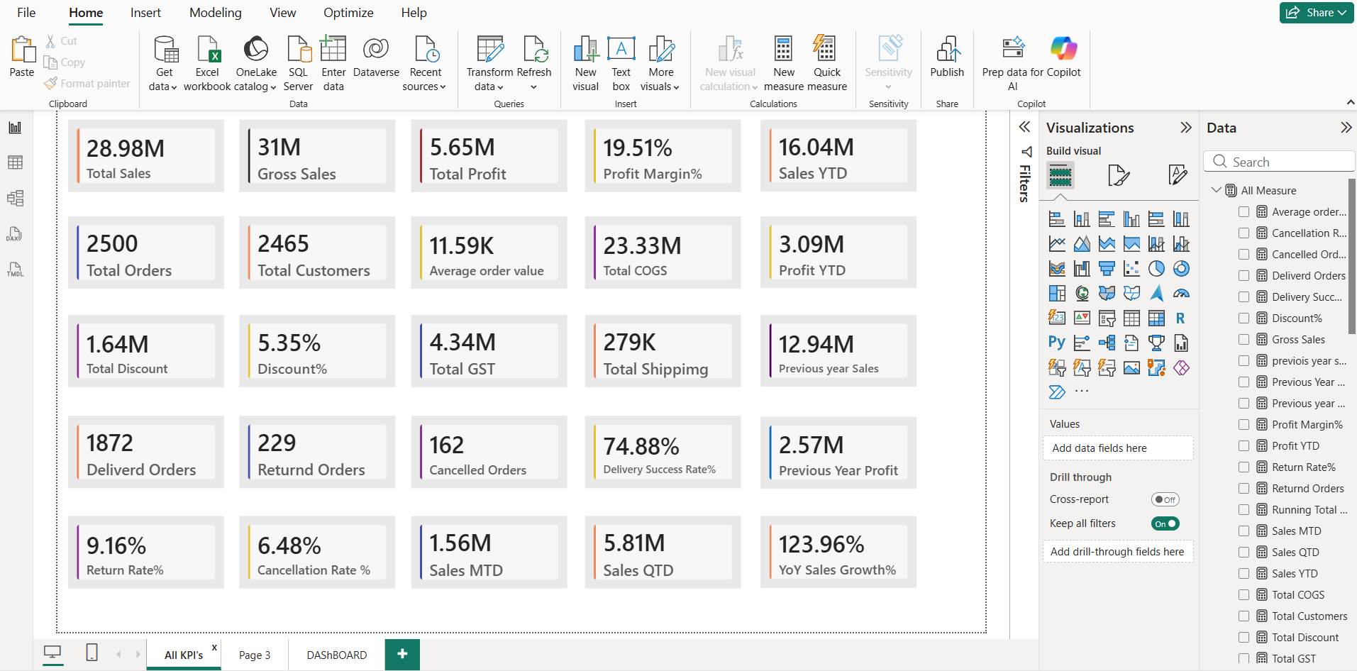
All KPI's page — 25 KPI cards

Page 2 — "Page 3" (Cover)
A project cover/title page — "KPI's Project — Total 27 KPI's" — plus the remaining 2 KPI cards: YoY Profit Growth% and Running Total Sales.
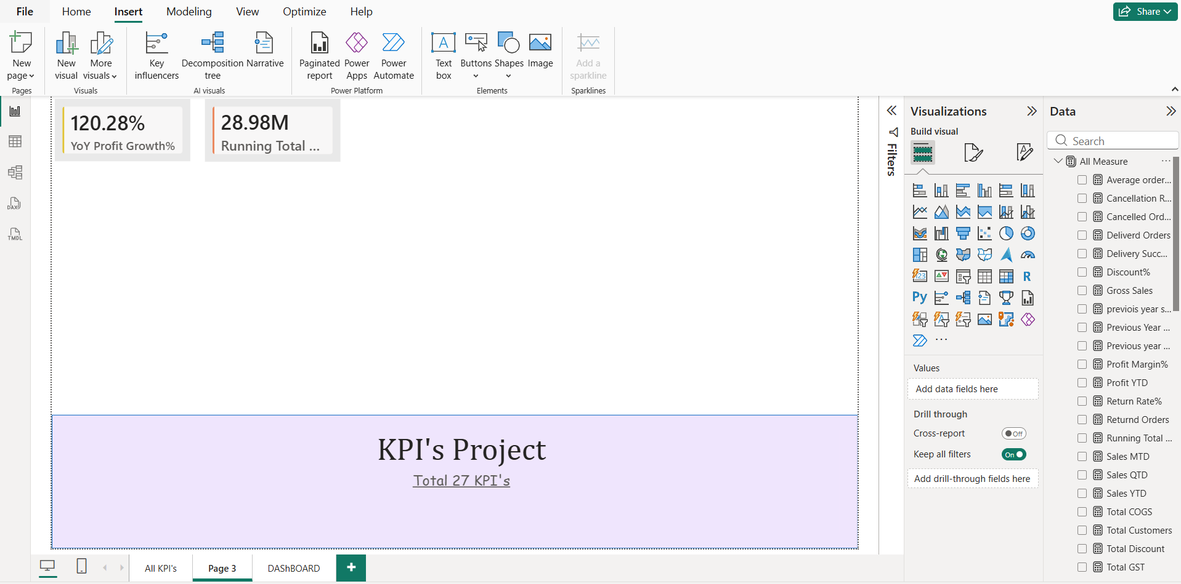
Cover page with the final 2 KPI cards

Page 3 — "DAShBOARD" (practice dashboard)
A supporting, normal analytical dashboard built for extra Power BI practice — not the main deliverable. It includes:
- Total Customers by months Name — column chart
- Total Sales by months Name — line/area chart
- Gross Sales by Quarter — pie chart
- Total Sales and Profit Margin% by year — donut chart (2024 vs 2025)
- Average order value by Order Status — bar chart
- Total Orders by Querter — bar chart
- YoY Sales Growth% by Querter — bar chart
- Slicers: Category, Order Status, Sales Channel, and an Order Date range slider
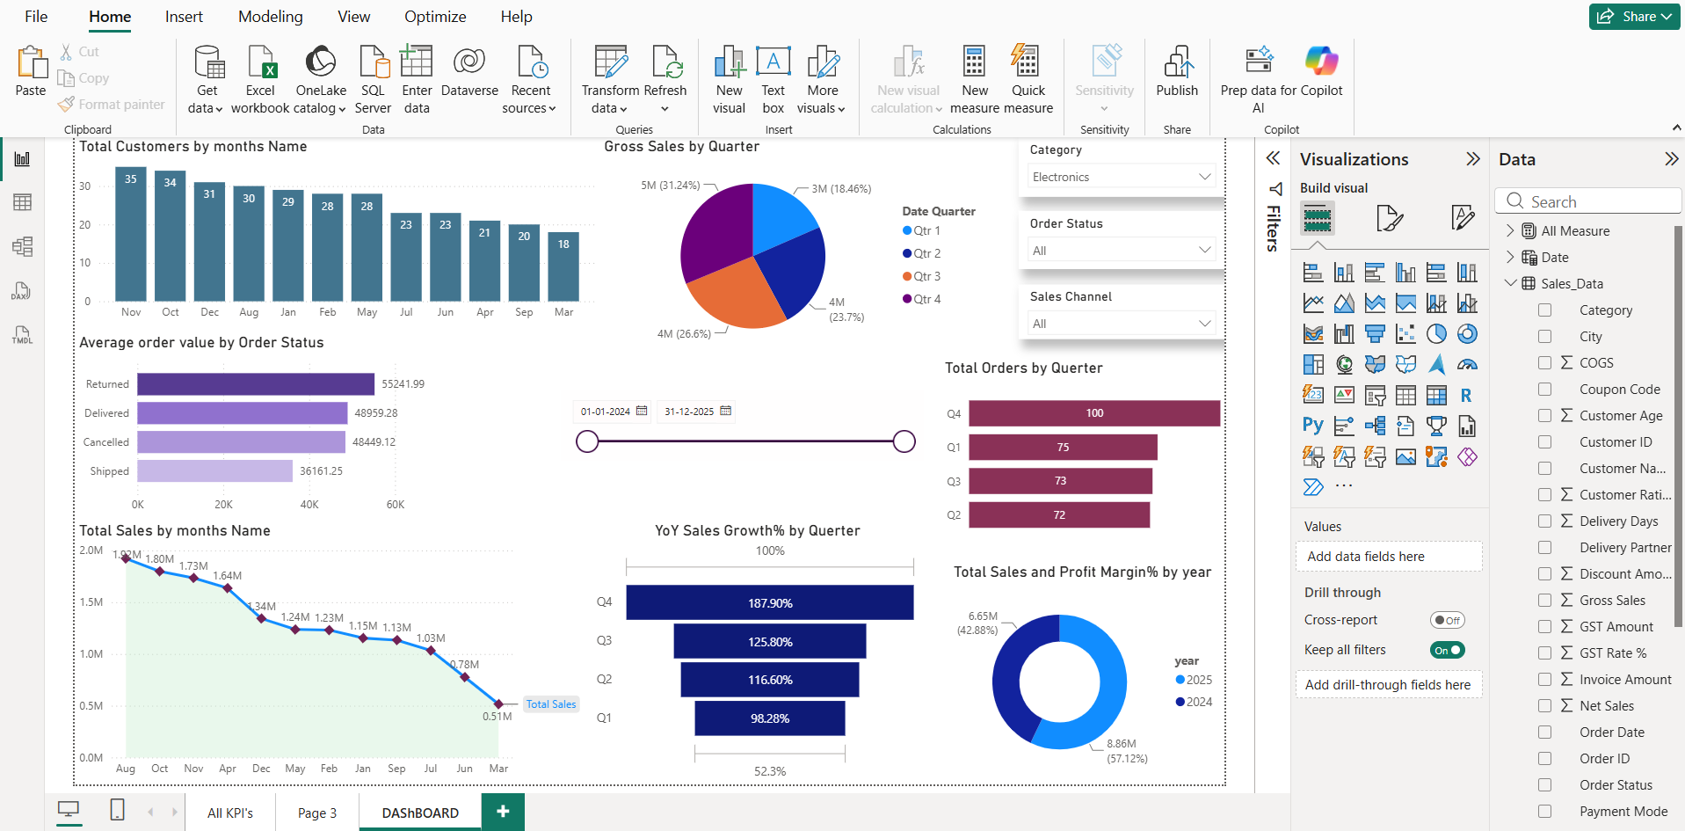
DAShBOARD page — practice dashboard

Tools Used
- Power BI Desktop — data modeling, report building
- Power Query — imported and typed the Sales_Data sheet from the Excel source
- DAX — all 28 measures (27 KPIs) built from scratch

