Docker commands can not be run without root user. To run without root user, we will have to add normal user into docker group using below command:
sudo usermod -aG docker $USER

Below command to open port:
sudo firewall-cmd --zone=public --add-port=80/tcp --permanent
sudo firewall-cmd –reload

command to check running docker containers:
docker ps
command to check all docker containers(running + stopped):
docker ps -a

Docker container directory:
/var/lib/docker/containers/

To execute the command inside the container, below command will do ls -larth inside container:
docker exec <image name> ls -larth

How to attach to the docker container, or enter into the container :
devops@devops-VirtualBox:~$ docker exec -it myweb /bin/bash
root@445d69cefe93:/#

Command to remove the docker image:
docker rmi <name>
example: docker rmi nginx

Command to remove the docker container:
docker rm <container id>

command to see images details:
docker inspect <image_name>

Command to see docker logs, to see any issue in container:
docker logs <container_id>

to set an variable in docker command, use -e var=mypass.

Any change we want to make in container, we update our image file as we can not login into container and make changes in it because containers are disposable, we delete them and re-create.
So, always make change in your image.

The data doesn’t persist when that container no longer exists. And it can be difficult to get the data out of the container if another process needs it.
A container’s writable layer is tightly coupled to the host machine where the container is running. You can’t easily move the data somewhere else.

Docker has two options for containers to store the files in the host machine.
- Volumes → We attach a directory to a container which going to the volumes.
All the volumes will be at /var/lib/docker/volumes/
command to create volume:
docker volume create <volume-name>
command to listing docker volumes:
docker volume ls
Command to run the docker container with volume:
docker run --name vprodb -d -e MYSQL_ROOT_PASSWORD=secretpass -p 3030:3306 -v mydbdata:/var/lib/mysql mysql:5.7

Now We can drop the container and attach this volume to newly created container too.

- Bind mounts → This is used to move/ingect data from host machine to container.
docker run --name vprodb -d -e MYSQL_ROOT_PASSWORD=secretpass -p 3030:3306 -v /home/devops/vprodbdata:/var/lib/mysql mysql:5.7
- Above command is running the mysql image where setting up the bind mounts volume.
/home/devops/vprodbdata is the host machine directory which we pointed to the container’s directory /var/lib/mysql .
2. When we stop the container or delete the container, data remains in host machine directory, ie. /home/devops/vprodbdata . Developer can keep pushing the code while container is running.

Build images

We need to create a Dockerfile to build a image, below are the instructions commands:
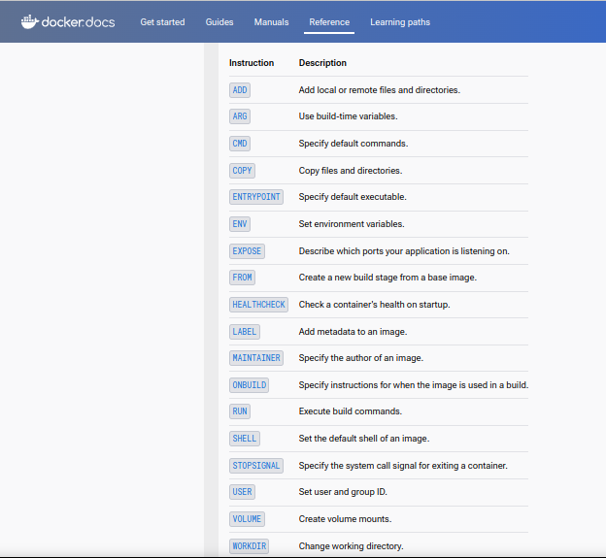

First Dockerfile:

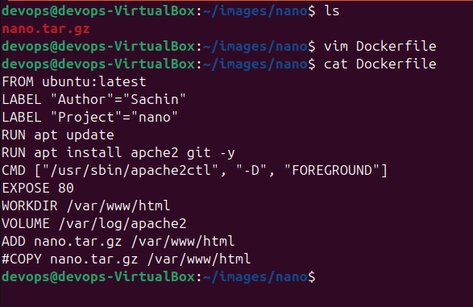

- Now build this Dockerfile using docker build command:
docker build -t <image-name> <docker-file-path>
- Now post build Dockerfile, run the image:
docker run -d --name nanowebsite -p 9080:80 nanoimg
- Command to push our image to docker hub:
docker push sachinbadhwar/nanoimg
- In a Dockerfile, if in cmd or entrypoint, there is a command but no argument, then while docker run user will have to pass the argument.
Ex: docker run <image-name> <argument>

Docker compose

It is a tool to run multi containers together.

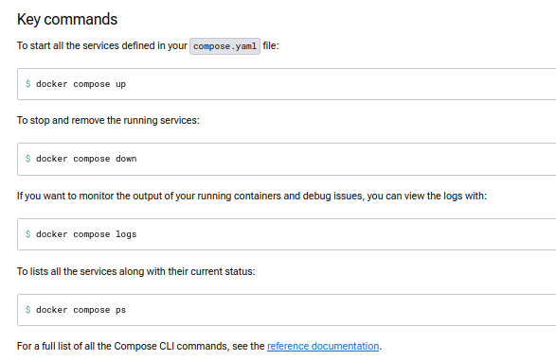
D

install docker compose

then create a Docker file and then a docker compose.yml file
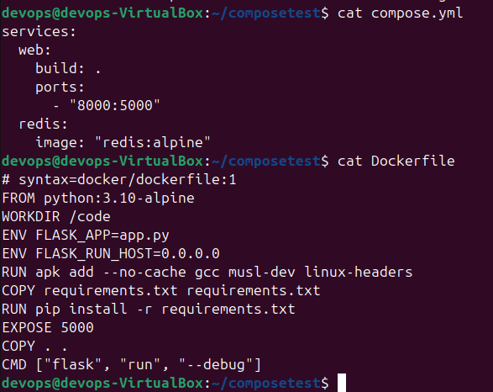
WORKDIR is the workdirectory for the container where everything will be stored, example this requirement.txt file is also getting saved into the container’s workdir which is /code

COPY requirements.txt requirements.txt, this command is copying the requirements.txt file from current directory of host file to the work directory of container.

RUN command is to run the linux commands.

Multi-stage Dockerfile

This we need when we want limited stuff in the container’s work directory and don’t want to over size the image. Then we create multi-stage.

