Linux

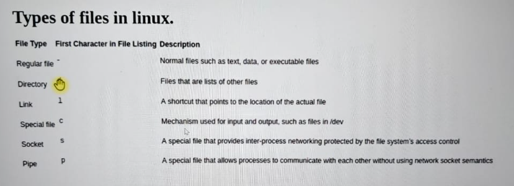

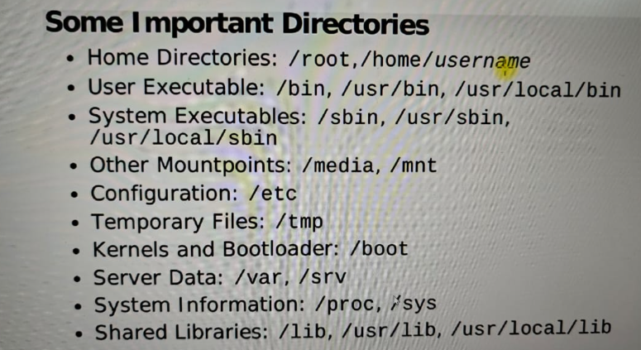

How to link a path to a variable.
Command: ln -s /opt/dev/ops/devops/test/command.txt cmds
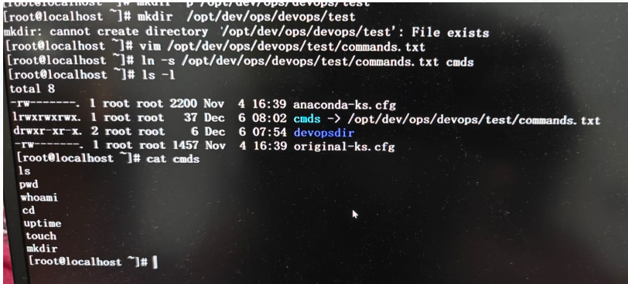

- grep -R <string> → R is for look inside the directory.
- Grep -vi sachin → this command shows everyline except lines which have sachin.
- Grep -c will give the count.
- Less command is a reader.
- Head first 5 lines.
- Tail give last 5 lines.
- Se num → will give line no in vim.
- Tail -f → this command keep opens the file, we can keep looking the dynamic updated data.
- Cut -d<seperator> -f1(first field) <path> → this command is to fetch columns if the data has proper separators.
- Example for above command: cut -d: -f1 /etc/passwd
- awk -F':' '{print $1}' passwd → this command will give the first value from each line having seperator as : .
- [sachin@centos ~]$ awk '/manager/ {print}' employee.txt output below:
ajay manager account 45000
varun manager sales 50000
amit manager account 47000
- [sachin@centos ~]$ awk 'length($0) >24' employee.txt → this command will gives lines having length greator than 24.
ajay manager account 45000
sunil clerk account 25000
varun manager sales 50000
amit manager account 47000
satvik director purchase 80000
- awk 'BEGIN {for(i=1;i<=6;i++) print i*i;}'
1
4
9
16
25
36

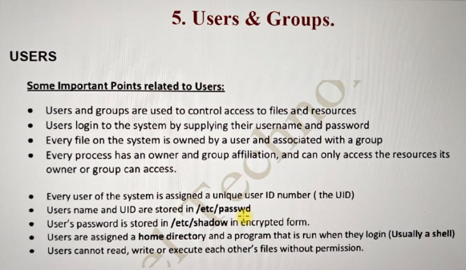

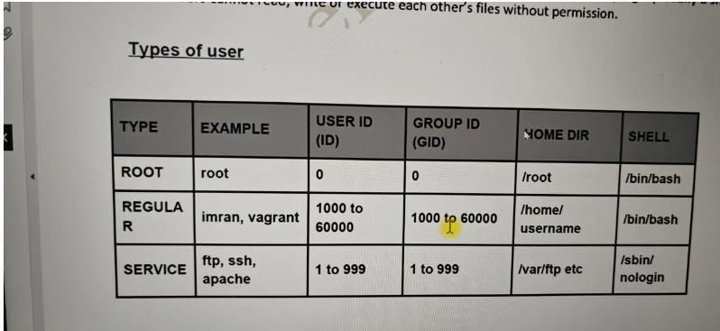
s

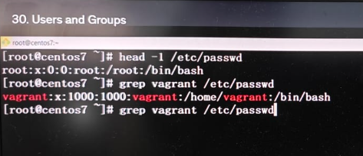
a

we can add users into a specific group either by using commands:
paste the screenshot here.

Or we can add users in specific group by editing the file <vi /etc/group> .

- Last → this command will tell you the last logged in users, with all details
- who → this will give you the current login user.
- Lsof -u username → this command will give you all the opened files.
- Userdel -r username→ to delete the user along with it’s user home directory.
- To make normal user execute like root user, need to update in sudoers file.(vi sudo)
- command line arguments → arguments passed along with executable script.
- System variables → system defined variables. Example: $? → to check last command status.
- Below command examples are for command substitution.
- up=`uptime`
[root@centos scripts]# echo $up
09:36:07 up 1:28, 3 users, load average: 0.00, 0.00, 0.00
[root@centos scripts]# current_u=$(who)
[root@centos scripts]# echo $current_u
sachin seat0 2024-08-18 08:08 (login screen) sachin tty2 2024-08-18 08:08 (tty2) sachin pts/1 2024-08-18 08:08 (192.168.1.14)
- To make a variable permanent for specific user even post logout, variable should be available. We need to save our variable as export variable in the user’s .bashrc file(command: ls -a).
- to make above variable permanent globally for all users, then save our export variable in the /etc/profile file.
- Read is for user input in bash scripting just like input in python.
- Read -sp → this is mostly for passwords, to hide the password.
- Read -p → this is for user prompt some text before user input. Like read -p username: USR
- any process is running in your system, then you can find the pid in /var/run/processname.’
- crontab -e → this will give edit option and write your cron script.
- Tu schedule the cron job, see below:
#MM HH DOM(date of month) mm(month) DOW(day of week) → this is a comment
30 20 * * 1-5
- Move files from 1 machine to another machine using SCP.
Scp testfile.txt sachin@web01:/tmp/ (SCP source file machinename@hostname:targetpath)
SCP works if ssh is working.
- if else in bash scripting.
#!/bin/bash

read -p “Enter a number: ” NUM
echo

if [ $NUM -gt 100 ]
then
echo “We have entered in IF block.”
sleep 3
echo “Your number is greater than 100.”
echo
date
fi

echo “Script execution completed successfully.”

___________________________________________________________

linux command for size

fdisk -l → this command will give you all of the disks.
/dev/xvda: 8589 MB, 8589934592 bytes, 16777216 sectors -- This is the root volume.
units = sectors of 1*512 = 512 bytes

Below is the partition of above root volume:

device Boot start End Blocks ID System
/dev/xvda1 * 2048 16777215 8387584 83 linux

And this is a root volume, which we can understand by looking at its mount: by running command df-h
you will find which proves it’s a root volume.

filesystem Size Used Avail Use% Mounted on
/dev/xvda1 8.0G 1007M 7.1G 13% /

If any disk is without partition in linux, we need to partition it, using fdisk utility, by passing the harddisk path.

Fdisk /dev/xvdf hit enter and follow the input asked by fdisk utility.
- Mkfs.ext4 is the utility to format the partition.
How to mount a disk on a particular directory.
- Mount /dev/xvdf1 /var/www/html/images -- This is for temporary mount, post reboot, mount will gone.
- umount /var/www/html/images – this is to unmount a directory.
- For permanent mount, update file vi /etc/fstab and in the last line mention below and hit mount -a after saving the file.
- /dev/xvdf1 /var/www/html/images ext4 defaults 0 0
- above last 3 values defaults for default settings, 0(no dump code) 0 (no fsck code)
- and enter mount -a command to mount /etc/fstab changes

