Logistic Regression:

Use logistic regression when the problem you're solving is a classification problem, meaning the output is a discrete, categorical value. It's a fundamental algorithm for tasks like:
- Binary Classification: When the output has only two possible classes (e.g., predicting if an email is spam or not spam, or if a customer will churn or not churn).
- Multi-class Classification: When the output has more than two possible classes (e.g., classifying a fruit as an apple, orange, or banana).
Logistic regression is a linear classifier that uses a logistic function (also known as the sigmoid function) to map any real-valued number into a value between 0 and 1. This output can then be interpreted as a probability. For example, an output of 0.8 would be interpreted as an 80% probability of belonging to the positive class.
It is a good choice when you need a model that is simple, fast, and highly interpretable. It works best when the relationship between your features and the target variable is roughly linear. For more complex, non-linear problems, you might consider more advanced algorithms like Support Vector Machines or neural networks.
Let take an example below of CGPA and IQ. You can see chart is linearly separable.
Green color students got placement and blue color students couldn’t get placement.
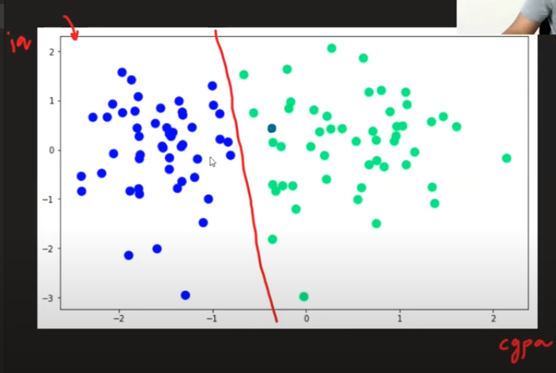
A

perceptron trick
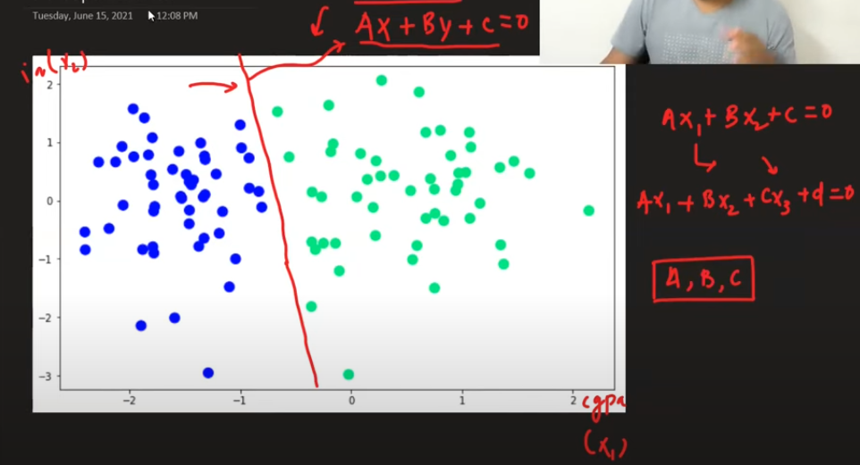
a
So, first we need to identify the A,B,C in case of 3 dimensional or A.B in case of 2 dimensional dataset. So that we can separate wo classes of data linearly.
Let try to do that using perceptron trick.
So, how perceptron trick works

The Perceptron Trick
The perceptron algorithm is a simple linear classifier that tries to find a decision boundary to separate two classes of data. The perceptron trick is the learning rule used to update the model's weights and bias whenever it makes a mistake.
The rule is:
- If the model misclassifies a positive data point, it moves the decision boundary closer to that point by updating the weights: w new=w old+αx
- If the model misclassifies a negative data point, it moves the decision boundary away from that point: w new=wold−αx
Here, w represents the weights, x is the data point (input), and α (alpha) is the learning rate, which controls the size of the update step. This iterative process continues until the model makes no more classification errors or reaches a certain number of iterations.

After training your model, you can identify whether a particular data point falls into the positive or negative category by using the model's decision function. This function calculates a score for each data point.
In the perceptron and logistic regression, the decision function is a linear combination of the features and their corresponding weights:
z=w1x1+w2x2+...+wn​xn​+b
Where:
- z is the decision score.
- w represents the weights.
- x represents the features of the data point.
- b is the bias.

How to use the score to identify the class:
- Perceptron: The perceptron uses a simple step function.
  - If z>0, the data point is classified as positive (+1).
  - If z≤0, the data point is classified as negative (-1).
- Logistic Regression: Logistic regression uses a sigmoid function to transform the score z into a probability between 0 and 1.
  - If the probability is ≥0.5, the data point is classified as positive.
  - If the probability is <0.5, the data point is classified as negative

