OLS
Ordinary Least Squares (OLS) is . It works by finding the "best-fitting" line (or hyperplane) through a set of data points by minimizing the sum of squared residuals.

Below is formula of sum of squared residuals(actual value minus predicted value)

All n all we are trying to find the best-fit line which is having minimum error, by minimizing the sum of squared residuals.
OLS in Matrix form
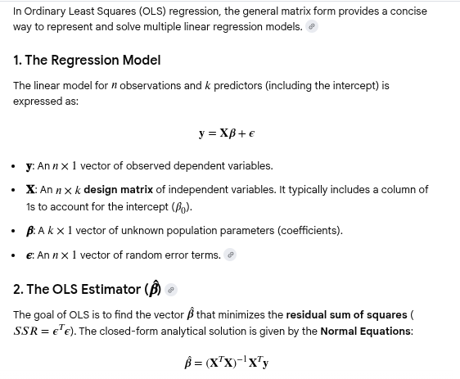

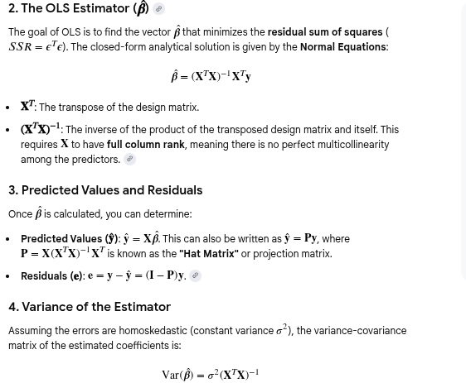

Ridge regression

You should use Ridge Regression in machine learning when your linear regression model is facing issues with overfitting or multicollinearity. It's a type of regularization that helps create a more robust and stable model, especially when dealing with complex datasets.

1. Overfitting
Overfitting occurs when a model learns the training data's noise and random fluctuations too well. This leads to the model performing excellently on the training set but poorly on new/test, unseen data. In linear models, overfitting often happens when the coefficients become very large, making the model overly sensitive to minor changes in the input features.
- How Ridge Regression Helps: Ridge Regression addresses this by adding a penalty term (the L2 regularization) to the cost function. This penalty is proportional to the squared magnitude of the coefficients. The algorithm's goal then becomes not only to minimize the error but also to keep the coefficient values as small as possible. This "shrinking" of coefficients prevents any single feature from having too much influence, simplifying the model and improving its ability to generalize to new data.

2. Multicollinearity
Multicollinearity is a problem that occurs when two or more independent variables (features) in a model are highly correlated. This can lead to unstable and unreliable coefficient estimates, making it difficult to interpret which feature is truly driving the prediction. Small changes in the data can cause drastic changes in the coefficient values.
- How Ridge Regression Helps: Ridge Regression handles multicollinearity by distributing the weights (coefficients) among the correlated features. Instead of letting one feature's coefficient become very large while others become small, the penalty term forces all the coefficients to shrink. This stabilizes the estimates and ensures that the model can still use all the correlated features without becoming unstable. Unlike Lasso Regression, Ridge Regression will not eliminate any features by setting their coefficients to zero; it will simply shrink them, making it suitable for cases where you believe all features have some predictive value

So, we need to reduce the loss function
in regularization we add extra term in loss function equation which is hyperparameter multiple by square of slope. Also known as lambda/alpha
Ridge regularization will reduce the variance which will help reducing the error and provide the best fit line by reducing the over-fitting.
Interview question - How does Ridge Regression handle Multicollinearity?
Ridge regression handles multicollinearity , unlike standard Ordinary Least Squares (OLS) which produces unstable, high-variance estimates with correlated variables. This "shrinking" distributes the influence of correlated features, preventing extreme coefficients, though it doesn't eliminate variables entirely, keeping all predictors in the model.

You should use Ridge regression when you have a linear regression problem with multicollinearity (highly correlated features). Ridge adds an L2 penalty to the loss function, which helps stabilize the model by shrinking the coefficients of correlated features toward each other. It's a good default choice for linear regression when you want to prevent overfitting.

You should use SGDRegressor when you have a very large dataset that cannot fit into your computer's memory. SGDRegressor implements various linear models (including Ridge) using Stochastic Gradient Descent, which processes data in smaller batches or one data point at a time. This makes it highly efficient for massive datasets and enables online learning, where the model is updated as new data becomes available.

Key Differences in Usage
Aspect | Ridge Regression (sklearn.linear_model.Ridge) | SGDRegressor (sklearn.linear_model.SGDRegressor)
Algorithm | Analytical Solution (uses a closed-form matrix calculation) | Gradient Descent (iterative optimization)
Best For | Small to medium-sized datasets. | Large-scale datasets and online learning.
Memory | High memory usage (stores the entire data matrix). | Low memory usage (processes data in batches).
Feature Scaling | Not strictly required, but still good practice. | Absolutely essential for good performance.
Speed | Generally faster on small datasets. | Can be much faster on very large datasets.
Hyperparameters | alpha (regularization strength). | alpha, eta0, max_iter, tol, penalty (e.g., 'l2').

Use Ridge for most standard linear regression problems on datasets that are not massive. It's simple, fast, and gives a direct, stable solution.
Use SGDRegressor when your dataset is so large that it is not feasible to load into memory. It is a more flexible but also more complex tool that requires careful hyperparameter tuning and feature scaling to get right.

Early Steps to run to decide whether data is linear, highly correlated
It sounds like you're looking for a quick and simple way to check if your data is linear, without needing to run extensive code or create a whole model first. Here are the most straightforward methods.

1. Visual Inspection with Scatter Plots 📊
This is the fastest and most intuitive way to get a feel for your data. Plot each of your features against the target variable.
- Linear Data: If the points on the scatter plot tend to cluster around a straight line, your data is likely linear.
- Non-linear Data: If the points form a curve, a cluster, or any other shape that is clearly not a straight line, the data is likely non-linear.

2. Pearson Correlation Coefficient 📈
This is a simple statistical test that gives you a single number to quantify the strength of a linear relationship between two variables.
- The value ranges from -1 to +1.
- A value close to +1 indicates a strong positive linear relationship.
- A value close to -1 indicates a strong negative linear relationship.
- A value close to 0 indicates no linear relationship.
For a quick check, you can calculate the correlation coefficient between each of your features and the target variable. A value with an absolute magnitude greater than 0.7 is often considered a strong linear correlation.

3. Residual Plot After Fitting a Linear Model
While this step involves running a little more code, it's a definitive check. Fit a simple linear model to your data and then plot the residuals (the errors between predicted and actual values).
- Linear Data: If the residuals are randomly scattered around zero with no discernible pattern, the data is likely linear.
- Non-linear Data: If the residuals form a clear pattern (e.g., a "U" shape or a fan shape), the linear model is not a good fit, confirming a non-linear relationship.

Question for Ridge regularization -
What if we increase the alpha value , what impact will come?
Ans. Your coefficient values will start getting reduced, but will not become 0 in case of Ridge, but Lasso will make some of coefficient to zero.

Ridge vs lasso regularization

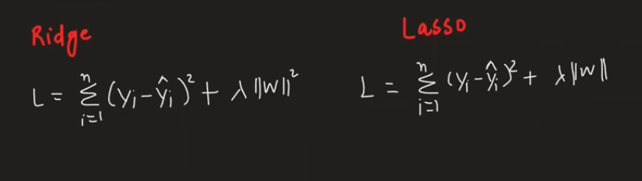

Choose Ridge regularization when you have many features that are all important, and some of them are highly correlated. Ridge handles multicollinearity well by shrinking the coefficients of all features, but it doesn't eliminate them. It keeps all features in the model, distributing the weight among them.
Choose Lasso regularization when you believe many of your features are irrelevant and you want to perform feature selection. Lasso can shrink some coefficients all the way to zero, effectively removing the corresponding features from the model. This results in a simpler and more interpretable model.

Key Differences in How They Work
Both Ridge and Lasso add a penalty term to the linear regression cost function to prevent overfitting and deal with multicollinearity, but the penalty terms are different.
- Ridge Regularization
  - Penalty: It adds the squared magnitude of the coefficients to the cost function. This is known as the L2 penalty.
  - Effect: It shrinks coefficients towards zero but never makes them exactly zero. This means every feature remains in the model, just with a reduced influence. It's great for keeping all relevant features when you're unsure which ones are more important.
- Lasso Regularization
  - Penalty: It adds the absolute magnitude of the coefficients to the cost function. This is known as the L1 penalty.
  - Effect: It can shrink coefficients all the way to zero, which is why it performs automatic feature selection. If a feature's coefficient becomes zero, it's effectively dropped from the model. This is very useful for models with a large number of features where many are not useful.

When to Choose Which
- Use Ridge when:
  - You have many correlated features.
  - You want to keep all features in the model.
  - You are more concerned with model stability and prediction accuracy than with a simple, interpretable model.
- Use Lasso when:
  - You suspect many features are irrelevant.
  - You need to perform feature selection automatically.
  - You want a simpler, more interpretable model with fewer features.
In practice, a technique called Elastic Net is often used, which combines both Ridge and Lasso penalties. It provides a good balance between shrinking coefficients and performing feature selection, often performing better than either method alone.
When you have lot of features, and couldn’t understand the importance of features. In that case also use Elastic Net

