Introduction to the machine learning

definition to AI
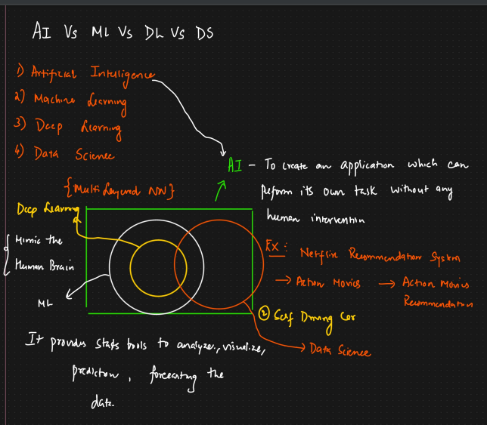
a
3 Types of machine learning:
1. Supervised machine learning
2. Unsupervised machine learning
3. Reinforcement machine learning

Supervised machine learning
In this we will always have independent/input features and dependent/output features.
And, if it is Regression problem statement, then output feature will be continuous and vice versa.
And, if it is Classification problem statement, then output feature will be categorical and vice versa.

Two types of problem statements
1. Regression problem statements(when output feature is continuous).
2. Classification problem statements(When output feature is categorical).

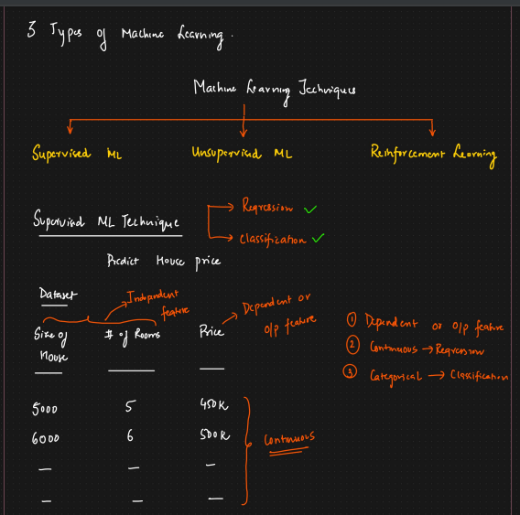
classification problem below :
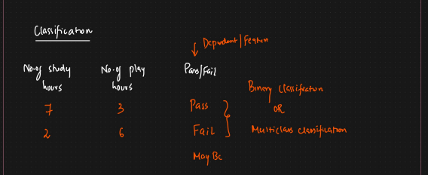
a

Unsupervised machine learning:
In this we don’t know the output feature. We don’t need to predict anything. Instead we need to find out similar clusters/Groups. That we will be doing with the help of algorithms mentioned below in screenshot.

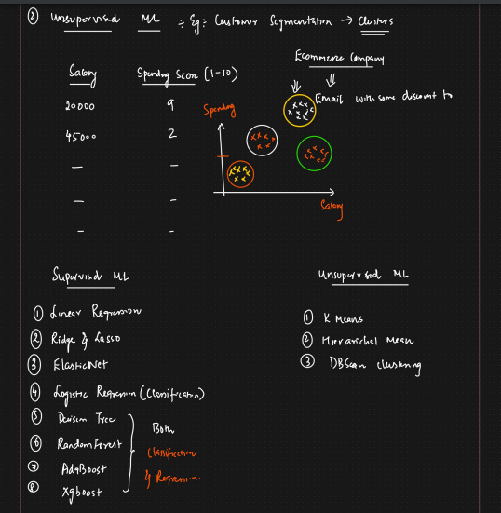

Equation of line:
y = mx + c
m = slope (unit movement with the x axis, how much movement is there with respective to y axis)
c (intercept) = at x is 0, where does the straight line meets the y axis.
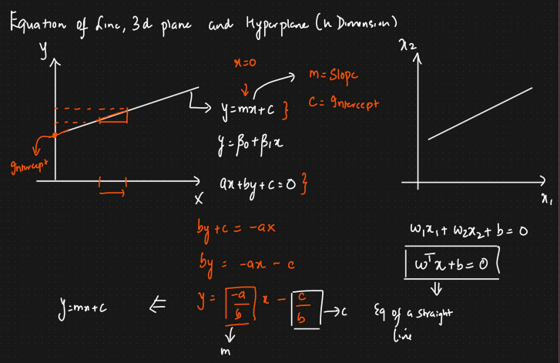

Equation of 3D
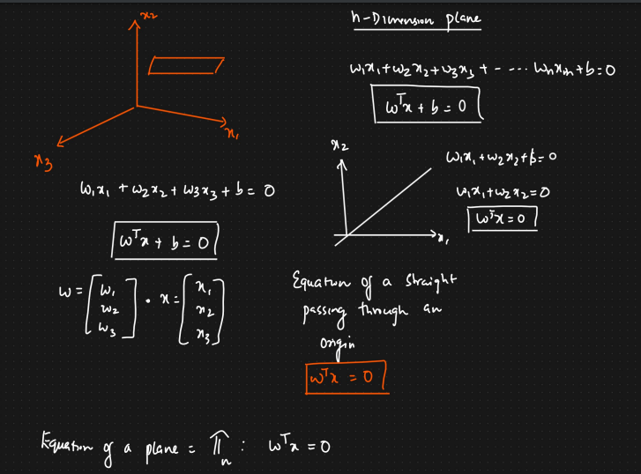
Equation of 3D plane - w1x1 + w2x2+w3x3 + b = 0 also put as wTx + b = 0
so, Equation of n-dimension plane - w1x1 + w2x2+w3x3 + --- wnxn + b = 0 which is also wTx + b = 0
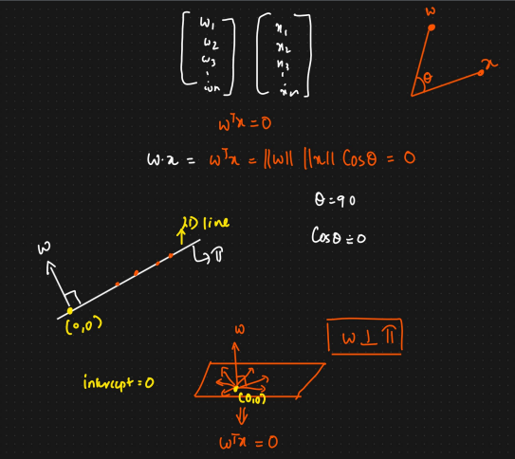

hyperplan
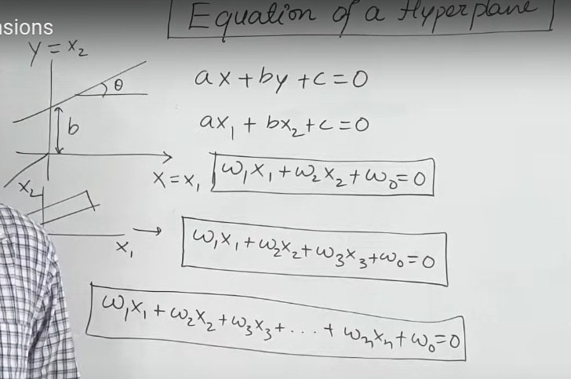

Distance of a point from a plan
The cos@ part is crucial:
- If you push horizontally (cos(0°) = 1), all of your force is used to move the box, and you do maximum work.
- If you push at a steep angle, only the horizontal component of your force contributes to the motion, and cos@ accounts for this.
- If you push straight down (cos(90°) = 0), none of your force moves the box, so no work is done.

The formula ||w|| ||s|| cos@ is a fundamental concept in linear algebra, geometry, and physics because it provides a simple way to calculate a scalar value from two vectors that tells you about their directional relationship.

The formula you've provided, ||w|| ||s|| cos@ / ||w||, represents the scalar projection of vector s onto vector w.

Simplification: The ||w|| in the numerator and the denominator cancel each other out.
∣∣w∣∣ ∣∣s∣∣ cosθ / ∣∣w∣∣ ​=∣∣s∣∣ cosθ
- Geometric Interpretation: The simplified formula, ||s|| cos@, has a clear geometric meaning. It represents the length of the "shadow" that vector s casts on vector w.
- It tells you how much of vector s is pointing in the same direction as vector w.
- This is a scalar (a single number), not a vector. The result is just the magnitude of the projected component.

2. The Angle Affects the Projection
The angle being less than 90 degrees is critical for the sign of the scalar projection, which is ||s|| cos@.
- If the angle is less than 90° (cos@ is positive), the projection is positive. This means vector s has a component that points in the same general direction as vector w.
- If the angle is greater than 90° (cos@ is negative), the projection is negative. This means vector s has a component that points in the opposite general direction of vector w.

Instance based learning vs Model based learning

Instance-Based Learning
Instance-based learning, also known as lazy learning, does not create a generalized model during the training phase. Instead, it memorizes the training data and postpones the learning process until a prediction is requested.
How it works:
- Training: The algorithm simply stores all the training instances (data points) and their corresponding labels. There is no complex calculation or model creation.
- Prediction: To make a prediction for a new, unseen data point, the algorithm looks at the stored instances that are "closest" or most similar to the new point. It then makes a prediction based on the labels of these neighboring instances, often through a simple majority vote or averaging.
Pros & Cons:
- Pros: Simple, easy to understand, and can handle complex decision boundaries without making assumptions about the data's structure. Can be very accurate for complex datasets.
- Cons: Computationally expensive at prediction time (it has to search through all stored data), requires a lot of memory to store all instances, and can be sensitive to noisy or irrelevant data points.
- Example: K-Nearest Neighbors (KNN) is the classic example. When you give it a new data point, it finds the 'K' closest data points from the training set and uses their labels to predict the new point's label.

Model-Based Learning
Model-based learning, also known as eager learning, creates a generalized model from the training data during the training phase. It summarizes the relationships and patterns in the data into a mathematical equation or a set of rules. The training process can be computationally intensive, but the resulting model is very efficient for making predictions.
How it works:
- Training: The algorithm learns a function that maps the input features to the output. This could be a linear equation (regression), a decision tree, or the weights of a neural network. It essentially "learns" the underlying pattern.
- Prediction: To make a prediction for a new data point, the algorithm simply plugs the new data into its pre-trained model. This is very fast and requires little memory.
Pros & Cons:
- Pros: Fast prediction time, requires less memory (as it doesn't store all the data), and the model itself can often be interpreted to understand the relationships in the data.
- Cons: Can be more complex to train, and if the chosen model (e.g., a straight line) doesn't fit the underlying data well, it will be inaccurate. It makes assumptions about the data's structure.
- Example: Linear Regression, Decision Trees, and Neural Networks. Once a linear regression model is trained, all you need is the equation (y=mx+b) to make predictions.

