Straight line
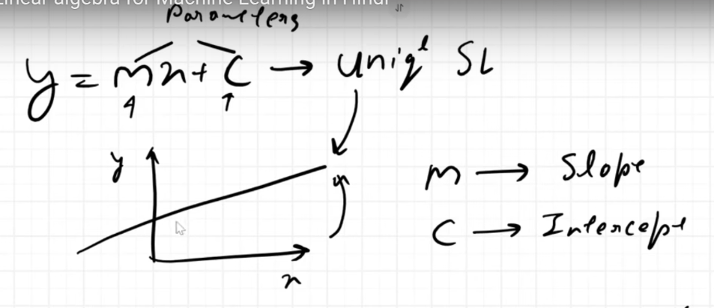
a
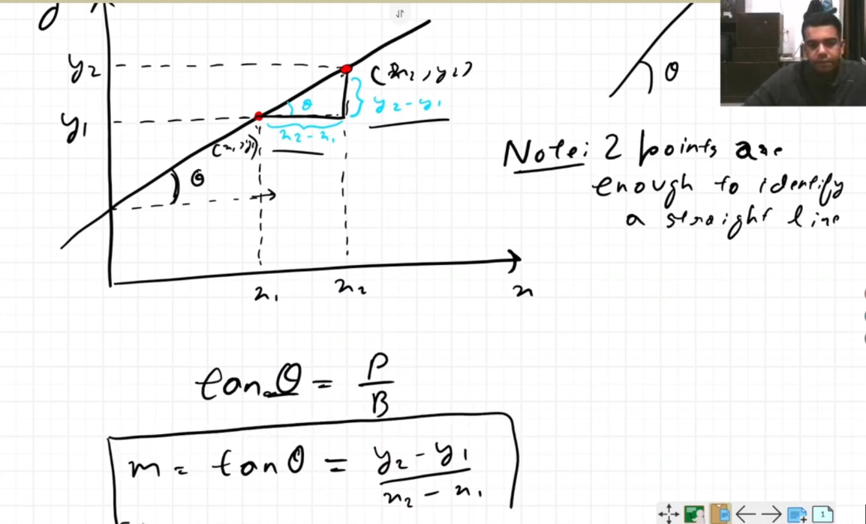
s
tan θ = p/b which is m

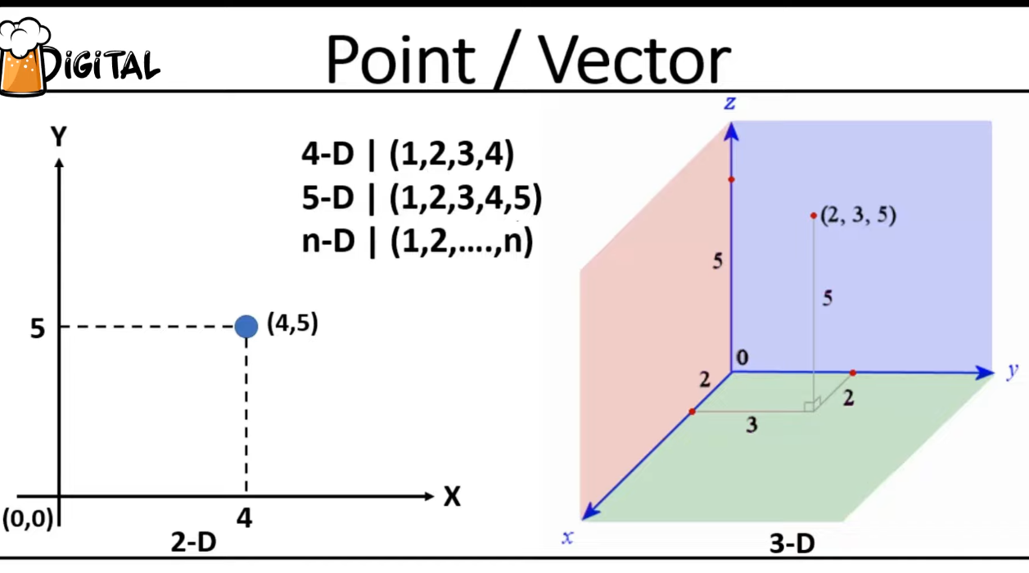
d
Find the distance from origin
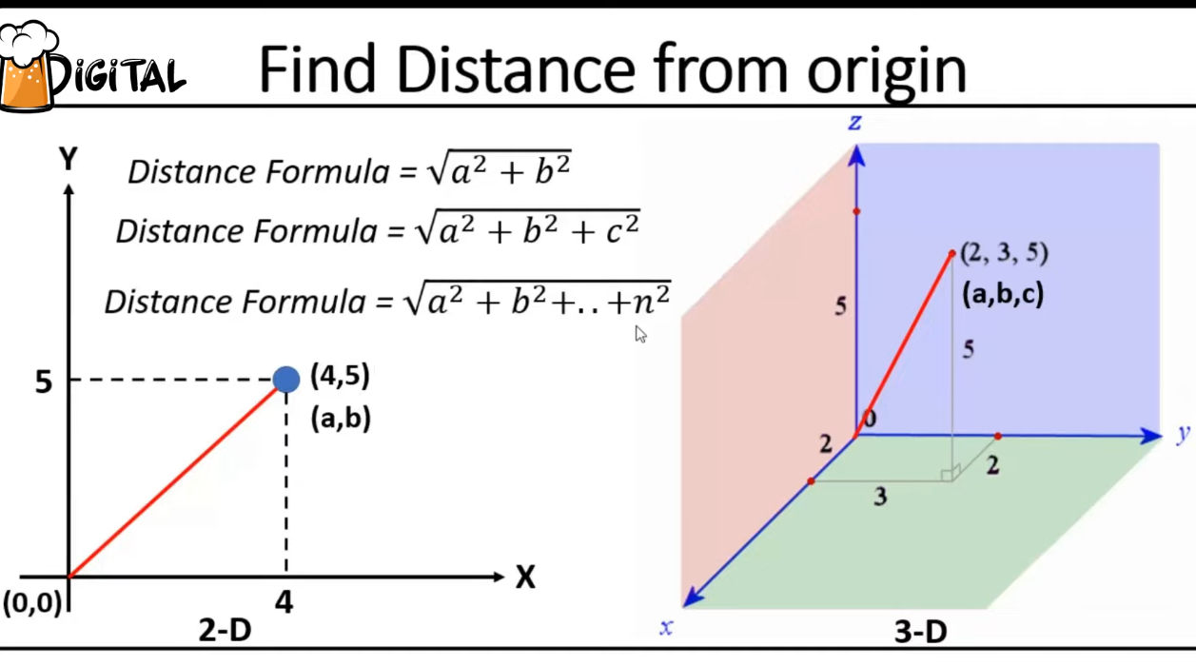
a

Distance between 2 points -
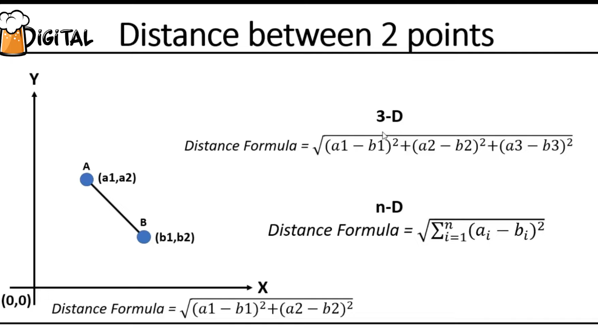
Basics of Vectors
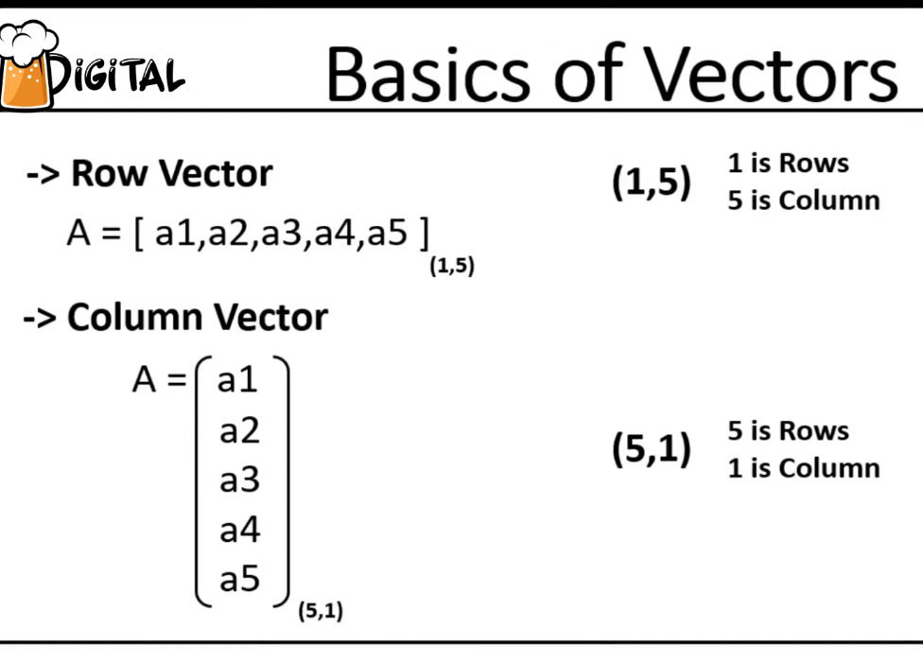

Basics of matrix
It is a list of list
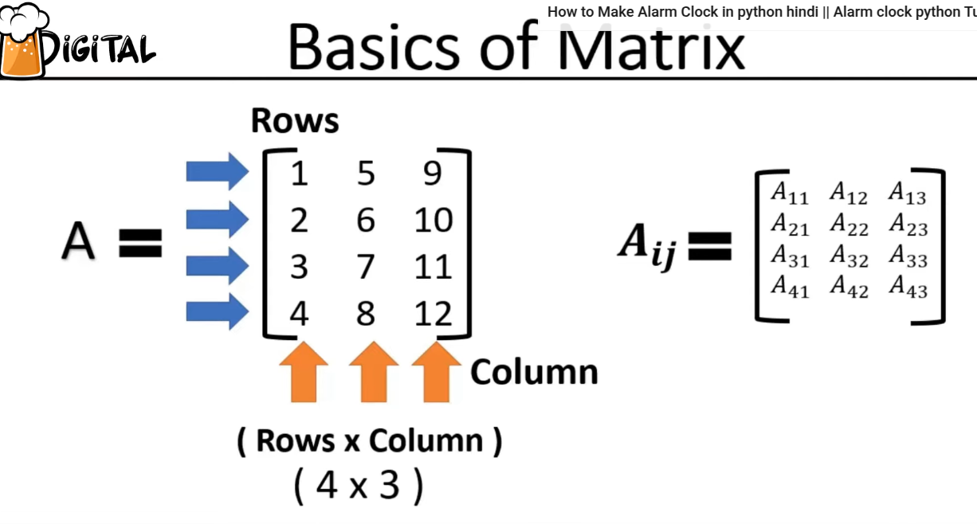
Transpose of Matrix.
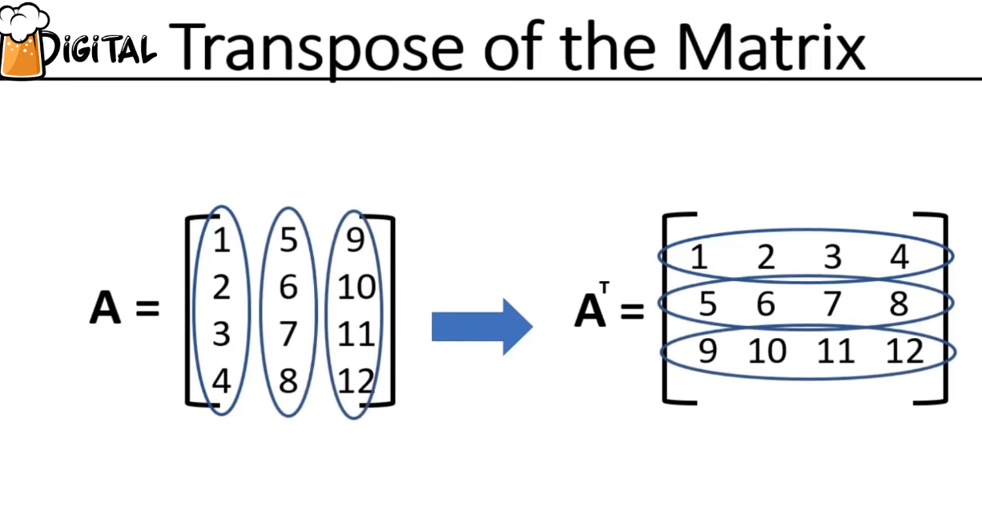

Matrix addition
rule – dimensions of both matrixes should be same to perform addition or subtraction.
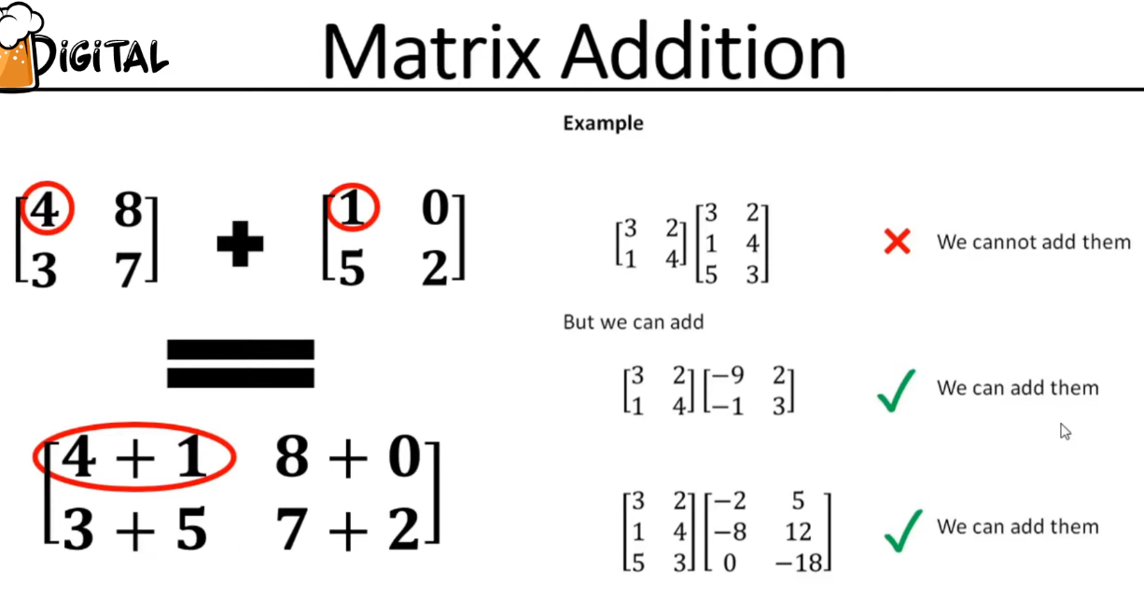
Matrix subtractions
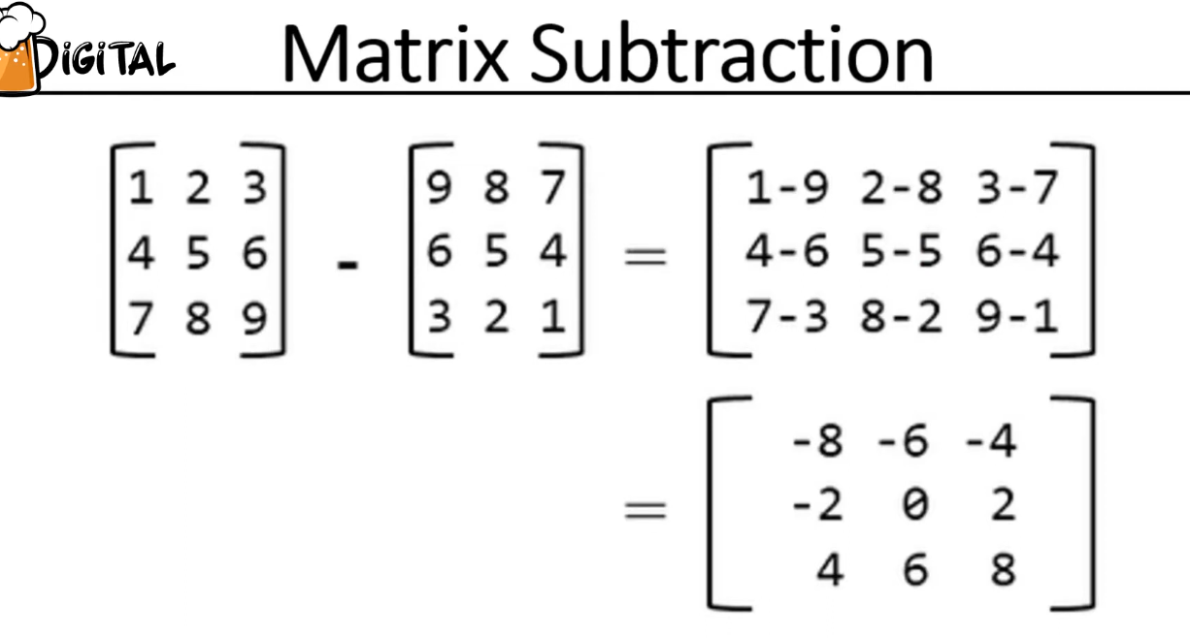
a
Dot product on vectors
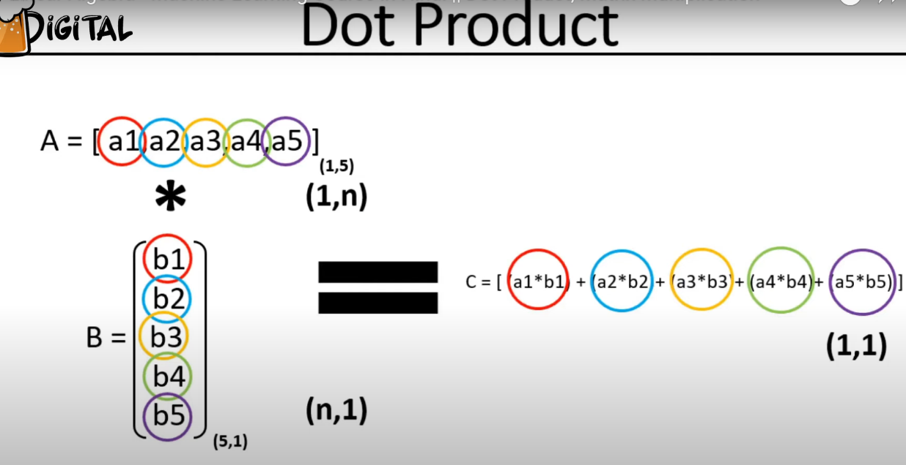
Dot product on matrixes
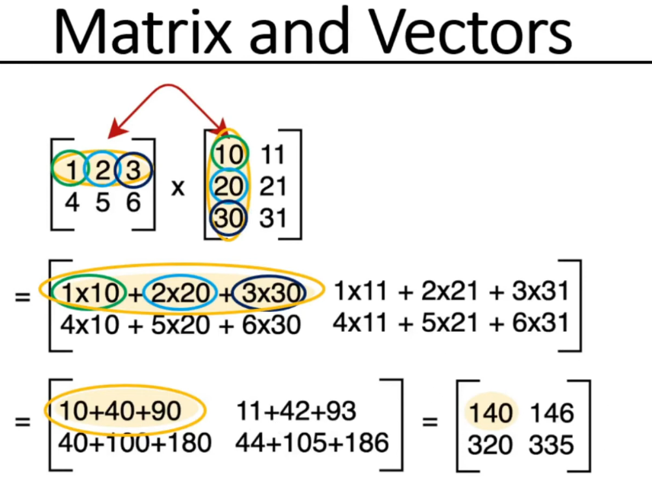
a

Diagonal Matrix:
  - A square matrix where all non-diagonal elements are zero.
  - Diagonal elements can be any real number (including zero).
  - Example: [[2, 0, 0], [0, 5, 0], [0, 0, 9]].
- Identity Matrix:
  - A square matrix with ones on the main diagonal and zeros everywhere else.
  - Example: [[1, 0, 0], [0, 1, 0], [0, 0, 1]].
  - It is a special case of a diagonal matrix.
  - It is denoted by the letter 'I'.
  - It serves as the multiplicative identity in matrix operations.
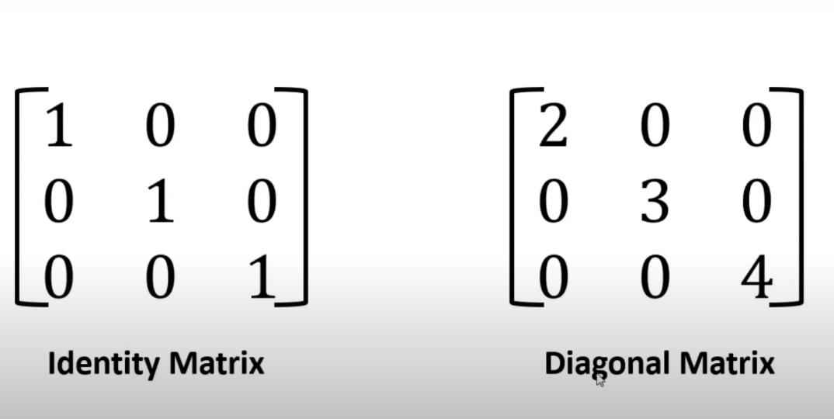
Angle between 2 vectors for 2-Dimensional data
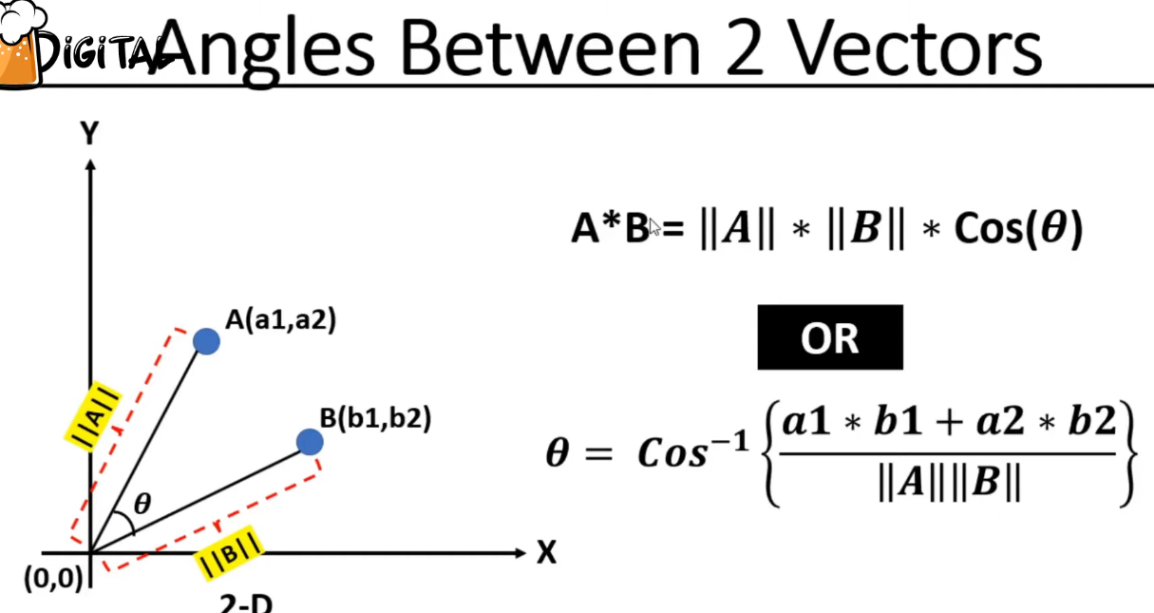
We can find the distance using formula mentioned above on the top
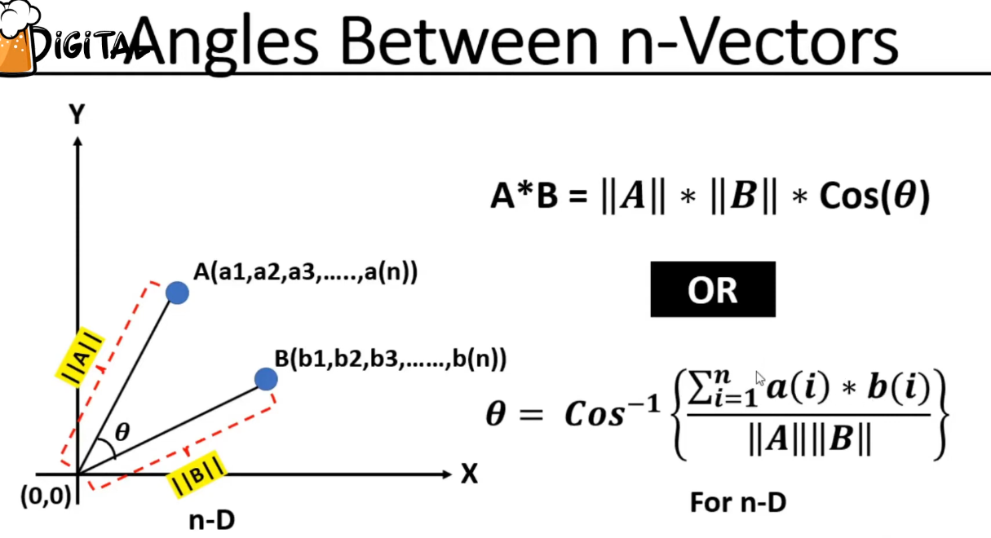
a
Angles between vectors, in case of when 2 lines have 90 degree.
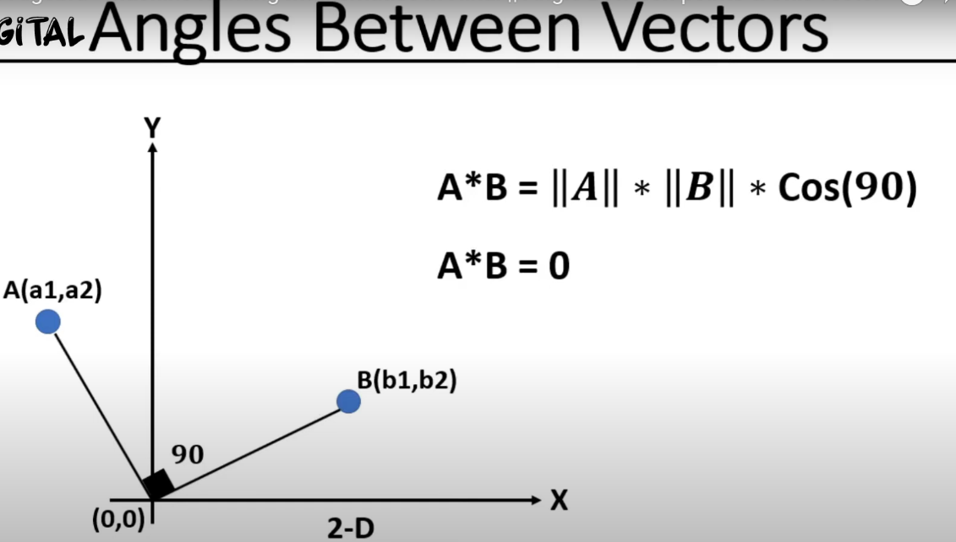
A
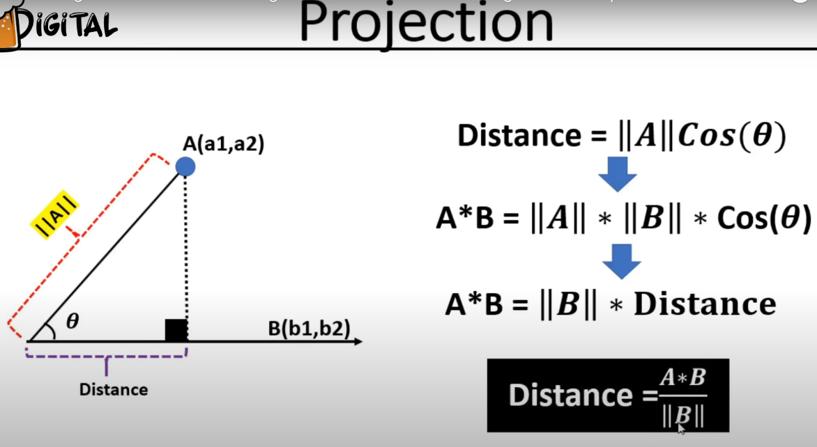
a
Unit vector:
A unit vector is a vector that has a magnitude (or length) of 1.
To find the unit vector in the same direction as any non-zero vector v, you divide the vector v by its own magnitude/distance. This process is called normalization.
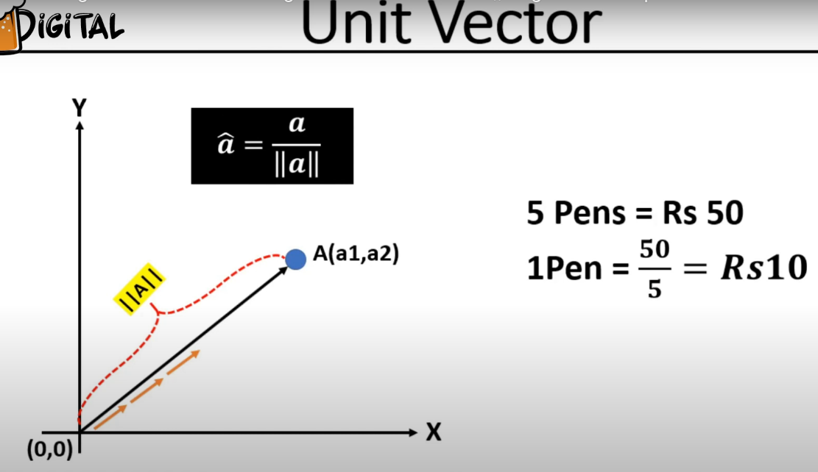
A
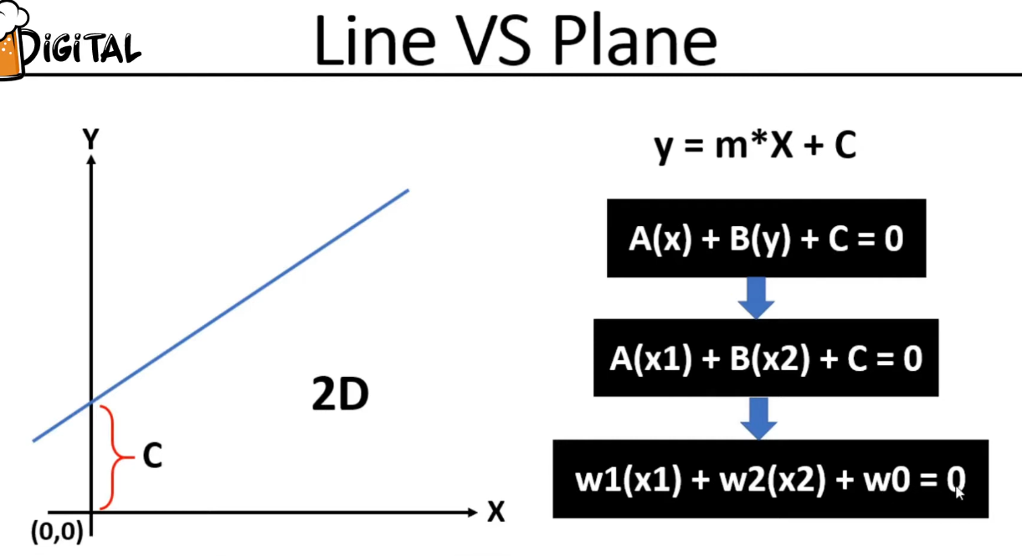
a
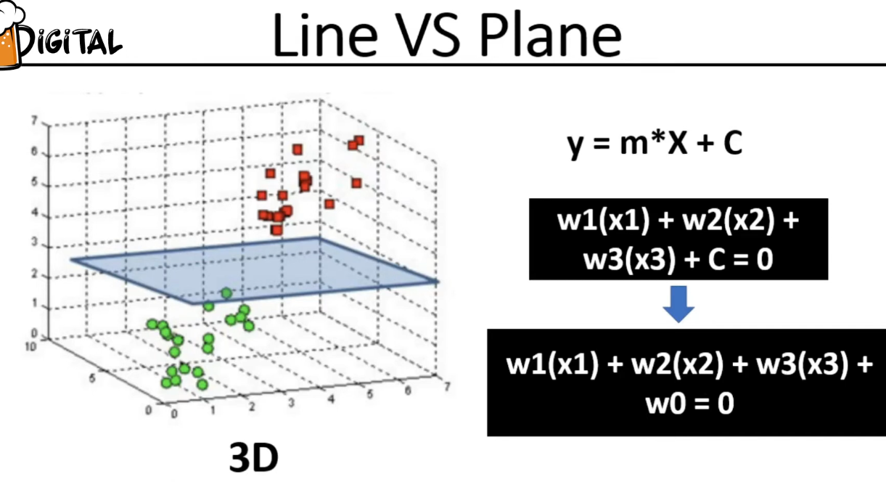
j
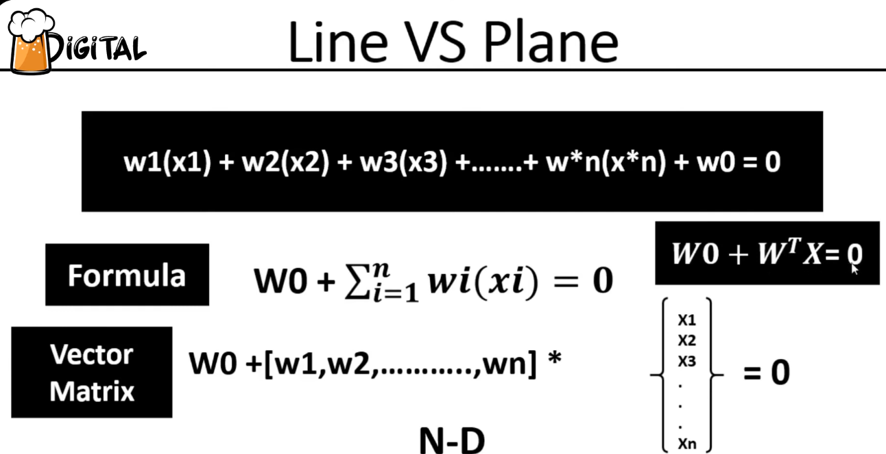
_______________________________________________________________________________
The formula w1x1+w2x2=0 represents a linear equation in two variables (x1 and x2) that passes through the origin (0,0).
Let's break down what each part means and then look at examples.
Understanding the Components:
- x1,x2: These are your variables or features. In many contexts (like machine learning, geometry, physics), they represent coordinates in a 2D space.
- w1,w2: These are coefficients or weights. They are constants that determine the orientation (slope) of the line. They indicate the "importance" or "influence" of x1​ and x2​ respectively.
- =0: This indicates that the equation is set to zero. This is crucial because it means the line must pass through the origin (0,0).
  - If you substitute x1=0 and x2=0 into the equation, you get w1(0)+w2(0)=0, which simplifies to 0=0. This is always true, confirming that (0,0) is a point on the line.
What kind of line does it represent?
This formula represents a straight line in a 2D Cartesian coordinate system.
Relationship to Slope-Intercept Form:
You can rewrite this formula into the more familiar slope-intercept form (y=mx+b). Let y=x2​ and x=x1​:
w1x1+w2x2=0
w2x2=−w1x1
x2=−w1/w2x1
So, the slope of this line is m=−w2/w1​, and the y-intercept is b=0.
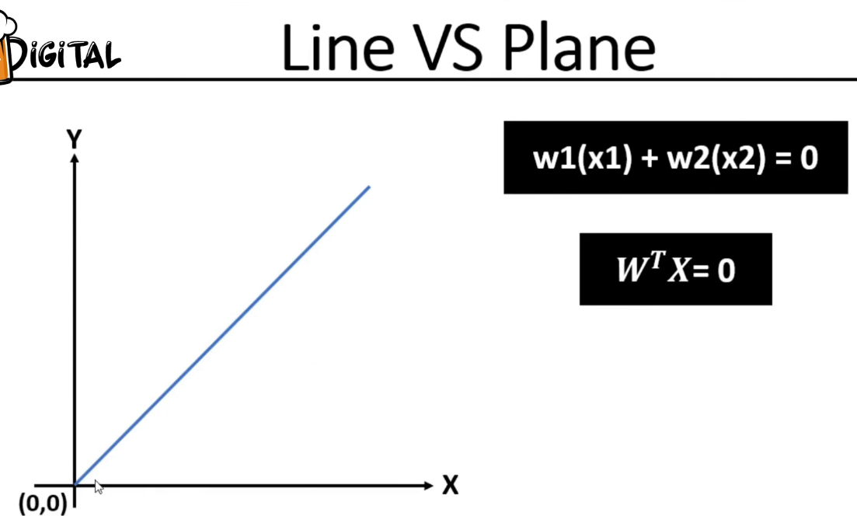
________________________________________________________________________________
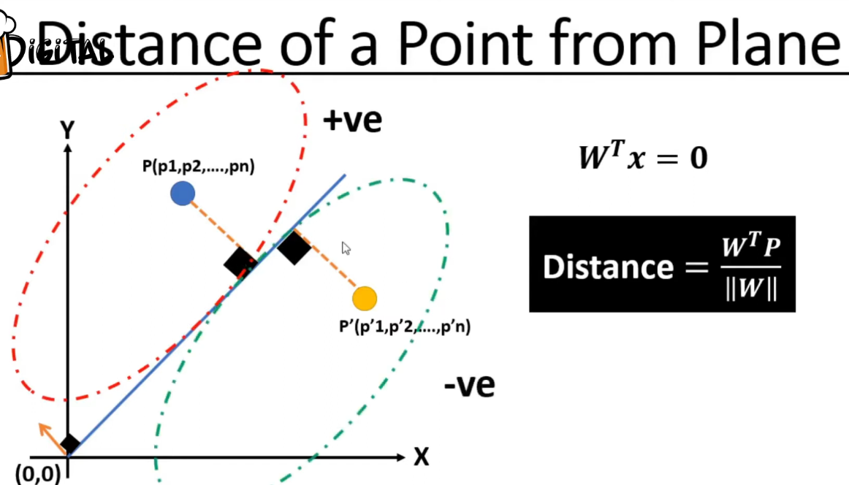
__________________________________________________________________________
check the point lie within the circle or outside the circle.
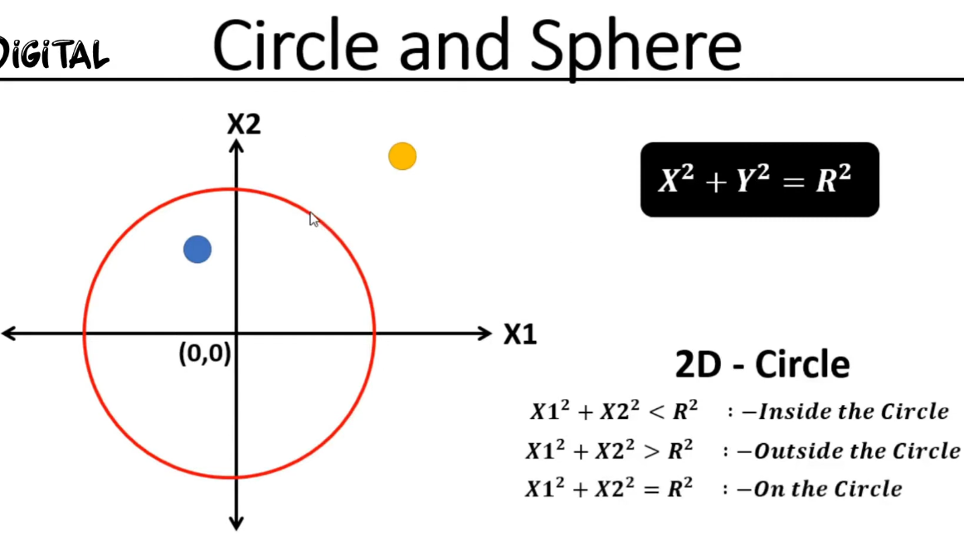
________________________________________________________________________
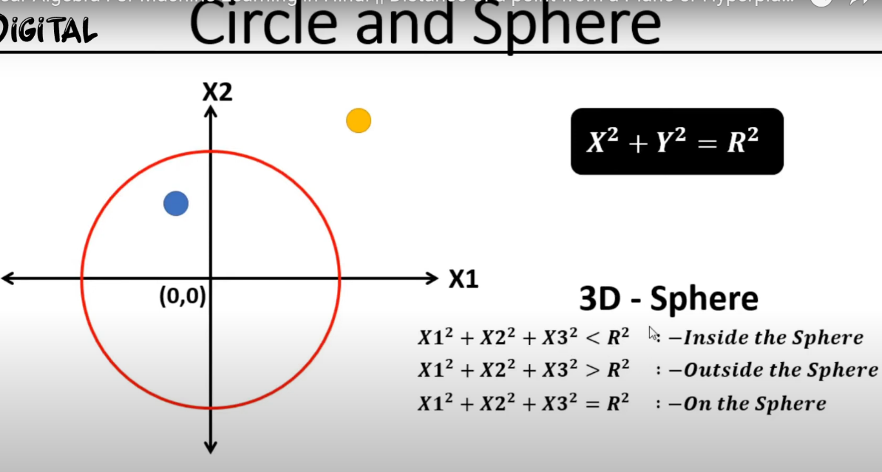
________________________________________________________________________________
Ellipse:
This doesn’t have same radius, as this is not a circle. Now find out point lie inside the ellipse or outside.
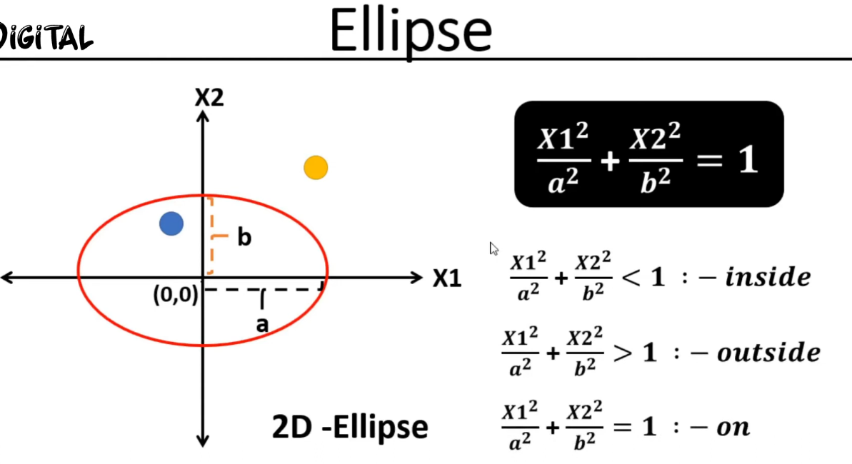
Below 3d and N-dimensional Ellipse:
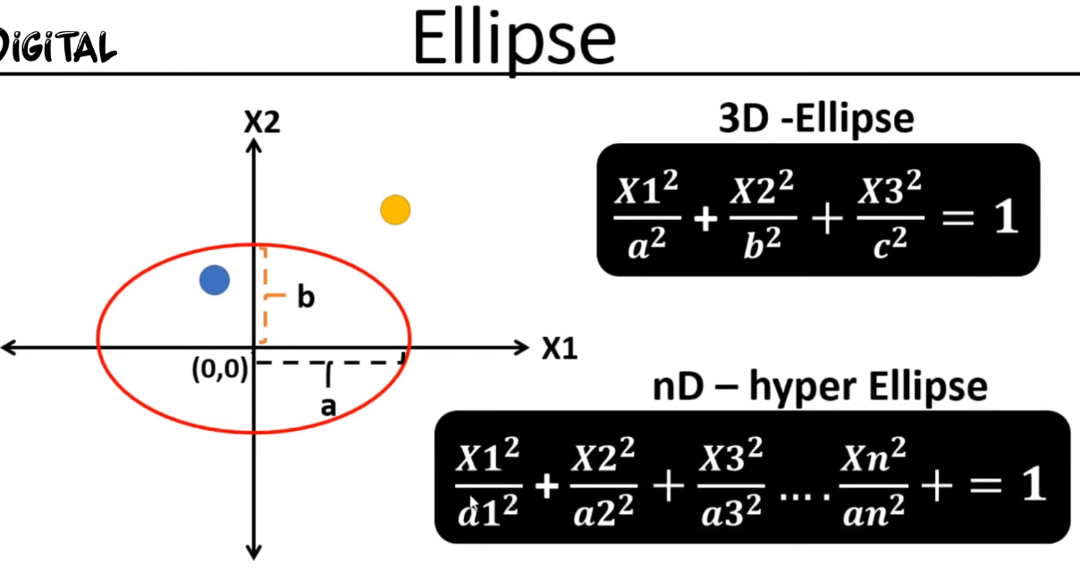
_____________________________________________________________________________
Now let’s find out whether point is inside or outside the rectangle.
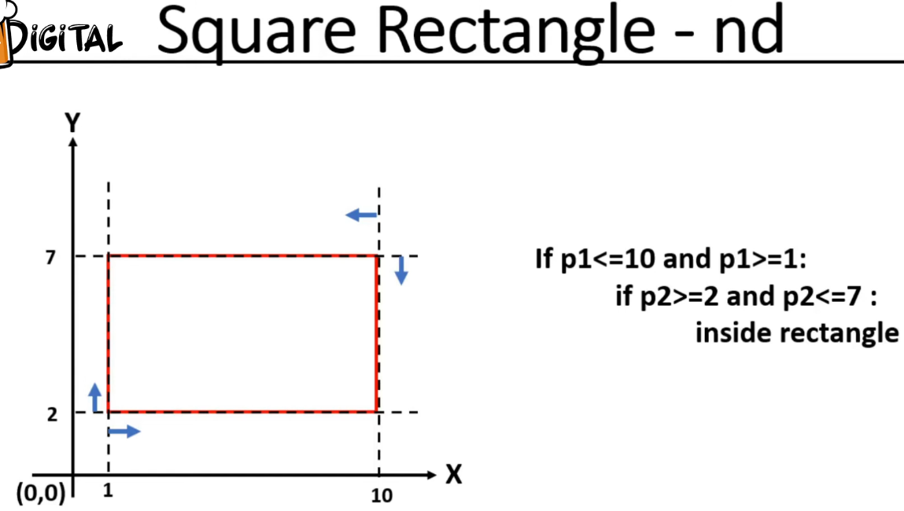
Dataset understanding, where x points to the input features and Y points to the target/output:
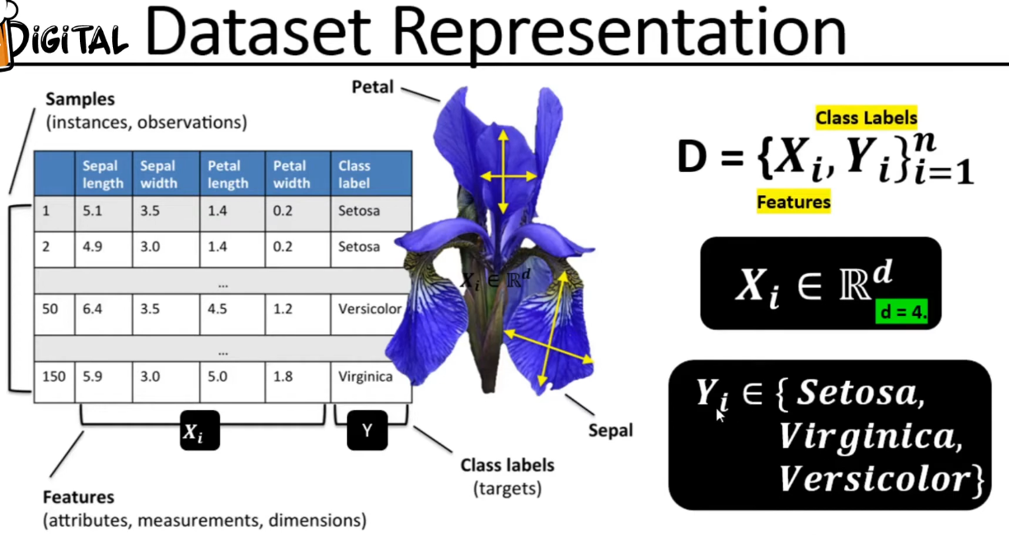
-
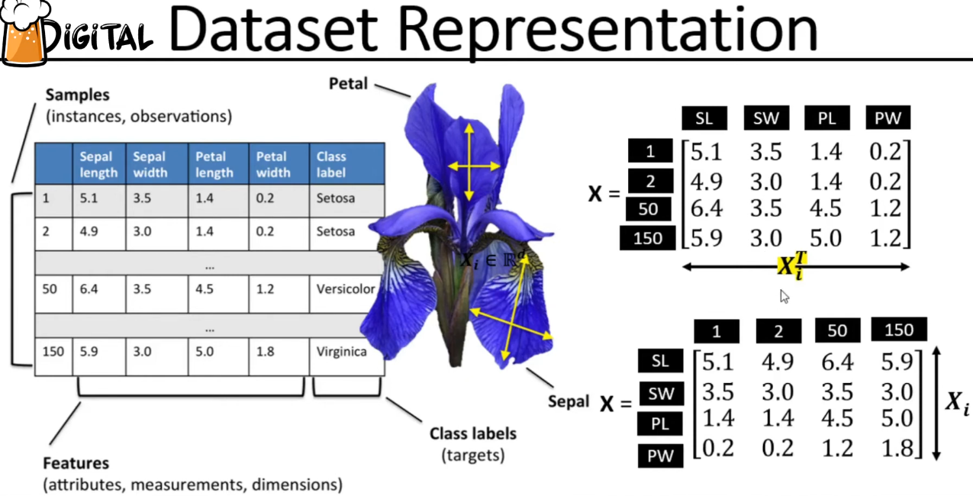
-
Mean vector:
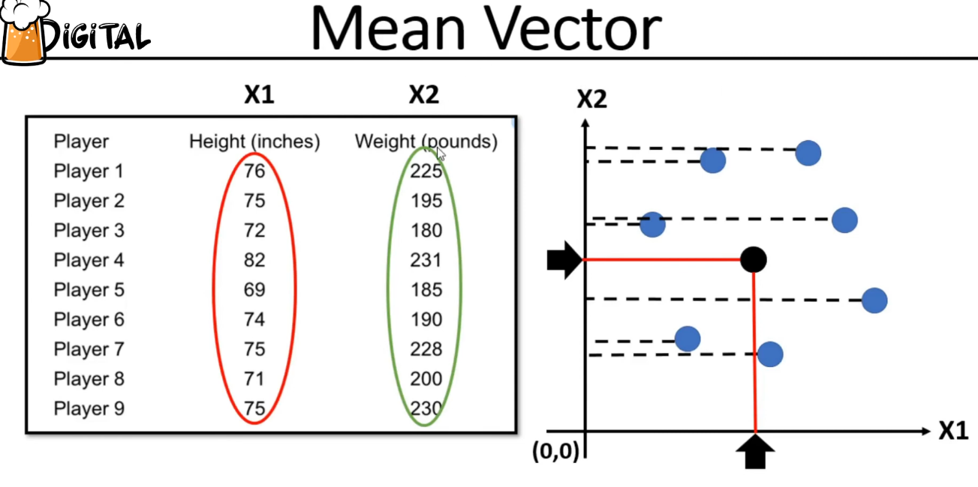
Methods under data pre-processing
1. Column Normalization
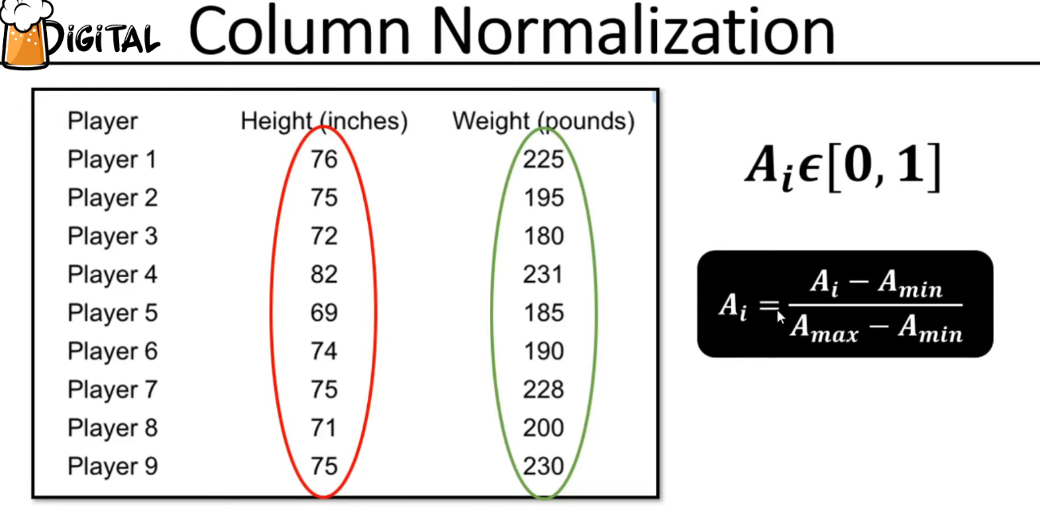
Column Standardization
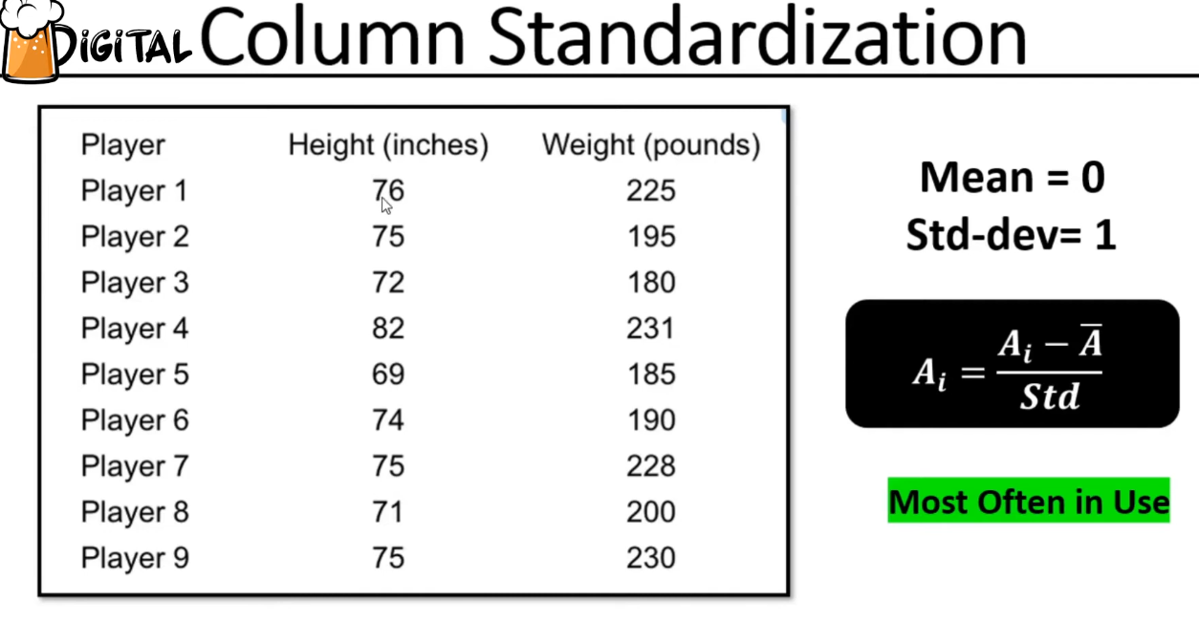
_
Covariance Matrix
Covariance matrix is always in pair, so it will always be square.



