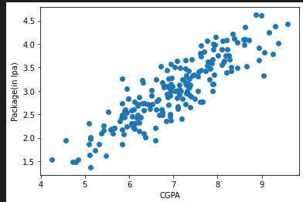
Linear regression -
- Simple LR(Single input features)
- Multiple LR(Multiple input features)
- Polynomial LR
- Regularized LR

Simple Linear regression
this has 1 input feature and 1 output feature.
Based on 1 input feature, predict the output feature.
For linear regression - your data should be linear(straight line) or sort of linear, as we will be working on real world data.
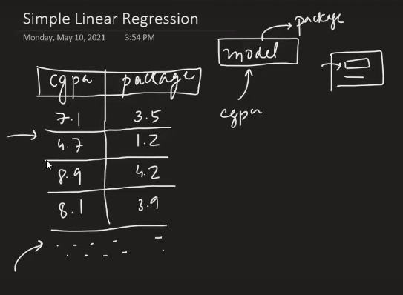

So, in case of sort of linear data, Linear regression algorithm will be calculating the best fit line which is doing minimum errors.
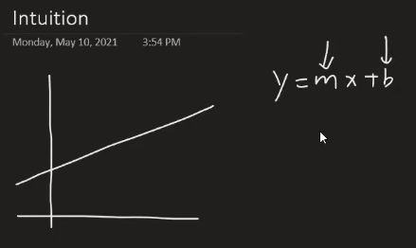
A

m = slope , b = intercept value
in more human term
m is a weightage - how much output feature depends upon input feature.
B is offset. Means in case of input column(x) becomes zero, even then there will be some value in B and so in y.
Below is the formula linear regression used to calculate slope and intercept .
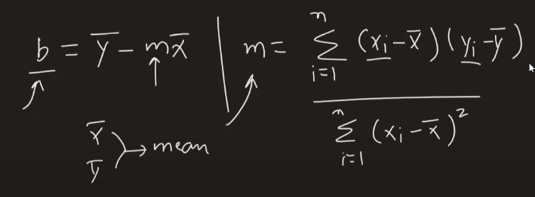
A
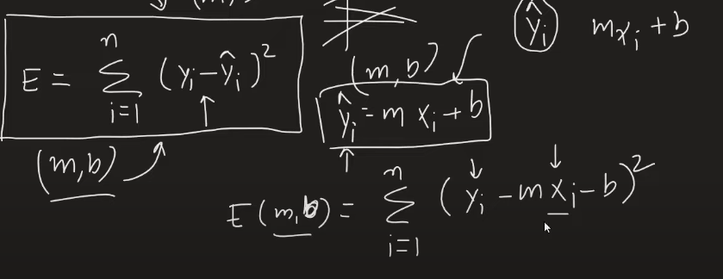
__
so, the thing is – we will have to randomly change the slope or intercept value to minimize the error( or some people call it cost function) and get the best fit line.
Convergence algorithm will help us in increasing and decreasing the slope value in an optimized way.
import matplotlib.pyplot as plt
import numpy as np
import pandas as pd
from sklearn.model_selection import train_test_split
## standardize the dataset Train independent data
from sklearn.preprocessing import StandardScaler
from sklearn.linear_model import LinearRegression
from sklearn.metrics import mean_squared_error,mean_absolute_error

df = pd.read_csv("height-weight.csv")
print(df)
# Divide our dataset into dependent and independent features.
X = df[["Weight"]] # independent feature
y = df["Height"] # dependent feature

# X_train - input feature for my training dataset
# y_train - output feature for my training dataset
# X_test - input feature for my test dataset
# y_test - output feature for my test dataset

X_train, X_test, y_train, y_test = train_test_split(X,y,test_size=0.2,random_state=42)
print(X_train.shape,X_test.shape,y_train.shape,y_test.shape)

# Let's standardize the data now, since weight and height both are in different units
scaler=StandardScaler()
print(X_train.head())
# fit_transform will apply z-score on every data point of X_train. In order to find the z-score
# we required mean and standard deviation. So, fit will compute the mean and standard deviation
# and transform will apply the z-score formula on every data point.
X_train=scaler.fit_transform(X_train)
# For training data above we need to do fit_transform
# for test data we only need to do transform. because my model should not know anything about
# the test data. It should only have the information about the training data.
X_test=scaler.transform(X_test)
# This model will helps in finding the best intercept and also all the slopes of the independent
# features while training the data.
regressor=LinearRegression()
regressor.fit(X_train,y_train) # X_train - independent feature, y_train - dependent feature.
print("The slope or coefficient of weight is: ",regressor.coef_)
print("Intercept:",regressor.intercept_)
plt.scatter(X_train,y_train)
plt.plot(X_train,regressor.predict(X_train),'r')
### prediction of train data
# 1. predicted height output= intercept +coef_(Weights)
#2. y_pred_train =157.5 + 17.03(X_train)
### prediction of test data
#1. predicted height output= intercept +coef_(Weights)
#2. y_pred_test =157.5 + 17.03(X_test)
# here passing the input test data(weight) to predict the ouput data(height)
y_pred_test=regressor.predict(X_test)
print("y_pred_test: ",y_pred_test)
print("y_test: ", y_test)
print("initial: ", df)

## new data point weight is 80, and let's test our model to predict the height for weight 80.
scaled_weight=scaler.transform([[80]])
print("scaled_weight: ",scaled_weight)
print("The height prediction for weight 80 kg is :",regressor.predict(scaled_weight))
## Performance Metrics - Now we will check the performance of our model

## MSE(find out the cost function(error) value),MAE,RMSE
## R square and adjusted R square
# minimum the values of mse,mae and rmse better performance of model
mse=mean_squared_error(y_test,y_pred_test)
mae=mean_absolute_error(y_test,y_pred_test)
rmse=np.sqrt(mse)
print(mse)
print(mae)
print(rmse)
## R square
"""Formula

**R^2 = 1 - SSR/SST**

R^2 = coefficient of determination
SSR = sum of squares of residuals
SST = total sum of squares

R square score value will tell us the percentage wise accuracy of our model.
"""
from sklearn.metrics import r2_score
score=r2_score(y_test,y_pred_test)
print("percentage wise accuracy of our model: ", score*100)

"""Adjusted R square
**Adjusted R2 = 1 – [(1-R2)*(n-1)/(n-k-1)]**

where:

R2: The R2 of the model
n: The number of observations
k: The number of predictor variables"""
#display adjusted R-squared
print("Adjusted R square: ", 1 - (1-score)*(len(y_test)-1)/(len(y_test)-X_test.shape[1]-1))

## Assumptions
## plot a scatter plot for the prediction, and if this is linearly straight line. your model
# performance is good.
plt.scatter(y_test,y_pred_test)

Multiple linear regression:
In case of Multiple linear regression, we will have multiple features, and due to the multiple features, we will have multiple coeficient/slope specific for each feature.
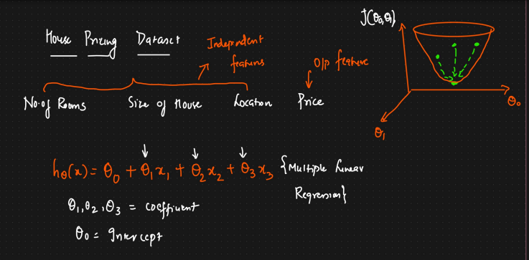
A
So, here since we have multiple coefficient/slope and 1 intercept. We will keep on changing them to reduce the cost function value or we can call error value.

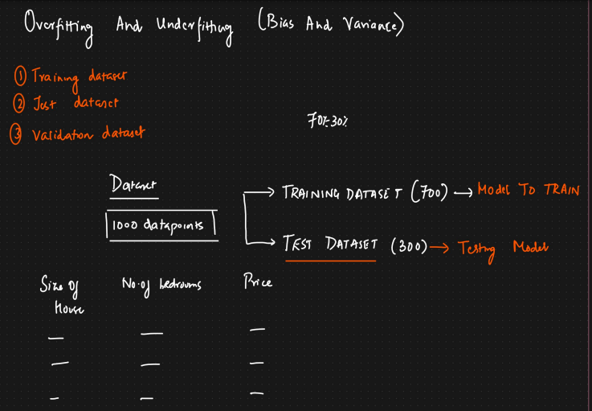
A

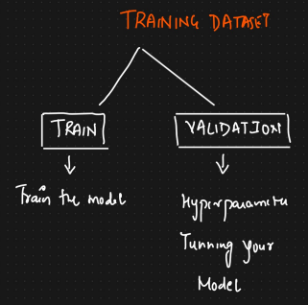
a

_
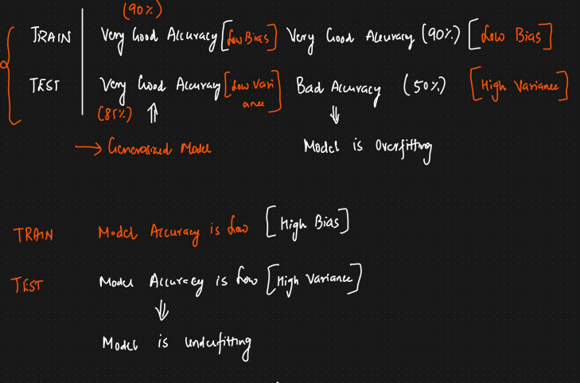
_

Polynomial regression:
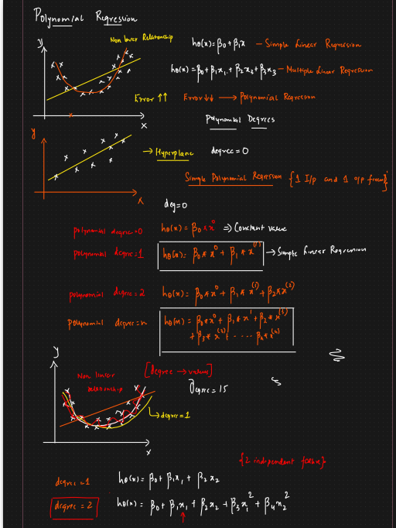
a

We perform polynomial regression, when data is not linear.
For example – in simple linear regression we have 1 input data x and 1 dependent y which we train it. but In polynomial regression we calculate the polynomial value/feature of x in the per-processing stage.

Like if we have degree 3, and x, the to extract the polynomial feature of x, we will get
x of 0, x of 1 and square of x
formula become - y = ax³ + bx² + cx + d
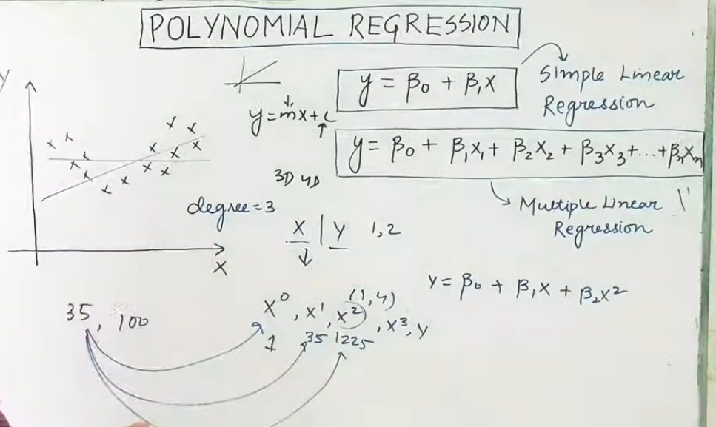
a
Now we need to decide what will be the value of degree(hyperparameter)
and this is very important. Because if it is less then graph can be under fit or poor/over fit graph in case of higher degree value, so we need to get the optimum/best value.
Relationship between y and the coefficient
The relationship between y (the dependent variable) and the coefficients in both linear and polynomial regression is that the coefficients determine how much y changes for a given change in the independent variable(s) or features. In both cases, the models are considered "linear" because the relationship between the dependent variable and the coefficients themselves is a simple sum of terms, where each term is a coefficient multiplied by a feature.

Gradient descent:
It is an optimization algorithm, if you give any function to the gradient which is differentiable then it will give us minima.

If the slope (or gradient) is negative, you should increase the value of b (the coefficient or weight) in gradient descent.

Explanation
The goal of gradient descent is to find the minimum of the cost function. The gradient tells you the direction of the steepest ascent. To move towards the minimum, you must move in the opposite direction of the gradient.
- Negative slope: A negative slope indicates that the cost function is currently decreasing as the value of b increases. To continue moving downhill towards the minimum, you need to further increase the value of b.
- Positive slope: A positive slope indicates that the cost function is increasing as the value of b increases. To move downhill, you need to decrease the value of b.

The update rule for a coefficient b in gradient descent is:
bnew = bold − learning_rate×gradient

Note – if learning rate is a large number, we can miss the solution and if it’s very small we will reach in lot of intervals.
So, picking up the learning rate is very crucial.

Now, further question is – when to stop here . Because this is iterative algorithm.
So, the answer is = Get the best value of Limit or epochs, means fix the value of iterations/loop.

