BIAS Variance Trade--OFF
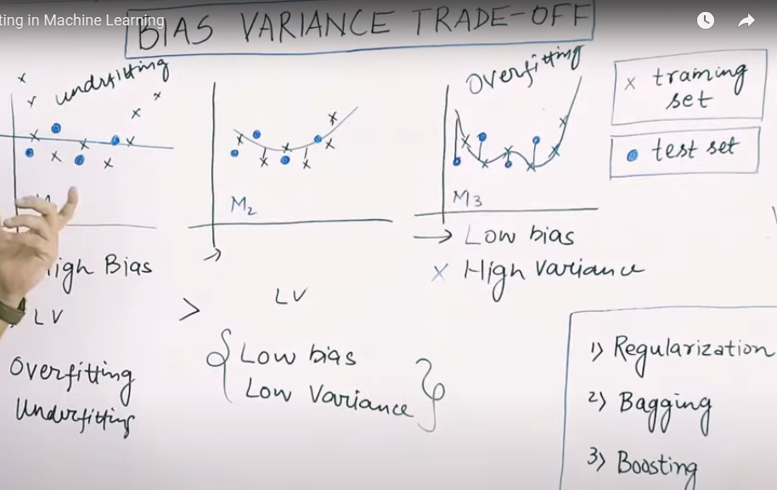
a
Over fitting – Your model is working exceptionally well on training data but not so well on test data.
Which means variance is high of such models where performance on training data is good but on test data performance is poor.
If slope is very high in a model then it’s over fitting and if slope is very less then it’s under fitting.

And to solve this issue we use 3 famous techniques 1. Regularization, 2. Bagging 3. Boosting

