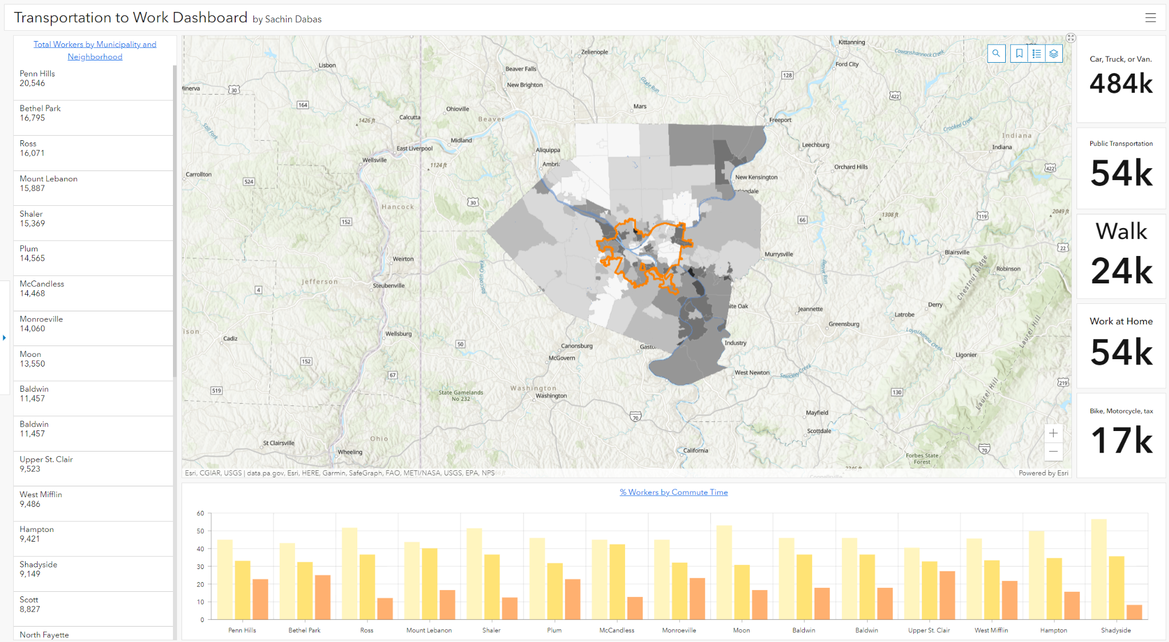

GIS / CAFM [48569]

PROFESSOR: *KRISTEN KURLAND*

TEACHING ASSISTANT’S: *SANAZ SAADATIFAR + MORGAN NEWMAN + SEAN XU*

STUDENT: *SACHIN DABAS*, MSSD, SOA

Date: 25/04/2022

ASSIGNMENT 12:

Transportation to Work

Link: <https://carnegiemellon.maps.arcgis.com/apps/dashboards/8687eab9c4514fff9274f1a05c6dcb8e>

.

Work produced in ArcGIS Pro 2.8

Spring’ 2022