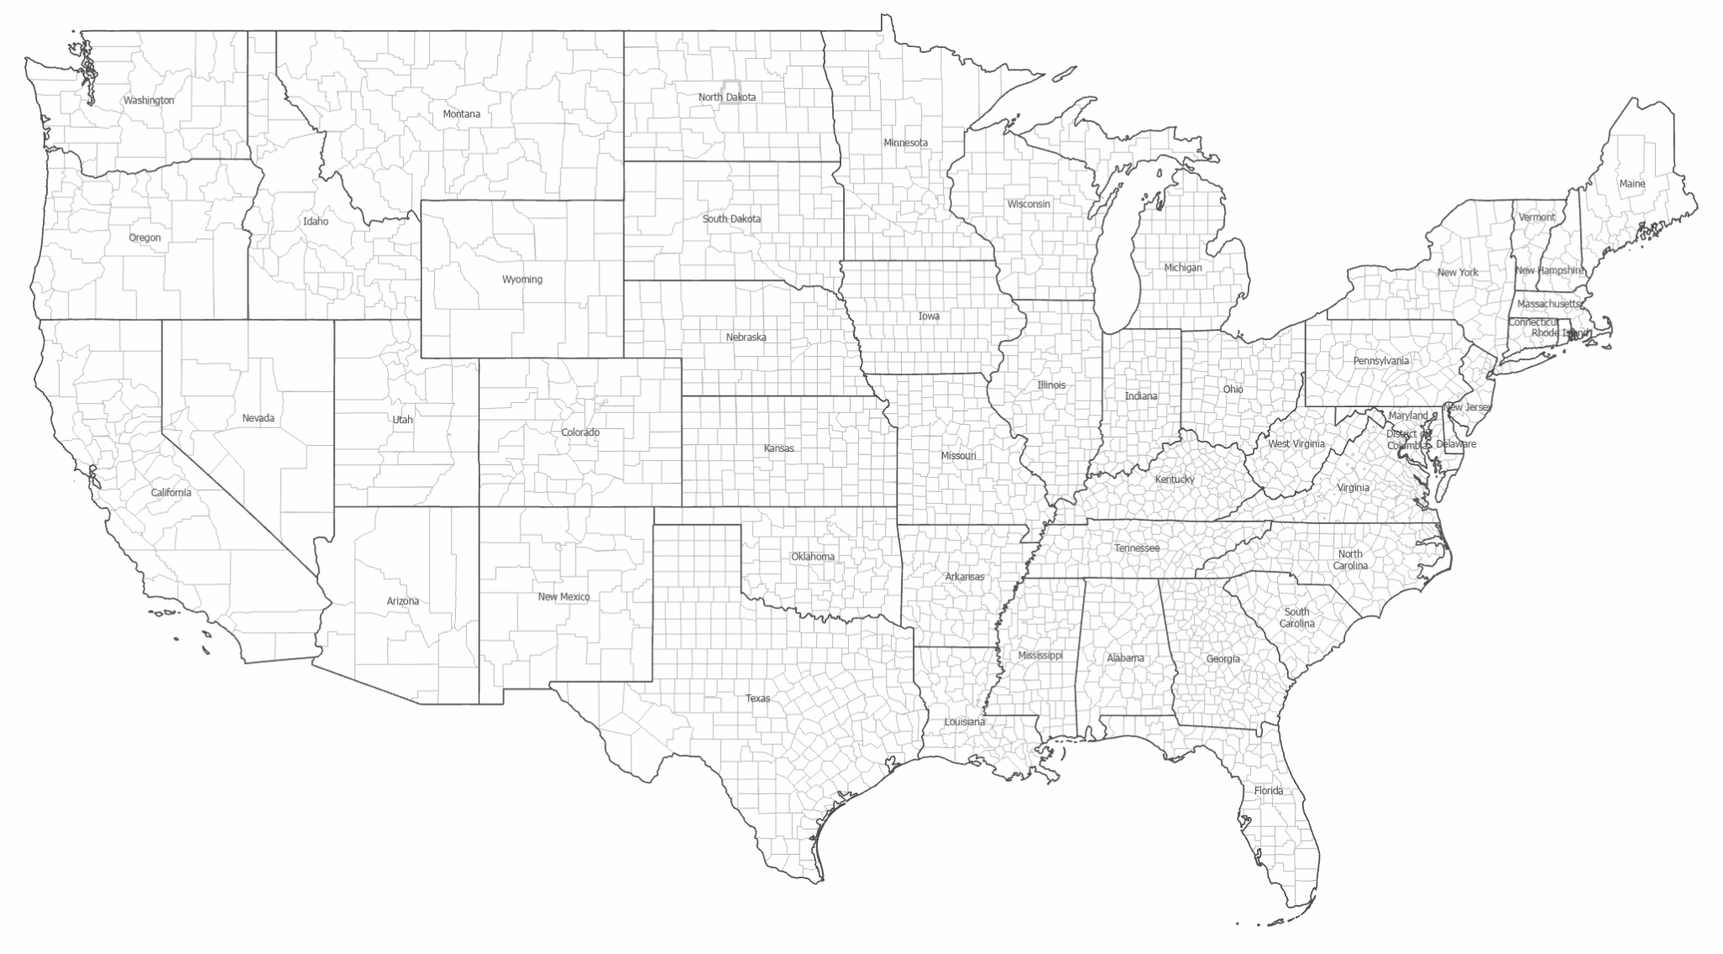

GIS / CAFM [48569]

PROFESSOR: *KRISTEN KURLAND*

TEACHING ASSISTANT’S: *SANAZ SAADATIFAR + MORGAN NEWMAN + SEAN XU*

STUDENT: *SACHIN DABAS*, MSSD, SOA

ASSIGNMENT 01:

ANALYZE HOUSING UNIT RENTALS BY COUNTY IN UNITED STATES

Date: 25/01/2022

The data for the project shows clearly that the highest housing unit rentals in the US are present in the major cities like California and Virginia. This demarcation is obvious since there are more people present in the cities than in the countryside or rural areas where the gross rent is very low for the housing units.

There can be multiple extracts that can be extracted from this data. It is also possible to see that the housing units number is very high as compared to lowest gross unit regions which directly points to the increased population in the cities.

Note1: The following data is between 2013 - 2017 and the actual scenario might be different from the shown data.

Note2: The various regions in the maps are not color coded (only single cyan color denoting all regions) to match the requirement of the assignment.

Fig 01: Map showing counties location with lowest Gross Rent

| LOWEST MEDIAN GROSS RENT 2013-2017 | | | | |
| --- | --- | --- | --- | --- |
| COUNTRY__AND_STATE | MEDIAN_GROSS_RENT | OCCUPIED_UNITS | OWNER_UNITS | RENTER_UNITS |
| Cottle County, Texas | 288 | 664 | 434 | 230 |
| Sheridan County, North Dakota | 330 | 684 | 537 | 147 |
| Owsley County, Kentucky | 349 | 1696 | 1252 | 444 |
| Hardin County, Illinois | 352 | 1452 | 1165 | 287 |
| Rolette County, North Dakota | 356 | 4740 | 3271 | 1469 |

Table 01: Table showing counties with lowest Gross Rent, Owner units and Renter units

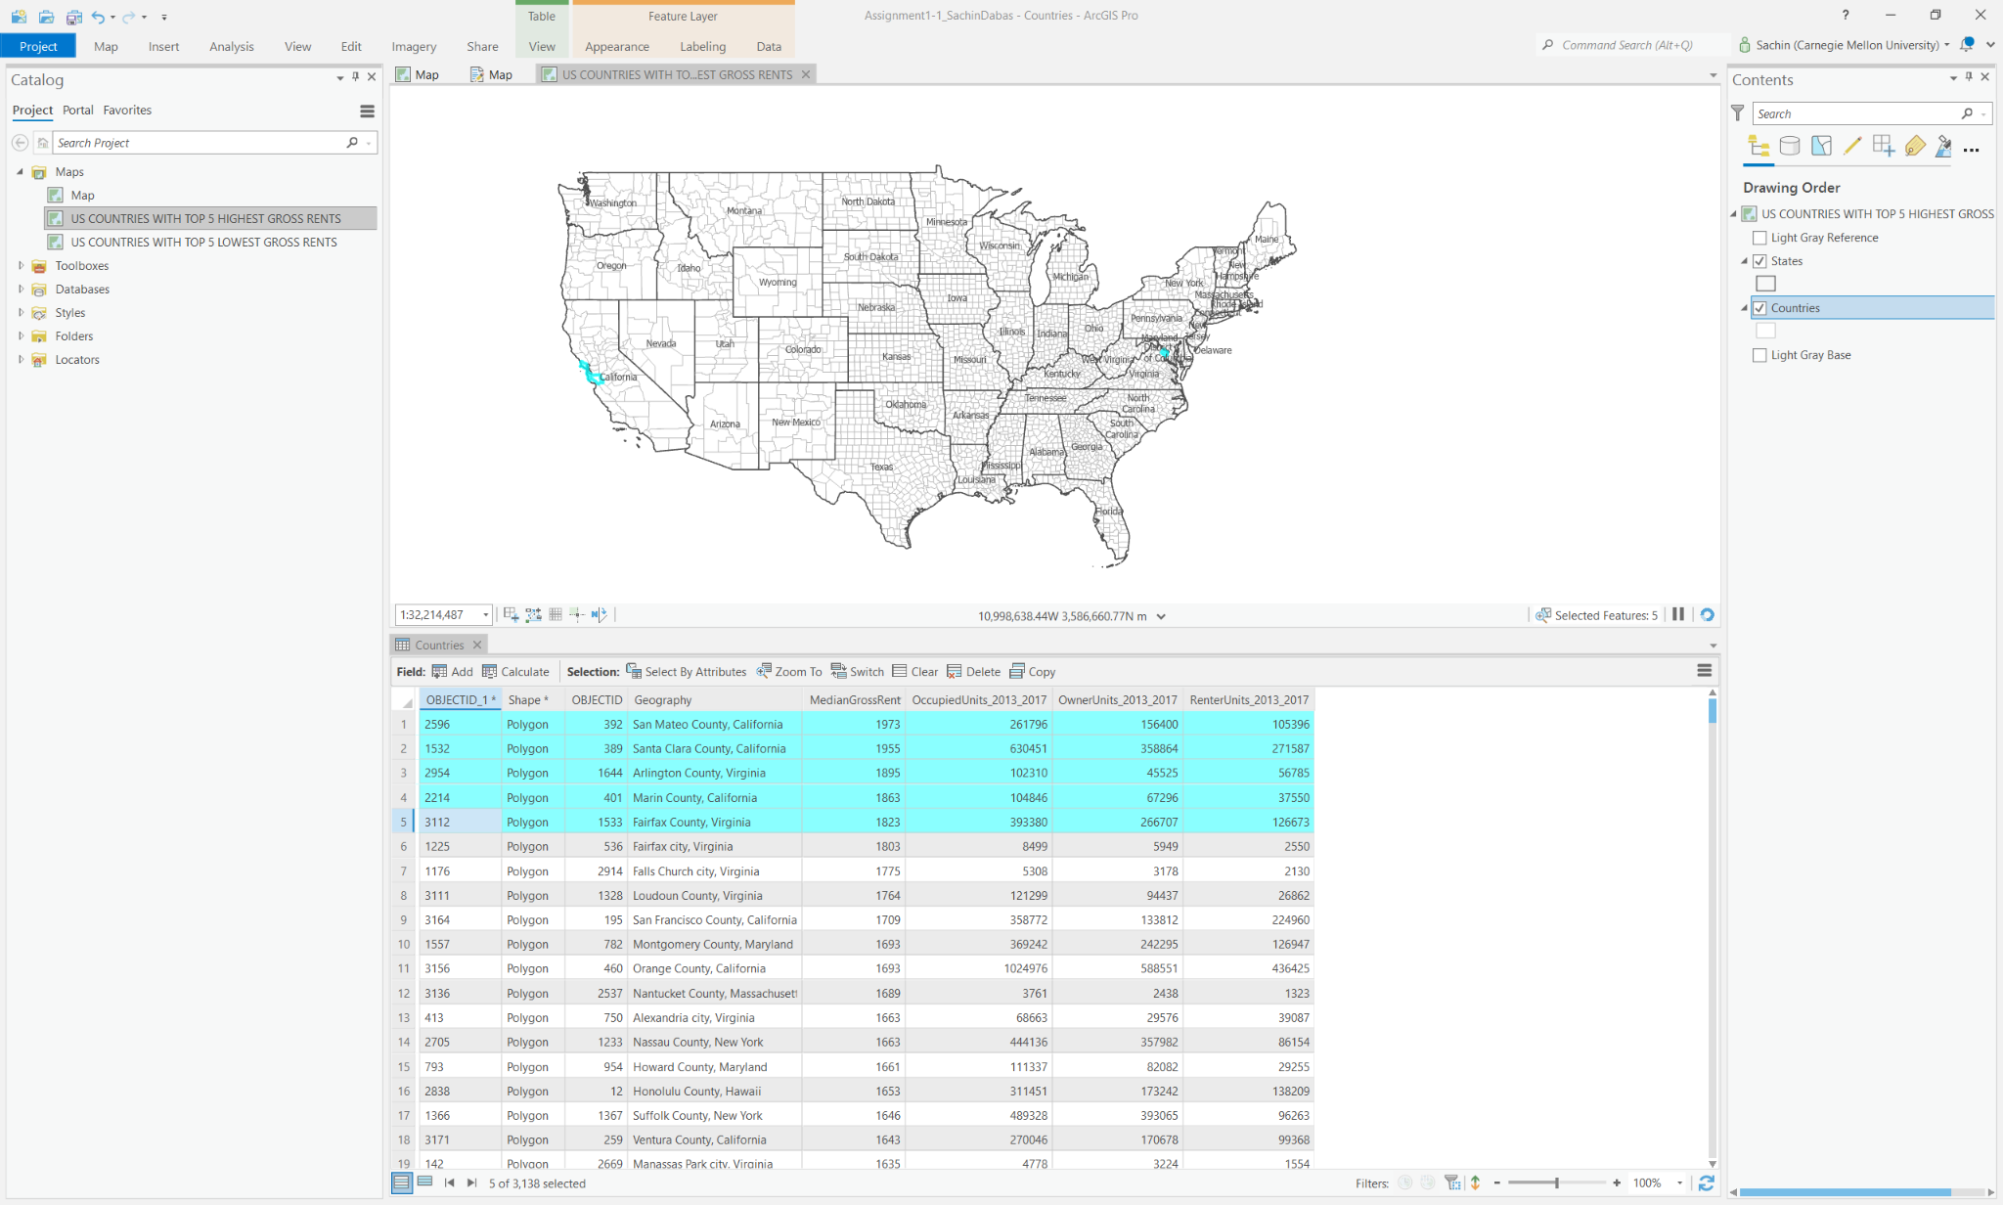

Fig 02: Map showing counties location with highest Gross Rent

| HIGHEST MEDIAN GROSS RENT 2013-2017 | | | | |
| --- | --- | --- | --- | --- |
| COUNTRY__AND_STATE | MEDIAN_GROSS_RENT | OCCUPIED_UNITS | OWNER_UNITS | RENTER_UNITS |
| San Mateo County, California | 1973 | 261796 | 156400 | 105396 |
| Santa Clara County, California | 1955 | 630451 | 358864 | 271587 |
| Arlington County, Virginia | 1895 | 102310 | 45525 | 56785 |
| Marin County, California | 1863 | 104846 | 67296 | 37550 |
| Fairfax County, Virginia | 1823 | 393380 | 266707 | 126673 |

Table 02: Table showing counties with highest Gross Rent, Owner units and Renter units

Work produced in ArcGIS Pro 2.8

Spring’ 2022