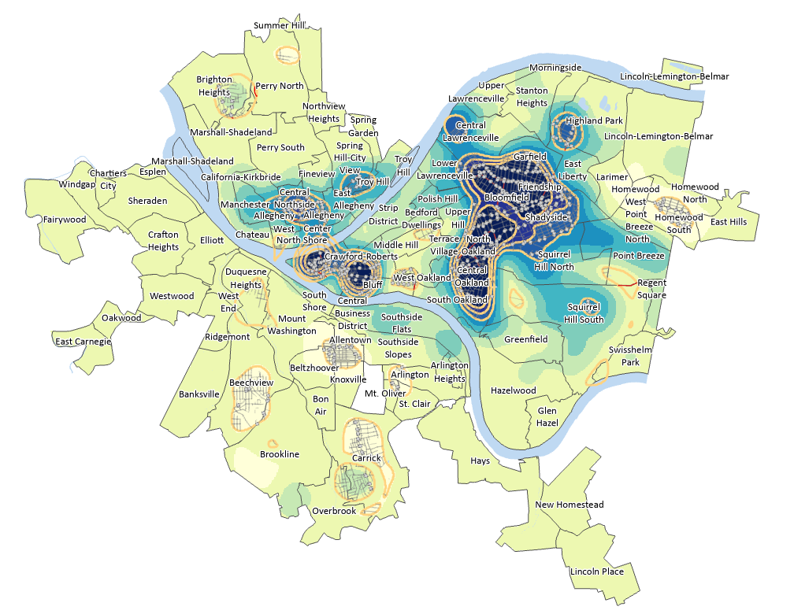

GIS / CAFM [48569]

PROFESSOR: *KRISTEN KURLAND*

TEACHING ASSISTANT’S: *SANAZ SAADATIFAR + MORGAN NEWMAN + SEAN XU*

STUDENT: *SACHIN DABAS*, MSSD, SOA

ASSIGNMENT 10:

Healthy Transportation to work

We explored the locations in a city where multiple variables are

concentrated in one map to not only identify where populations are taking healthy means to work

but to also inform public works department where focus for maintaining infrastructure such as

sidewalks are needed, or where bike lanes or transit stops are needed. You could do so using

transportation data by block group combined in a model with one raster map as the result.

Data Sources:

• Pittsburgh, outline of the city. Obtained from the City of Pittsburgh.

• Neighborhoods, neighborhood polygons for the city of Pittsburgh. Obtained from the

City of Pittsburgh.

• Rivers, water polygons for the city of Pittsburgh. Obtained from the City of Pittsburgh.

• PortAuthorityStops, point features of bus stops in the city of Pittsburgh. Obtained from

the Western PA Regional Data Center and Allegheny County Port Authority (9/1/2019 to

11/23/2019)

• BikeLanes, bike lane polylines in the city of Pittsburgh. Obtained from the Western PA

Regional Data Center and Bike Pittsburgh (2019 data)

• Sidewalks, sidewalk polylines in the city of Pittsburgh. Obtained from the Southwestern

Pennsylvania Commission (SPC) 2019

• BlockGroups, point layer of census block groups centroids. US Census American

Community Survey (2015-2019)

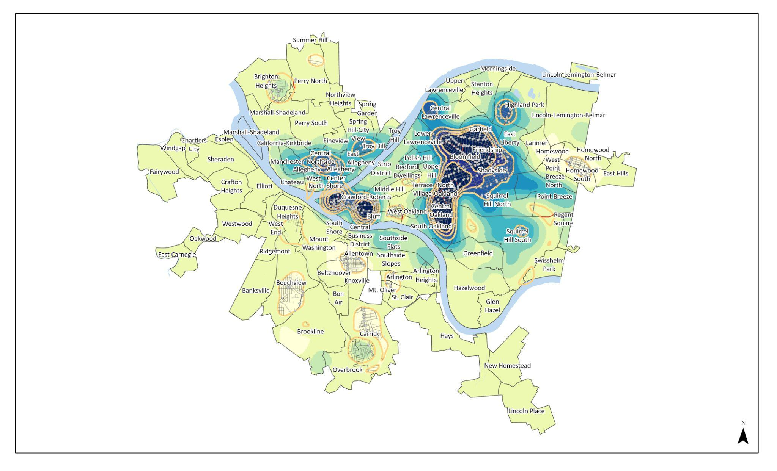

Fig1: The map showing the healthy transportation

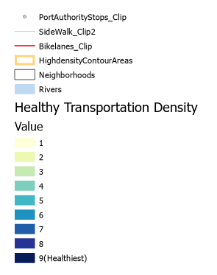

Fig2:Index

Summary:

i. Number of Bike Lanes: 25

ii. Number of Port authority Stops: 682

iii. Sum of sidewalk(length mile): 391.104

.

Work produced in ArcGIS Pro 2.8

Spring’ 2022