SUBTRACTION OF TWO 16-BIT NUMBERS

AIM

To develop an assembly language program to subtract two 16-bit numbers.

ALGORITHM

Algorithm 1 Addition of two 16-bit numbers

1: Start

2: Read the two numbers (n1,n2).

3: Subtract the LSB of n2 from n1 and store the result in lower .

4: Subtract the MSB of n2 from n1 and store the result in upper .

5: upper = upper − borrow

6: The LSB of diff is lower and the MSB of diff is upper .

7: Print the result (diff).

8: Stop

SOURCE CODE

ORG 0000H

CLR C

MOV A,#013H;lower byte

SUBB A,#003H;lower byte

MOV R1,A

MOV A,#055H ;Higher byte

SUBB A,#010H ;Higher byte

MOV R0,A ;lower byte of result in R1 higher byte in R0

END

OUTPUT:

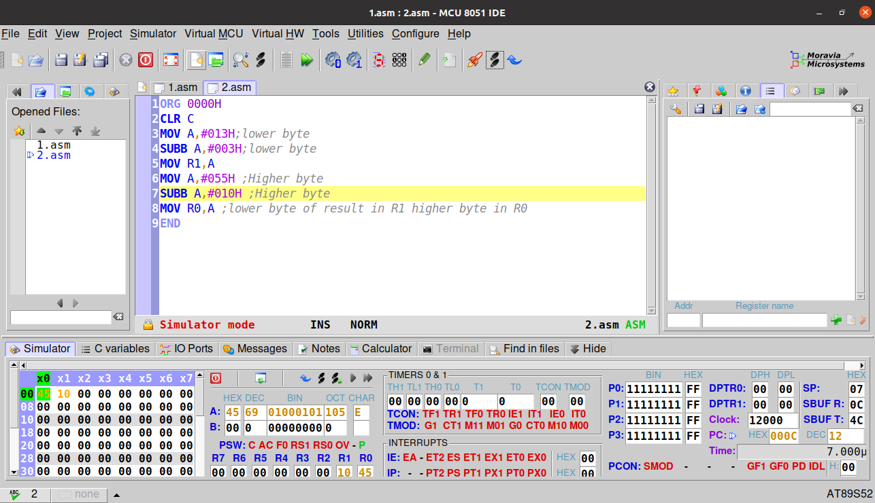

RESULT:
Executed program to Subtraction of two 16-bit numbers in emu8086 and obtained the required outputs.

SACHIN G

RO:54

