HEXADECIMAL TO DECIMAL

AIM

To develop an assembly language program to convert a number in Hexadecimal to it’s decimal equivalent.

ALGORITHM

Algorithm 1 Hex to decimal conversion

1: Start

2: Read the input in hexadecimal (hex).

3: m = hex/A

4: d ec = hex + 6 ∗ m

5: Print the result in decimal (d ec).

6: Stop

SOURCE CODE

mov a , r0

mov b,#0ah

div ab

mov b,#06h

mul ab

add a , r0

mov r1 , a

stop: sjmp stop

INPUT:

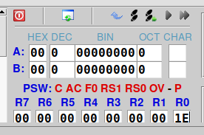

Input in R0

OUTPUT:
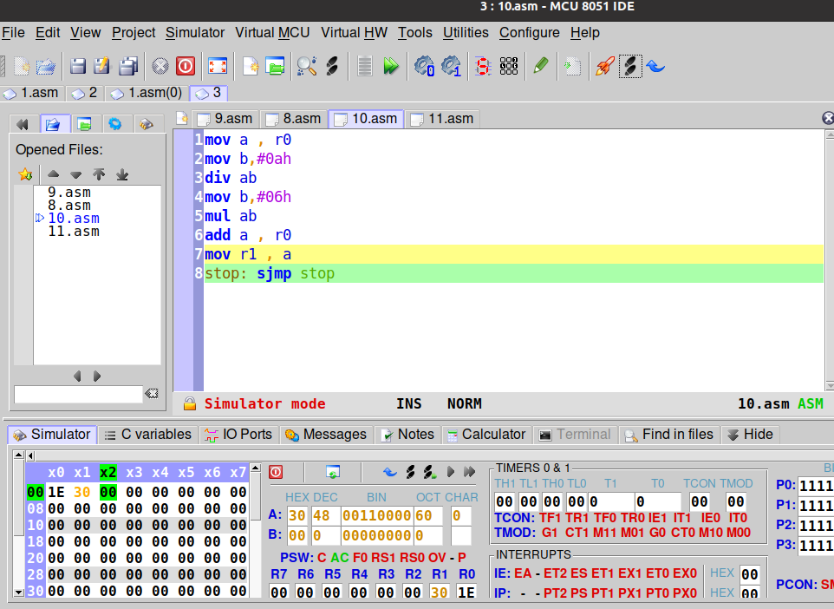

Output in R1

RESULT:
Assembly language program for converting a number in hexadecimal to it’s equivalent decimal has been developed and verified using MCU-8051-IDE.

SACHIN G

RO:54

