DECIMAL TO HEXADECIMAL

AIM

To develop an assembly language program to convert a number in decimal to it’s equivalent Hexadecimal.

ALGORITHM

Algorithm 1 Decimal to hex conversion

1: Start

2: Read the input in decimal (d ec).

3: m = d ec/16

4: hex = d ec − 6 ∗ m

5: Print the result in hexadecimal (hex).

6: Stop

SOURCE CODE

MOV A , R0

MOV B,#10H

DIV AB

MOV B,#06H

MUL AB

MOV R1 , A

MOV A , R0

SUBB A , R1

MOV R1 , A

STOP: SJMP STOP

INPUT:
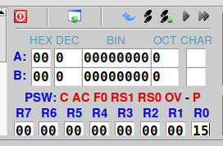

Input in R0

OUTPUT:
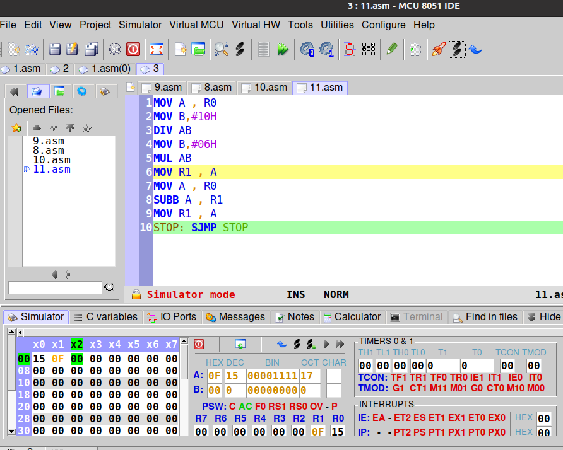

Output in R1

RESULT:
Assembly language program for converting a number in decimal to it’s equivalent hexadecimal has been developed and verified using MCU-8051-IDE.

SACHIN G

RO:54

