MULTIPLICATION AND DIVISION OF TWO 8-BIT

NUMBERS

AIM

To develop an assembly language program to multiply and divide two 8-bit numbers.

ALGORITHM

Algorithm 1 Multiplication and Division of two 8-bit numbers

1: Start

2: Read the two numbers (n1,n2).

3: product = n1 ∗ n2

4: quotient = n1/n2

5: remaind er = n1%n2

6: Print the results (product,quotient,remainder).

7: Stop

SOURCE CODE

ORG 00000H

MOV A,#18H

MOV R3,A

MOV B,#09H

MOV R4,B

MUL AB

MOV R0,A ;Product is in R0 and R1 (Higher order byte)

MOV R1,B

MOV A,R3

MOV B,R4

DIV AB

MOV R2,A ;Quotient is in R2

END

OUTPUT:
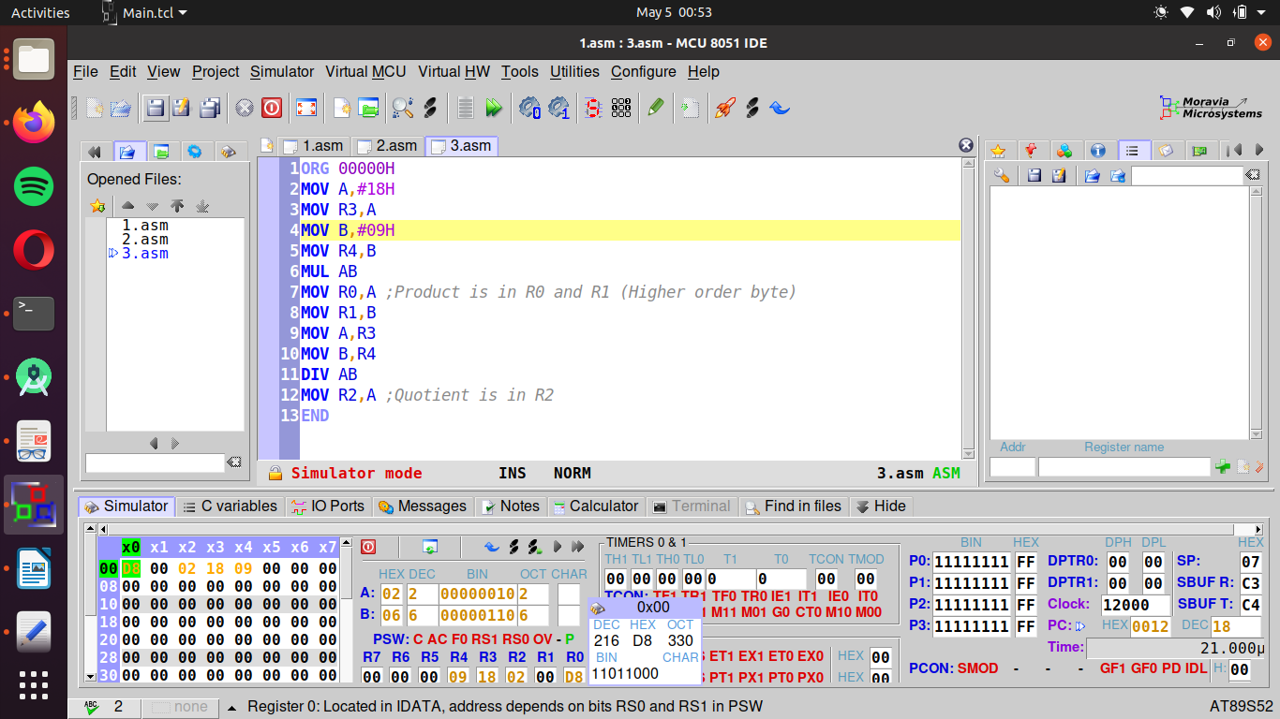

RESULT:
Executed program to Multiplication and Division of two 16-bit numbers in emu8086 and obtained the required outputs.

SACHIN G

RO:54

