POSITIVE OR NEGATIVE

AIM

To develop an assembly language program to check whether the given number is positive or negative.

ALGORITHM

Algorithm 1 Check whether given number is positive or negative

1: Start

2: Read the input (n).

3: Let n i be the MSB of n.

4: if n i = 1 then

5: print "The number is negative"

6: else

7: else

8: end if

9: Stop

SOURCE CODE

ORG 0000H

MOV A, R7

RLC A

JC neg

MOV B,#00H ;if positive then 0 else 1

SJMP last

neg:MOV B,#01H

last:END

OUTPUT:

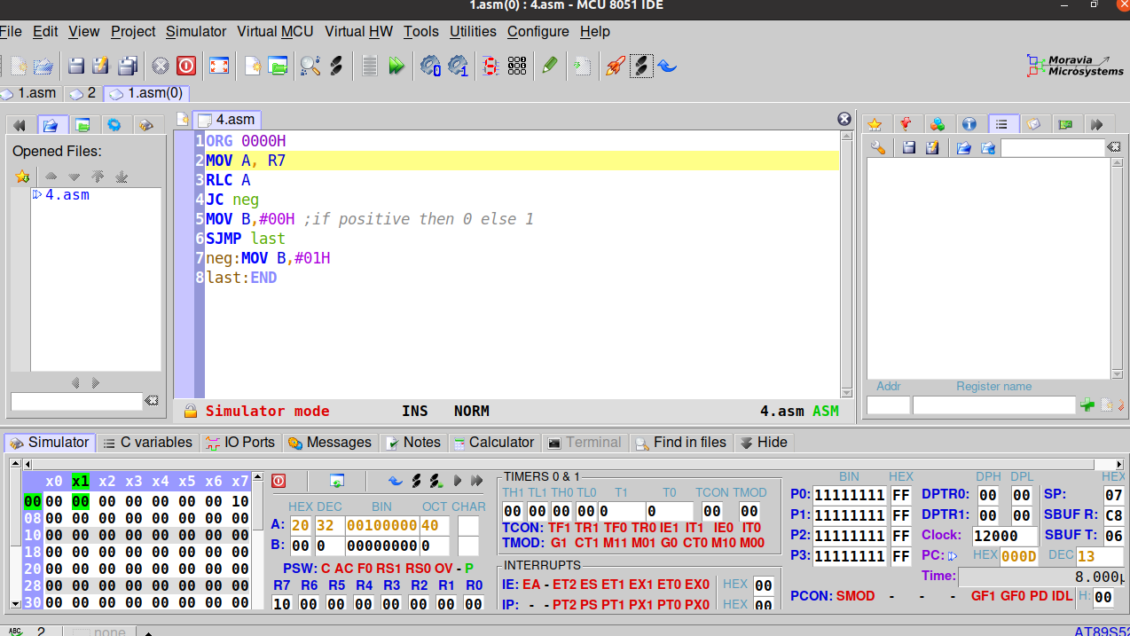
Output with R7 = 10H

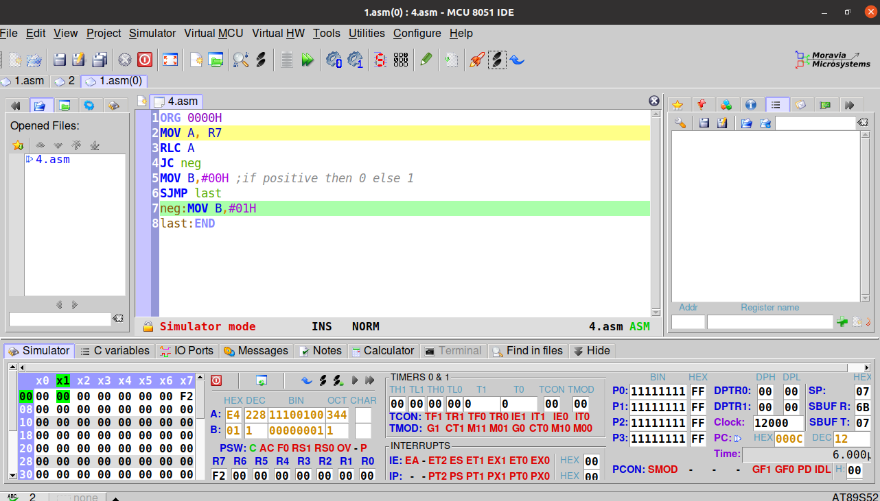

Output with R7 = F2H

RESULT:
Assembly language program to check whether a given number is positive or negative has been developed and verified using MCU-8051-IDE.

SACHIN G

RO:54

