LINEAR SEARCH

AIM

To develop an assembly language program to perform linear search on an array of 8-bit numbers.

ALGORITHM

Algorithm 1 Linear search on an array of 8-bit numbers

1: Start

2: Read the size of input array (n).

3: Read the input array (ar r ).

4: Read the number to be searched(ke y).

5: for i = 0 to n do

6: if ar r [i ] = ke y then

7: Break the loop.

8: end if

9: end for

10:if i = n then

11: Print "Element not found"

12:else

13: Print "Element found at index:",i

14:end if

15:Stop

SOURCE CODE

MOV R0,#01H

MOV R6,#05H

LOOP: MOV A ,@R0

CJNE A,#42H,DOWN

MOV A , R0

MOV R7, A

SJMP STOP

DOWN: INC R0

DJNZ R6 ,LOOP

STOP: SJMP STOP

OUTPUT:
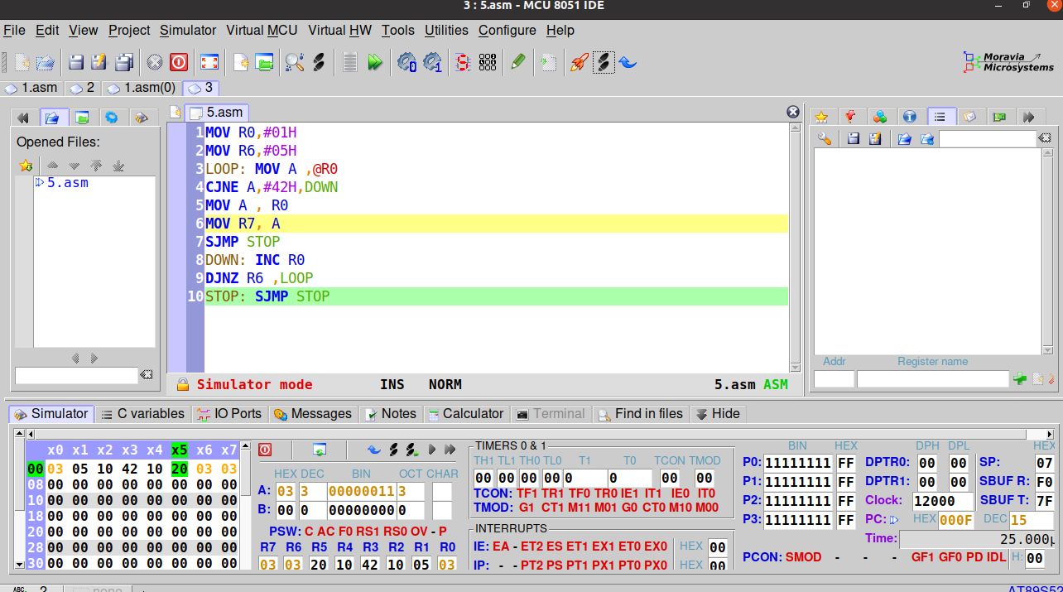

Output at R7

RESULT:
Assembly language program to perform linear search on an array of 8-bit numbers has been has been developed and verified using MCU-8051-IDE.

SACHIN G

RO:54

