LINEAR SEARCH

AIM

To develop an assembly language program to find the factorial of an 8-bit number.

ALGORITHM

Algorithm 1 Factorial of an 8-bit number

1: Start

2: Read the number (n).

3: fact = 1

4: for i = 1 to n do

5: fact = fact∗ i

6: end for

7: Print the result (fact).

8: Stop

SOURCE CODE

ORG 0000H

MOV B,R0;number whose factorial should be found

MOV R1,B

MOV A,#01H

DO:MUL AB;

DEC R1

MOV B,R1

CJNE R1,#01,DO

END

OUTPUT:
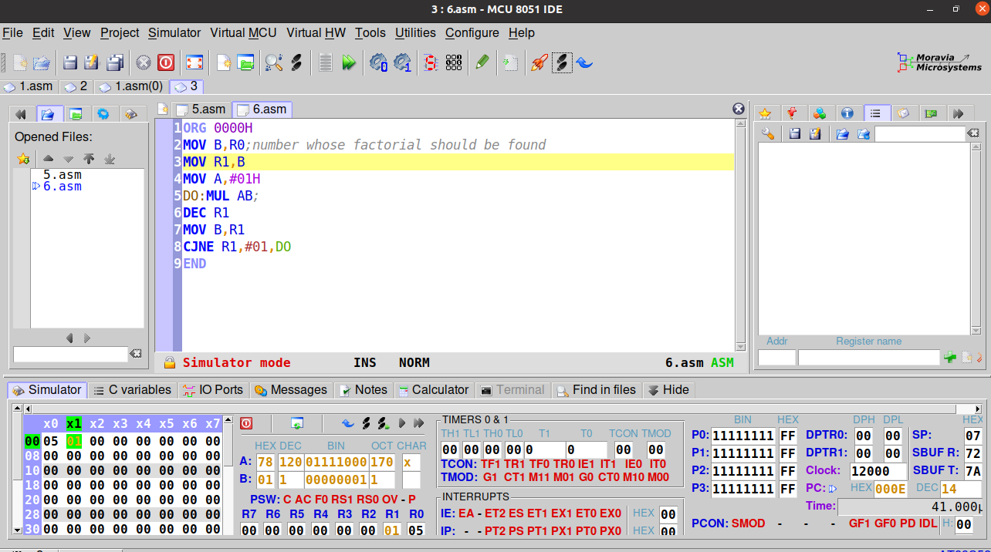

Output at A for input in R0

RESULT:
Assembly language program for finding the factorial of an 8-bit number has been developed and verified using MCU-8051-IDE.

SACHIN G

RO:54

