SMALLEST AND LARGEST

AIM

To develop an assembly language program to find the largest and smallest of 8-bit numbers.

ALGORITHM

Algorithm 1 Largest and smallest of 8-bit numbers

1: Start

2: Read the size of array (n).

3: Read the array (arr).

4: max = arr [0]

5: mi n = arr [0]

6: for i = 1 to (n− 1) do

7: if arr[i]>max then

8: max = arr[i]

9: else if arr[i]< mi n then

10: min = arr[i]

11: end if

12:end if

13:Print largest (max) and smallest (min) of the numbers.

14:Stop

SOURCE CODE

ORG 0000H

MOV R0, #030H ;Start address of array

MOV R7,#04H ;number of elements

MOV A,@R0 ;smallest stored in R1

MOV R1,A

MOV B,@R0

MOV R2,B ;largest stored in R2

INC R0

Find:DJNZ R7,next

JMP END

next:CLR C

MOV A,R1

SUBB A,@R0

JNC small ;a is small

JMP check

small:MOV A,@R0

MOV R1,A

check:CLR C

MOV A,R2

SUBB A,@R0

JC large

JMP finish

large:MOV A,@R0

MOV R2,A

finish:INC R0

JMP find ;smallest in R1 ,largest in R2

END: END

INPUT:
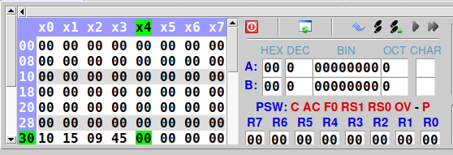

Input at addresses starting from 0x30

OUTPUT:
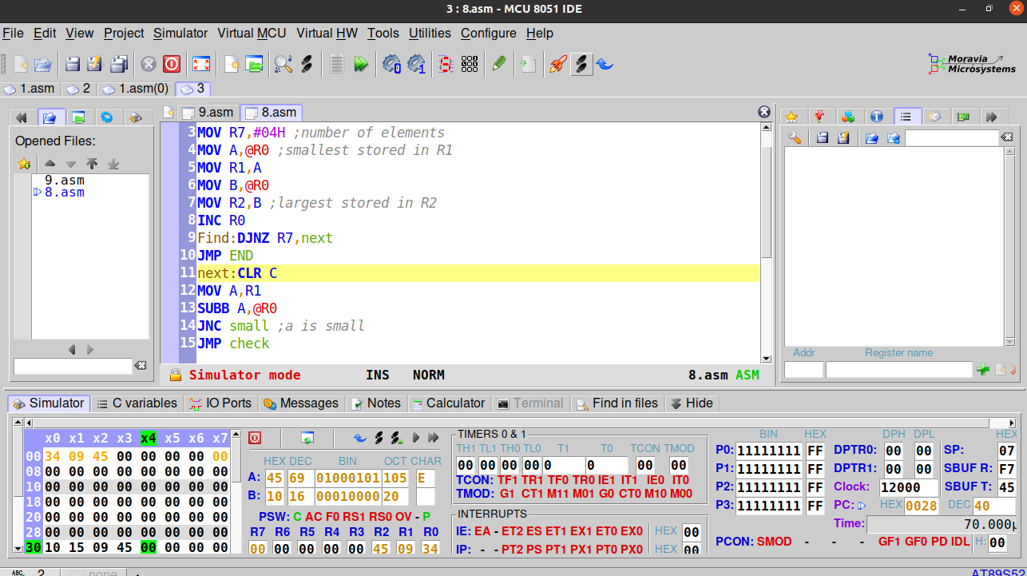

Smallest in R1 and Largest in R2

RESULT:
Assembly language programs for finding the largest and smallest of 8-bit numbers have been developed and verified using MCU-8051-IDE.

SACHIN G

RO:54

