BUBBLE SORT

AIM

To develop an assembly language program to perform bubble sort on 8-bit numbers.

ALGORITHM

Algorithm 1 Bubble sort on 8-bit numbers

1: Start

2: Read the array size (n) and the array(arr).

3: for i = 0 to (n−1) do

4: for j = 1 to (n−i−1) do

5: if arr[j] < arr[j+ 1] then

6: Swap arr[j] and arr[j+1]

7: end if

8: end for

9: end for

10:Print the sorted array (arr).

11:Stop

SOURCE CODE

MOV R4,#05H

AGAIN: MOV R3,#04H

MOV R0,#30H

CLR C

UP:MOV A ,@R0

MOV R1 , A

INC R0

MOV A ,@R0

SUBB A , R1

JNC SKIP

MOV A ,@R0

DEC R0

MOV @R0, A

MOV A , R1

INC R0

MOV @R0, A

SKIP:DJNZ R3 ,UP

DJNZ R4 , AGAIN

STOP:SJMP STOP

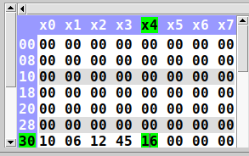
INPUT:

Input at addresses starting from 0x30

OUTPUT:
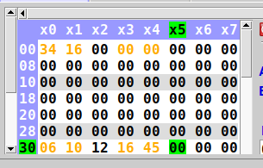

Output at addresses starting from 0x30

RESULT:
Assembly language program to perform bubble sort on 8-bit numbers has been developed and verified using MCU-8051-IDE.

SACHIN G

RO:54

