Wireshark : UDP

Aim

Using Wireshark observe data transferred in client server communication using UDP and identify the UDP datagram.

Theory

Wireshark

Wireshark is a network packet analyzer. A network packet analyzer will try to capture network packets and tries to display that packet data as detailed as possible. Some of the main uses include:

• Network administrators use it to troubleshoot network problems
• Developers use it to debug protocol implementations
• QA engineers use it to verify network applications
• Network security engineers use it to examine security problems
• People use it to learn network protocol internals

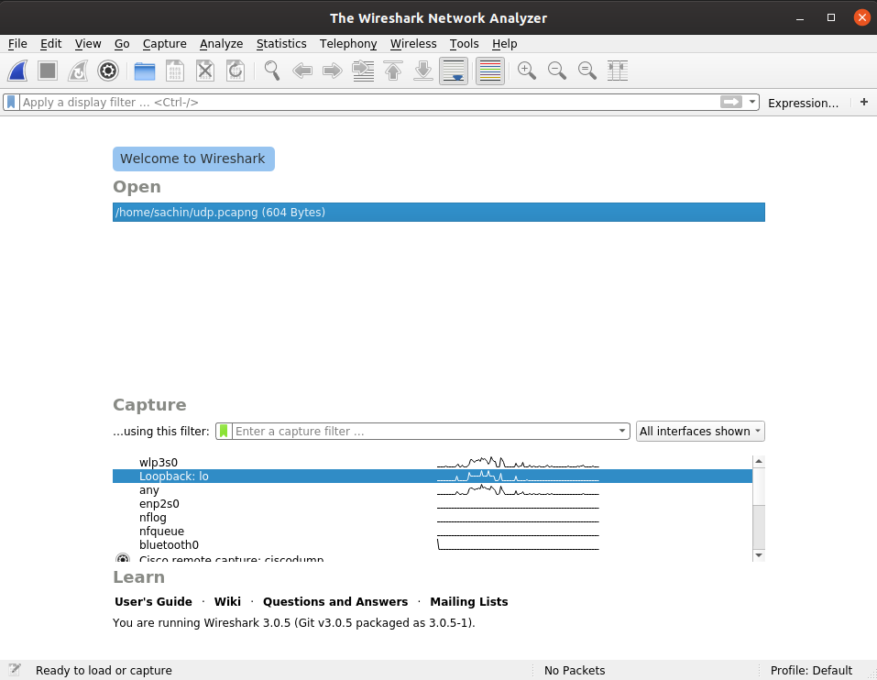
Wireshark Interface

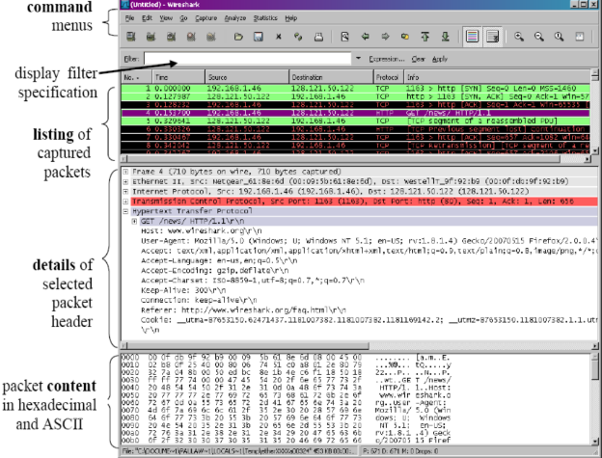
Wireshark components

Capturing Packets: After downloading and installing Wireshark, one can launch and select a network interface under Capture to start capturing packets on that interface. That is, if you want to capture traffic on your bluetooth interface, select the bluetooth interface. Advanced features can be configured by clicking Options in Capture tab. As soon as you click the interface’s name, you’ll see the packets start to appear in real time. Wireshark captures each packet sent to or from your system. If you have promiscuous mode enabled(default), you’ll also see all the other packets on the network instead of only packets addressed to your network adapter.

Filtering Packets: For inspecting something specific, filtering comes in handy. The most basic way to apply a filter is by typing it into the filter box at the top of the window and clicking Apply (or pressing Enter). For example, type “dns” and you’ll see only DNS packets.

Output

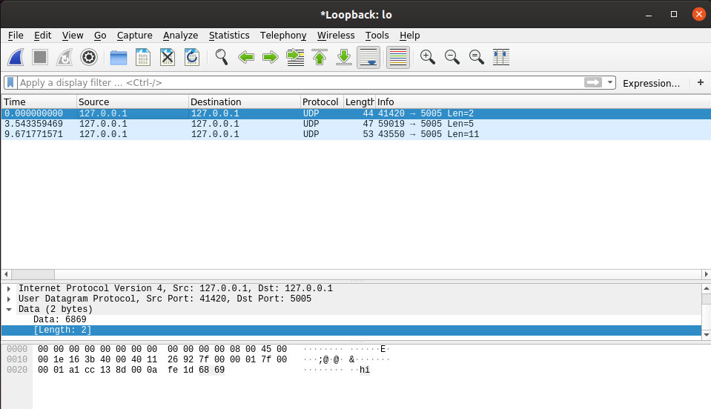

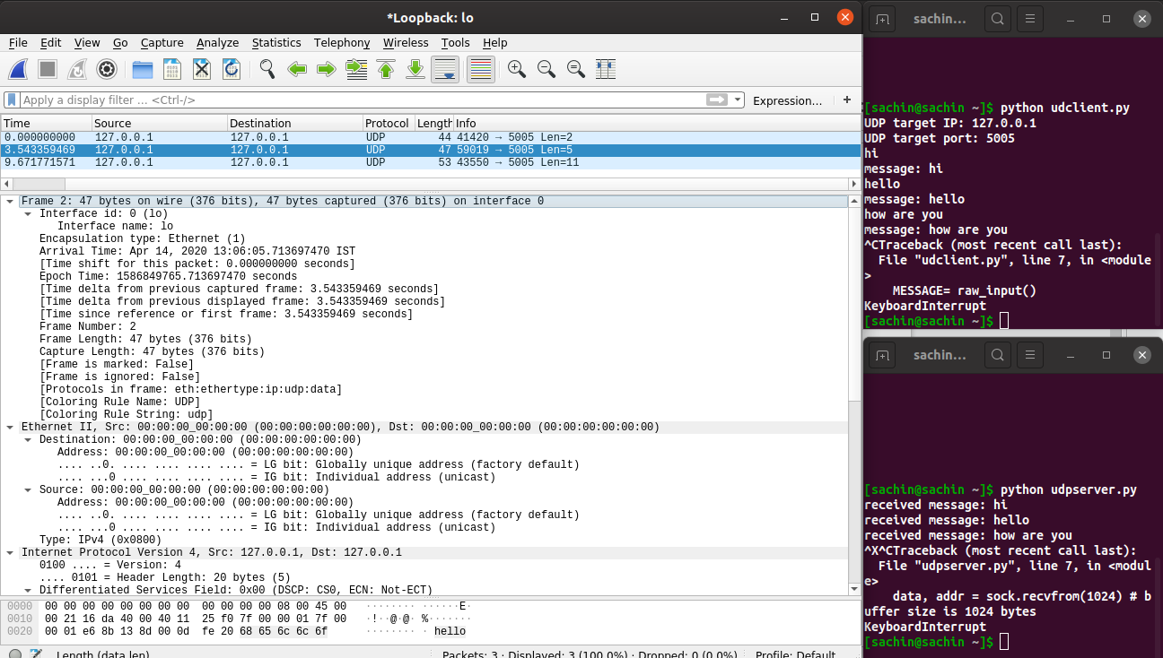

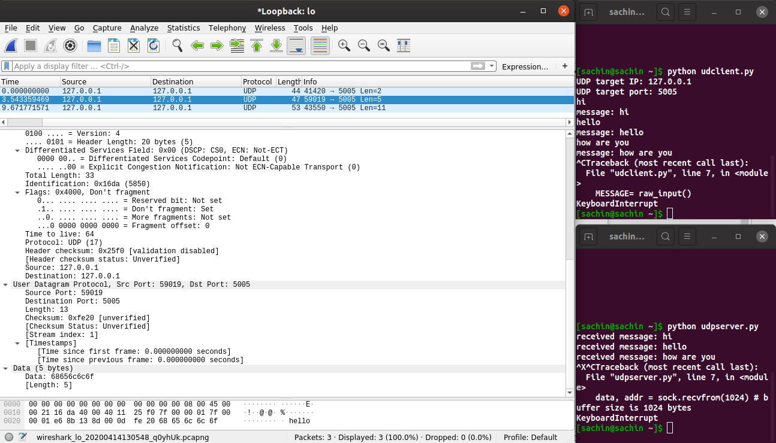

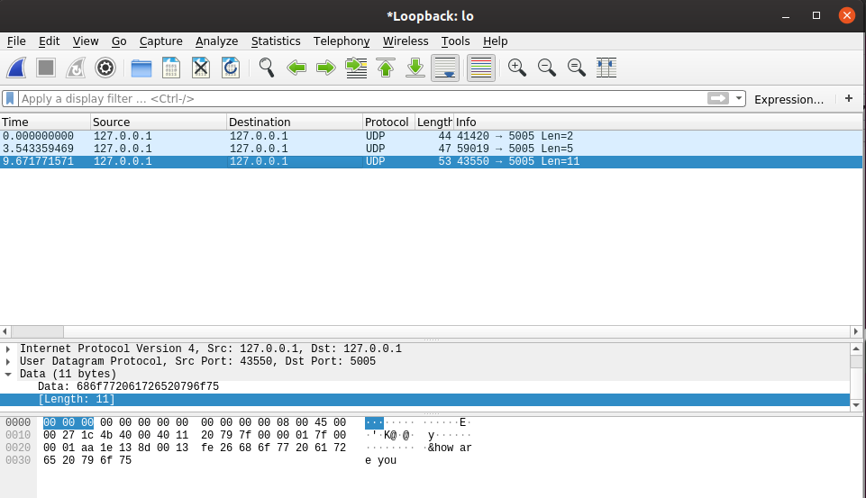

Result

Wireshark was installed and Packet transfer using UDP was observed .

