Wireshark : Three Way handshaking of TCP

Aim

Using Wireshark observe three way handshaking connection establishment, data transfer and three way handshaking connection termination in client server communication using TCP.

Theory

Wireshark

Wireshark is a network packet analyzer. A network packet analyzer will try to capture network packets and tries to display that packet data as detailed as possible. Here, we make use of the packet capturing ability of Wireshark to capture the 3 way handshaking signal packets in a TCP transmission.

What is three way handshaking and how does it work?

TCP provides reliable communication using the concept called Positive Acknowledgement with Re-transmission(PAR). A device using PAR resends the data unit until it receives an acknowledgement. If the data unit received at the receiver’s end is damaged, then the receiver discards the segment. So the sender has to resend the data unit for which positive acknowledgement is not received. From this, we can understand that three segments are exchanged between sender(client) and receiver(server) for a reliable TCP connection to get established. These three steps can be explained as follows:

• Step 1(SYN): Here, the client wants to establish a connection with server, so it sends a segment with SYN(Synchronize Sequence Number) which informs the server that the client is likely to start communication and with what sequence number it starts the segments with.

• Step 2(SYN + ACK): In response, the server replies with a SYN-ACK. The
acknowledgment number is set to one more than the received sequence number, and the sequence number that the server chooses for the packet is another random number.

• Step 3(ACK): Finally, the client sends an ACK back to the server. The sequence number is set to the received acknowledgement value , and the acknowledgement number is set to one more than the received sequence number.

Output

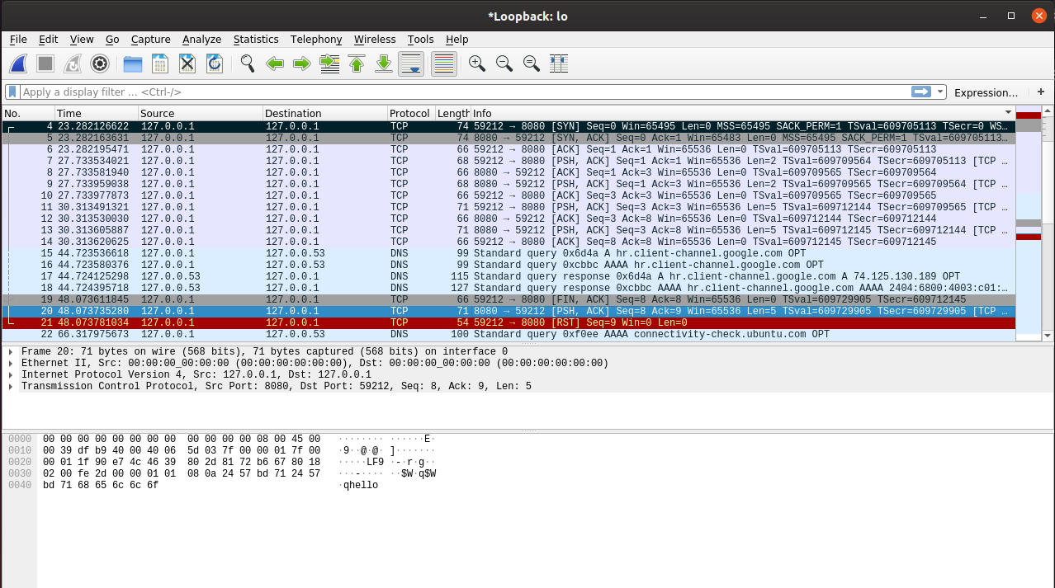

Result

Using Wireshark observed three way handshaking connection establishment, data transfer and three way handshaking connection termination in client server communication using TCP.

