Addition/subtraction of an array of 16-bit numbers

1. Addition

CODE:

data segment

arr dw 1111h,2222h,3333h,4444h,5555h

count db 5

result dw ?

data ends

code segment

assume cs:code, ds:data

start:

mov ax,data

mov ds,ax

lea si,arr

mov ax,0

mov cl,count

up: add ax,[si]

add si,2

dec cl

jnz up

mov result,ax

mov ah,4ch

int 21h

code ends

end start

INPUT:

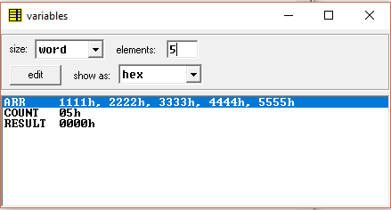

OUTPUT:

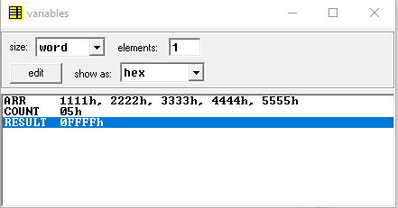

1. Subtraction

CODE:

data segment

arr1 dw 1111h,2222h,3333h,4444h,5555h

arr2 dw 1000h,2000h,3000h,4000h,5000h

count db 5

result dw ?,?,?,?,?

data ends

code segment

assume cs:code, ds:data

start:

mov ax,data

mov ds,ax

lea si,arr1

lea di,arr2

lea bx,result

mov cl,count

up: mov ax,0

add ax,[si]

sub ax,[di]

mov [bx],ax

add si,2

add di,2

add bx,2

dec cl

jnz up

mov ah,4ch

int 21h

code ends

end start

INPUT:

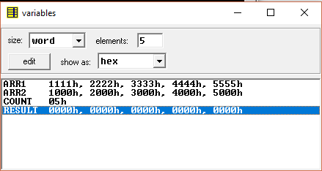

OUTPUT:

