# Bitwise palindrome

CODE:

include 'emu8086.inc'

data segment

num1 dw 01001001b

num2 dw 10100101b

data ends

code segment

assume cs:code,ds:data

start:

mov ax,data

mov ds,ax

push num1

CALL check

push num2

CALL check

mov ah,4ch

int 21h

check PROC

mov bx,sp

add bx,2

mov ax,[bx]

CALL print_num

mov bx,ax

mov bh,al

mov al,0

mov cl,8

mov ch,2

up: mul ch

ror bx,1

jnc dwn

inc al

dwn: dec cl

jnz up

cmp bh,al

je final

PRINTN " is NOT bitwise palindrome"

jmp term

final: PRINTN " is bitwise palindrome"

term:

RET

check ENDP

code ends

DEFINE_PRINT_NUM

DEFINE_PRINT_NUM_UNS

end start

INPUT:

Specified in the code.

OUTPUT:

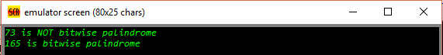

RESULT:

Executed program to check if a number is bitwise palindrome in emu8086 and obtained the required outputs.