# To check whether the given string is palindrome or not.

CODE:

include 'emu8086.inc'

data segment

CALL pthis

str1 db "malayalam","$",0

str2 db "Hello","$",0

data ends

code segment

assume cs:code,ds:data

start:

mov ax,data

mov ds,ax

mov si,offset str1

CALL print_string

mov di,offset str1

CALL palindrome

mov si,offset str2

CALL print_string

mov di,offset str2

CALL palindrome

mov ah,4ch

int 21h

palindrome PROC

loop1: mov ax,[si]

cmp al,'$'

je l1

inc si

jmp loop1

l1: dec si

loop2: mov al,[si]

mov bl,[di]

cmp al,bl

je l2

jmp l3

l2: inc di

dec si

cmp si,di

jge loop2

jmp l4

l3: PRINTN " is NOT palindrome"

jmp final

l4: PRINTN " is palindrome"

final:

RET

palindrome ENDP

code ends

DEFINE_PTHIS

DEFINE_PRINT_STRING

end start

INPUT:

Specified in the code.

OUTPUT:

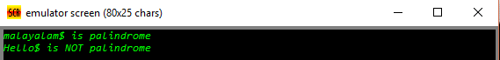

RESULT:

Executed program to check whether the given string is palindrome or not in emu8086 and obtained the required outputs.