# To count the no. of vowels in the string

CODE:

include 'emu8086.inc'

data segment

string db "Education","$"

vowel db ?

data ends

code segment

assume cs:code,ds:data

start:

mov ax,data

mov ds,ax

mov si,offset string

mov ah,0

up: mov al,[si]

cmp al,'a'

je found

cmp al,'A'

je found

cmp al,'e'

je found

cmp al,'E'

je found

cmp al,'i'

je found

cmp al,'I'

je found

cmp al,'o'

je found

cmp al,'O'

je found

cmp al,'u'

je found

cmp al,'U'

je found

cmp al,'$'

je exit

jmp down

found: inc ah

down: inc si

jmp up

exit: mov vowel,ah

mov ah,4ch

int 21h

code ends

end start

INPUT:

Specified in the code.

OUTPUT:

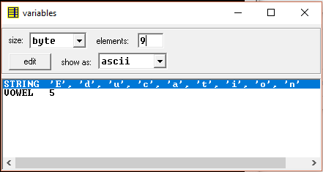

RESULT:

Executed program to count the no. of vowels in the string in emu8086 and obtained the required outputs.