# Substring search in a given string.

CODE:

include 'emu8086.inc'

data segment

CALL pthis

string db "MICROPROCESSOR","$",13,10,0

sub1 db "HELLO","$",13,10,0

sub2 db "PROC","$",13,10,0

data ends

code segment

assume cs:code,ds:data

start:

mov ax,data

mov ds,ax

PRINT "STRING : "

mov si,offset string

CALL print_string

PRINT "SUBSTRING 1 : "

mov si,offset sub1

CALL print_string

mov si,offset string

mov di,offset sub1

CALL substring

PRINT "SUBSTRING 2 : "

mov si,offset sub2

CALL print_string

mov si,offset string

mov di,offset sub2

CALL substring

mov ah,4ch

int 21h

substring PROC

mov cl,0

mov ch,0

loop1: mov al,[si]

cmp al,"$"

je exit

mov ah,[di]

cmp al,ah

jne down

mov bx,si

mov dx,di

mov ch,1

loop2: mov al,[si]

mov ah,[di]

cmp ah,"$"

je exit

cmp al,ah

jne reset

inc si

inc di

jmp loop2

reset: mov ch,0

mov di,dx

mov si,bx

down: inc si

inc cl

jmp loop1

exit: cmp ch,0

jne found

PRINTN "SUBSTRING NOT FOUND"

jmp final

found: PRINT "SUBSTRING FOUND AT INDEX : "

mov al,cl

mov ah,0

CALL print_num

final:

RET

substring ENDP

code ends

DEFINE_PTHIS

DEFINE_PRINT_STRING

DEFINE_PRINT_NUM

DEFINE_PRINT_NUM_UNS

end start

INPUT:

Specified in the code.

OUTPUT:

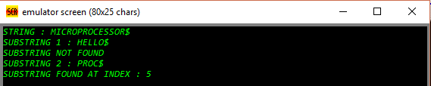

RESULT:

Executed program to perform substring search in a given string emu8086 and obtained the required outputs.