# Convert a string in uppercase to lowercase

CODE:

include 'emu8086.inc'

data segment

string db "MICROPROCESSOR","$",13,10

data ends

code segment

assume cs:code,ds:data

start:

mov ax,data

mov ds,ax

PRINT "OLD STRING : "

mov si,offset string

CALL print_string

mov bl,20h

up: mov al,[si]

cmp al,"$"

je down

add al,bl

mov [si],al

inc si

jmp up

down: mov si,offset string

PRINT "NEW STRING : "

CALL print_string

mov ah,4ch

int 21h

code ends

DEFINE_PRINT_STRING

end start

INPUT:

Specified in the code.

OUTPUT:

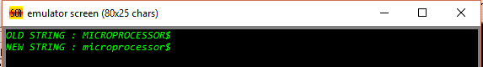

RESULT:

Executed program to convert a string in uppercase to lowercase in emu8086 and obtained the required outputs.