# Factorial of a number

CODE:

data segment

num db 5h

result db ?

data ends

code segment

assume cs:code, ds:data

start:

mov ax,data

mov ds,ax

mov cl,num

mov al,1

up: mul cl

dec cl

jnz up

mov result,al

mov ah,4ch

int 21h

code ends

end start

INPUT:

Specified in the code.

OUTPUT:

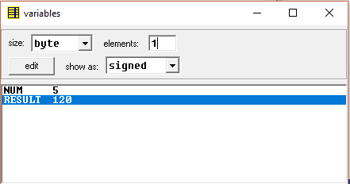

RESULT:

Executed program for finding factorial of a number in emu8086 and obtained the required outputs.