# Perform bubble sort on a list of numbers

CODE:

data segment

arr db 23h,43h,12h,54h,36h

count db 5

data ends

code segment

assume cs:code, ds:data

start:

mov ax,data

mov ds,ax

mov cl,count

loop1: lea si,arr

mov ch,cl

dec ch

jz final

loop2: mov ah,[si]

inc si

mov al,[si]

dec si

cmp ah,al

jc term

xchg al,[si]

inc si

xchg ah,[si]

dec si

term: inc si

dec ch

jnz loop2

dec cl

jnz loop1

final:

mov ah,4ch

int 21h

code ends

end start

INPUT:

Specified in the code.

OUTPUT:

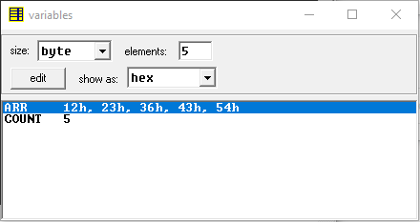

RESULT:

Executed program for performing bubble sort on a list of numbers in emu8086 and obtained the required outputs.