# Binary to BCD conversion

CODE:

data segment

num db 00110001b

bcd dw ?

data ends

code segment

assume cs:code, ds:data

start:

mov ax,data

mov ds,ax

mov ah,0

mov al,num

mov bl,00001010b

div bl

mov cl,6

mul cl

mov bh,0

mov bl,num

add ax,bx

mov bcd,ax

mov ah,4ch

int 21h

code ends

end start

INPUT:

Specified in the code.

OUTPUT:

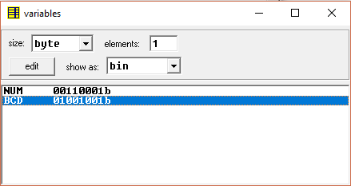

RESULT:

Executed program for performing Binary to BCD conversion in emu8086 and obtained the required outputs.