# Find the LCM and GCD of two given numbers

CODE:

data segment

num1 db 10

num2 db 15

lcm db ?

gcd db ?

data ends

code segment

assume cs:code, ds:data

start:

mov ax,data

mov ds,ax

mov al,num1

mov bl,num2

l1: cmp al,bl

je l3

cmp al,bl

jl l2

add bl,num2

jmp l1

l2: add al,num1

jmp l1

l3: mov lcm,al

mov bl,lcm

mov cl,num2

mov al,num1

mul cl

div bl

mov gcd,al

mov ah,4ch

int 21h

code ends

end start

INPUT:

Specified in the code.

OUTPUT:

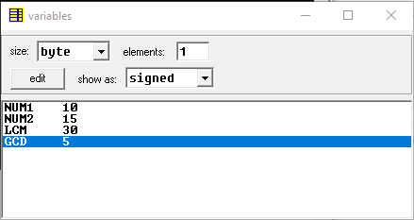

RESULT:

Executed program to find the LCM and GCD of two given numbers in emu8086 and obtained the required outputs.