# Bit manipulation to check whether the data is odd or even

CODE:

include 'emu8086.inc'

data segment

num1 dw 5

num2 dw 6

data ends

code segment

assume cs:code,ds:data

start:

mov ax,data

mov ds,ax

push num1

CALL check

push num2

CALL check

mov ah,4ch

int 21h

check PROC

mov bx,sp

add bx,2

mov ax,[bx]

CALL print_num

ror ax,1

jnc pve

PRINTN " is ODD"

jmp final

pve: PRINTN " is EVEN"

final:

RET

check ENDP

code ends

DEFINE_PRINT_NUM

DEFINE_PRINT_NUM_UNS

end start

INPUT:

Specified in the code.

OUTPUT:

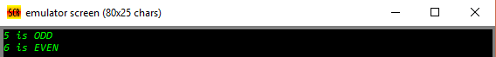

RESULT:

Executed program to perform bit manipulation to check whether the data is odd or even in emu8086 and obtained the required outputs.