# Bit manipulation to count the no. of 1s and 0s in a given no.

CODE:

data segment

num db 01001001b

noof0 db ?

noof1 db ?

data ends

code segment

assume cs:code,ds:data

start:

mov ax,data

mov ds,ax

mov al,num

mov cl,8

mov bx,0

up: ror al,1

jc one

inc bl

jmp down

one: inc bh

down: dec cl

jnz up

mov noof0,bl

mov noof1,bh

mov ah,4ch

int 21h

code ends

end start

INPUT:

Specified in the code.

OUTPUT:

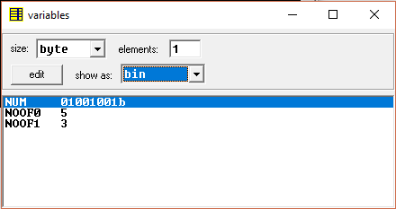

RESULT:

Executed program to perform Bit manipulation to count the no. of 1s and 0s in a given no. in emu8086 and obtained the required outputs.