1. Introduction

1.1 Purpose of this Document

The purpose of the Software Requirements Specification is to outline the requirements for the MQTT-DrawBoard. It will be built using HTML5 with CSS and JavaScript. It will be operating system independent and accessible with any standard compliant browser on Desktop, Laptop or Mobile devices.

1.2 Scope of the Development Project

MQTT-DrawBoard will be a web platform for conveying illustrative representations of messages to the subscribed clients using a virtual canvas.

1.3 Definitions, Acronyms and Abbreviations

HTTP – Hyper Text Transfer Protocol
MQTT – Message Queuing Telemetry Transport
IoT – Internet of Things
M2M – Machine to Machine
TCP – Transmission Control Protocol
Ack - Acknowledgement
QoS – Quality of Service
Broker – Server in MQTT protocol
png – Portable Network Graphics
JSON – JavaScript Object Notation
JS - JavaScript

1.4 References

https://slides.com/sachinkmr/iot

https://www.eclipse.org

https://github.com/mcollina/mosca

1.5 Overview of Document

This document contains all of the software requirement specifics. It contains a general description of the types of users who will be using our application, how it is going to work, and what technologies we are using to make it work. We will also outline and describe specific components of the project.

2. General Description

2.1 User Personas and Characteristics

Creator – The creator is given the control of the draw-board. Creator is the one who can draw illustrations on the canvas which are viewed by the subscribed spectators.
Spectator(s) – The spectator(s) can only view the draw board with real-time updates on their devices.
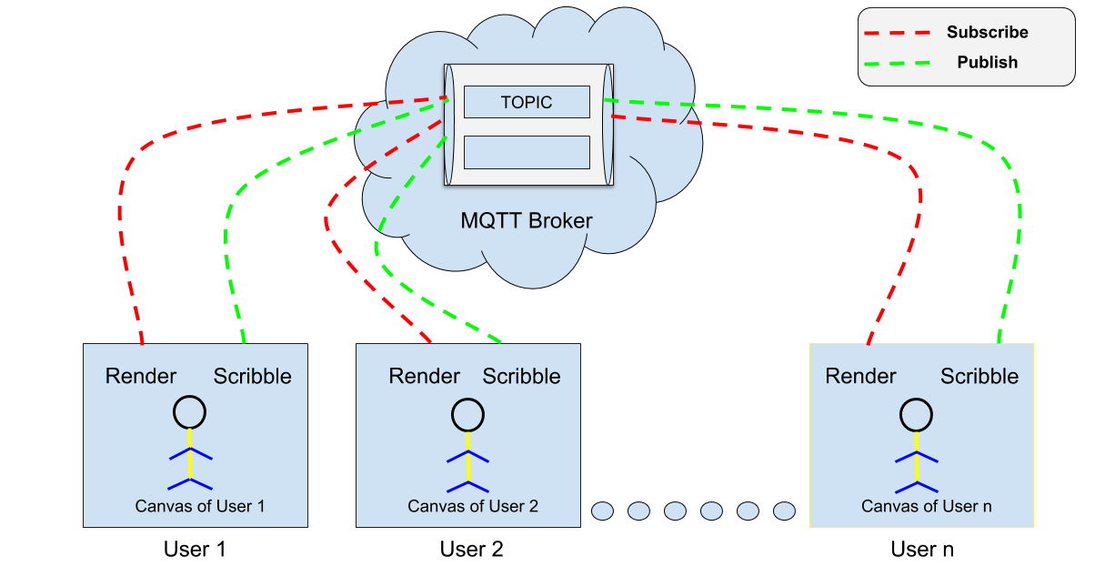
Figure 1: Block Diagram

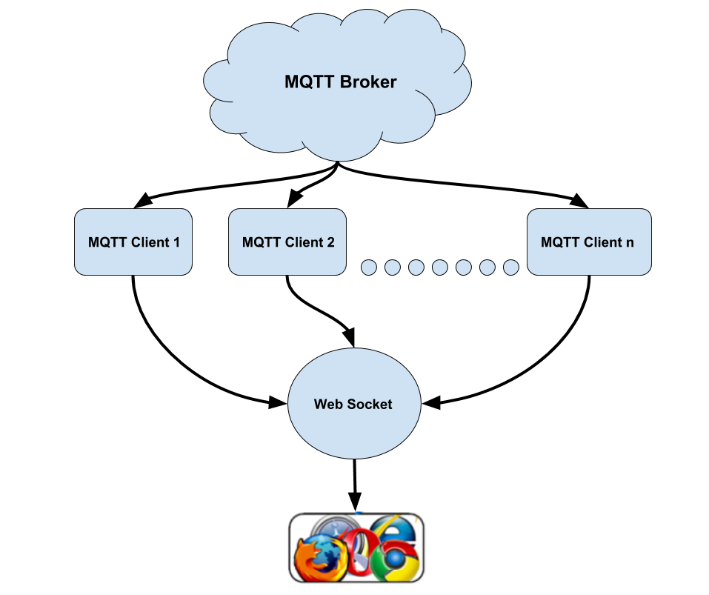
Figure 2: Browser acting as MQTT Client

2.2 Product Perspective

This product is designed to run on any system that is capable of receiving mouse or touch input. This covers a wide variety of machines, including operating systems like Mac OS X, Windows XP, Windows Vista, Linux, Android OS and iOS. The sole requirement for the user is a web browser (Google Chrome, Opera, Safari, Firefox or Internet Explorer) with an active Internet connection.

2.3 Overview of Functional Requirements

- Must be able to receive input in the form of mouse clicks and/or touch.

- Must be able to connect clients to MQTT broker.

- Must contain an easy interface.

2.4 General Constraints, Assumptions, Dependencies, Guidelines

This program will work with virtually any system that can connect to the internet and browse web pages.

2.5 User View of Product Use

The user comes to the website:

Canvas:

- The user can draw the illustrations on the canvas using a mouse or touch input.

- He/She can use the color picker to change the color of the brush or the slider to change the size of the brush strokes.

- Clear button is be used to clear the canvas.

- Undo button undoes the last stroke.

- Save button will save the drawing on the canvas in png format.

Objectives:

The purpose of this website will be to allow creators to communicate with spectators using drawing illustrations. These can be used for real time broadcast teaching remotely as well as for personal purposes. For example, playing Pictionary with friends and/or family.

3. Specific Requirements

3.1 External Interface Requirements

- Operator/user interface characteristics from the human factors point of view

  - This will interface with most browsers, especially Internet Explorer, Firefox and Safari. As long as the user has knowledge to operate a web browser, they will be able to operate our website efficiently.

- Characteristics required of the interface between the software product and each of the hardware components

3.2 Detailed Description of Functional Requirements

3.2.1 Template for describing functional requirements

This is a typical template you can use to describe each of the functional components that were identified in Section 2.3. These sections should be at least the following:



purpose

inputs

processing

outputs

a description of the functional requirement and its reason(s)

which inputs; in what form/format will inputs arrive; from what sources input will be derived, legal domains of each input element

describes the outcome rather than
the implementation; include any validity checks on the data, exact timing of each operation (if needed), how to handle unexpected or abnormal situations

the form, shape, destination, and volume of the output; output timing; range of parameters in the output; unit measure of the output; process by which the output is stored or destroyed; process for handling error messages produced as output

3.2.4 Teacher/Proctor UI


purpose

inputs

processing

outputs

This will explain what the user can do once the successfully login to the site.

Mouse clicks and keyboard web browser hot keys will allow the user to navigate the tasks, accept them, do them, receive payment, cancel tasks, assign tasks, setup new tasks and many more to be defined.

This will be done with Drupal/PHP as well, processing any clicks etcetera. All information is stored via Drupal's MyPHPadmin API in the MySQL database. Any modules needed will access this database as well.

The output will be a sequentially correct webpage determined by the given task.

3.3 Performance Requirements

Since the project involves using a content management system as requested by TAA, some decisions on performance are highly correlated to Drupal. Issues such as the number of connections to the website are based on TAA's current settings for their website and will be modifiable in their PHP settings file. Other decisions like these are also decided by TAA after our project is done and delivered to their company.

However, one part we can define is the efficiency of our own Drupal modules. We will try to utilize what is standard and modular about Drupal, with an emphasis on what works correctly first, followed by an emphasis on code clarity, and then on speed. No page on the website should take more than a two seconds to load completely, and file uploads will limited to a reasonable size of 15 MB, although it should be easily configurable for TAA's purposes.

Searches will create tables with a configurable number of Tasks included, much like Google allows a varying number of results. The range will span from as few as 1 to up to 100.

Code will be clear and well commented, preferably following the guidlines established by the Drupal community for easy integration should any module be submitted to the official project. This is less important as the modules will likely deal to specific TAA needs.

The number of different simultaneous users and connections per second should only be limited by PHP's configuration, specified by TAA and irrelevant to our project.

3.4 Quality Attributes

The website should be as hacker proof as possible, protecting from injection attacks, robots, and other threats. This includes protecting user-enterable forms from clients. Otherwise, this involves PHP settings that will be at TAA's descrection.

The site will only be available to TAA employees and affiliates who are Teachers, Proctors, or otherwise affiliated with education. The code will be clear and well commented to allow modification if necessary. All commonly changed settings should provide an administrator interface to apply the changes. The code should be modular in nature and incremental so that changes and tweaks are easy.

The webpages we work on should provide good error output on forms the clients will complete. Warning messages should appear when something is incomplete, and Error messages will appear in the unlikely event that something doesn't work as intended, as well as information on how to resolve the issue relevant to the user.

3.5 Data Model and Description

In this section a brief description of each data object is given. For each data object, function and semantics associated with it are summarized. This section also describes major attributes of data objects.

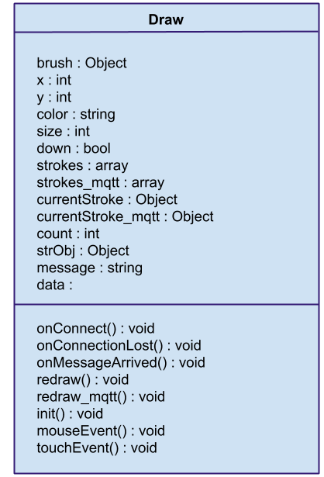

3.6 Other requirements

None at this time.

