CONVERGENCE OF THE BINOMIAL TO THE BLACK-SCHOLES MODEL – Don Chance
Source: www.fenews.com 15 May 03

It is well known that the binomial model converges to the Black-Scholes model when the number of time periods increases to infinity and the length of each time period is infinitesimally short. This proof was provided in Cox, Ross and Rubinstein (1979). That proof, however, relies on a specific case of the Central Limit Theorem (see their discussion on pp. 250 and 252) and is derived for the condition in which the up and down factors are given by specific formulas that allow the distribution of the stock return to have the same parameters as the desired lognormal distribution in the limit. Effectively, their distribution converges to the lognormal in the limit. They go on to show that the binomial model then converges to the Black-Scholes model under their assumptions.^{[1]}
A more general proof of the convergence of the binomial to the Black-Scholes model is provided by Hsia (1983). His paper, published in The Journal of Financial Research, received virtually no attention; yet, it may well be the best overall proof. It imposes no restrictions on the choice of up and down parameters.
We start by stating our ultimate goal, the Black-Scholes model.
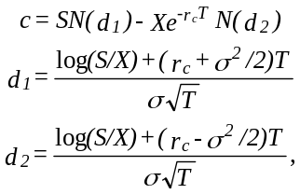

where S is the current stock price, X is the exercise price, r_{c} is the continuously compounded risk-free rate, T is the time to expiration and σ² is the variance of the continuously compounded return on the stock. N(d_{i}) is the cumulative normal probability for i = 1 and 2 as defined above. The binomial model for the case where the option=s life is divided into n time periods is
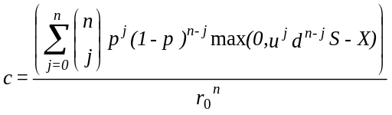
where 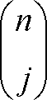 is n!/(j!(n - j)!) and represents the number of paths the stock can take to reach a certain point in a binomial tree, p is the risk neutral probability of an up move, u and d are one plus the return per period on the stock if it goes up and down, respectively, and r₀ is one plus the discrete interest rate per period. The numerator is the expected payout of the option at expiration under the risk neutral binomial probability, and the denominator discounts this term to the present.
This expression can be simplified. For some outcomes, max(0,u^{j}d^{n-j}S - X) is zero. Let a represent the minimum number of upward moves for the call to finish in the money. That is, a is the smallest integer (a # n) such that
uªd^{n-a}S > X.
Then for all j < a, max(0,u^{j}d^{n-j}S - X) = 0. For j $ a, max(0,u^{j}d^{n-j}S - X) = u^{j}d^{n-j}S - X. Now we need only count binomial paths from j = a to n so we can write the model as
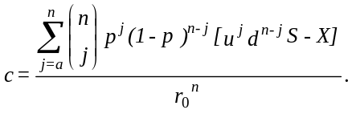

Now let us break this up into two terms:
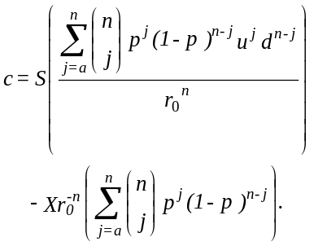

Let us call the two terms in the large parentheses B₁ and B₂. The latter is the formula for the probability of a or more successes in n trials if the probability of success on any one trial is p. B₁ is similar but cannot be expressed quite as easily without redefining the probability. Note the following:
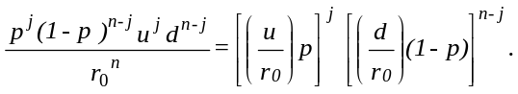

Thus, we can write this as
p^{*j}(1 - p*)^{n-j} where p* = (u/r₀)p, and 1 - p* = (d/r₀)(1 - p).
Thus, B₁ is a binomial probability as stated but with the probability of each trial being p*. Now, we can write the binomial model compactly as
c = SB₁ - Xr₀^{-n}B₂.
We need this to converge to the Black-Scholes formula as given above. Obviously, we shall have to get B₁ and B₂ to converge to N(d₁) and N(d₂), respectively. First, however, recall that r₀^{-n} is the present value factor for n periods where the per period rate is r₀. The per period rate can be related to an annual rate applied for T years by the relationship 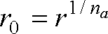 where n_{a} is the number of periods per year. Then,
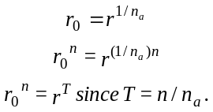

Thus, the present value factor for T years is r^{-T}. It follows that the present value of $1 is PV where
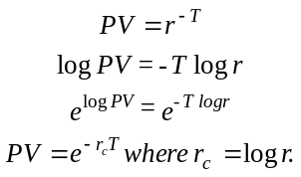

Thus, our present value factor is equivalent to exp(-r_{c}T) when the interest rate is continuously compounded. So the binomial formula is equivalent to
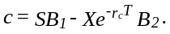

Now let us proceed to get this binomial formula to converge to the Black-Scholes formula.
Since we require Suªd^{n-a} > X, it follows that

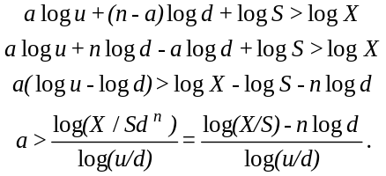

We require that a be an integer, but the formula above for a will not likely produce an integer. For example, with S = 100, X = 100, u = 1.10, d = 0.95, and n = 10, we have a = 3.4988. This means that it would take at least 4 upward moves for the option to finish in-the-money. Let us express this as follows:
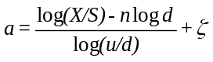

where ζ is a number added to our computed number to make a an integer. We need to know precisely the number of upward moves to start evaluating positive payoffs of the option. In the limit ζ will converge to zero as there will be an infinite number of integer steps.
Now we proceed to work through Hsia=s elegant and simple proof. We appeal to the famous DeMoivre-LaPlace limit theorem, which says that a binomial distribution converges to the normal if np 6 4 as n 6 4. That is, for example, for B₁ we need
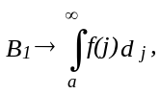

where f(j) is the density for a normal distribution. Since j is not a standard normal, however, let us convert it to one by defining z = (j - E(j))/σ_{j}. Then we would have^{[2]}
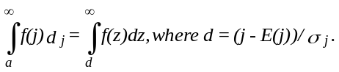

Hsia, however, defines d = -(j - E(j))/σ_{j}. This allows him to write the above as
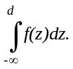
Thus,

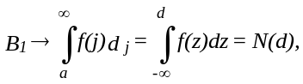
where j has been converted to z, a standard normal. An identical procedure would be applied to B₂.
Now let S* be the stock price at expiration. After n periods and j up moves, S*/S = u^{j}d^{n-j}. Thus, the log return on the stock over the life of the option is
log(S*/S) = j logu + (n - j)logd
= j log(u/d) + nlogd.
We take the expectation,
E[log(S*/S)] = E(j)log(u/d) + n logd.
Thus,
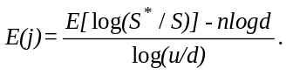

The variance of the log return on the stock over the life of the option is
Var[log(S*/S)] = Var(j)[log(u/d)]².
Thus,
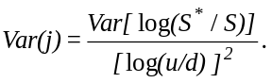

Since d = (-a + E(j))/σ_{j}, a = (log(X/S) - nlogd)/log(u/d) + ζ, and E(j) and Var(j) are as given above,
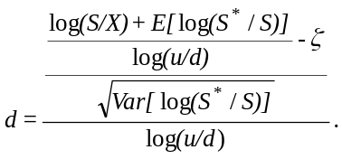

From the properties of the binomial distribution, it is known that Var(j) = nq(1 - q) where q is the probability per outcome.^{[3]} So
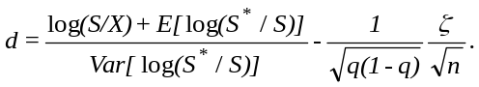

As n goes to infinity, the last term clearly disappears. Our discrete binomial process is then converging to a continuous lognormal process, for which it is known that Var[log(S*/S)] = σ²T. Thus, we have
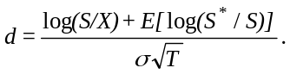

We need this to equal d₁ and d₂ as defined by the Black-Scholes formula when the probabilities are p* and p, respectively, as defined above. This means that we need
E[log(S*/S)] = (r_{c} + σ²/2)T if the probability is p*
E[log(S*/S)] = (r_{c} - σ²/2)T if the probability is p.
Now let us work on the first case. First recall the value of p*:
p* = (u/r₀)p = (u/r₀)(r₀ - d)/(u - d).
Rearrange to solve for r₀:
r₀ = [p*(1/u) + (1 - p*)(1/d)]⁻¹.
Recall that r₀^{n} = r^{T} so^{[4]}
r₀^{n} = r^{T} = [p*(1/u) + (1 - p*)(1/d)]^{-n}.
Now note that S/S* can be expressed as follows:
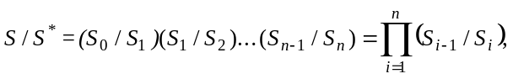

where S = S₀ and S* = S_{n}. The expectation of this would be
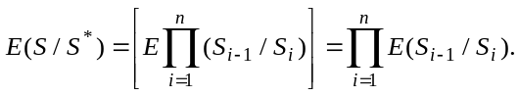

Note that our ability to express the expected value of a product as the product of the expected values comes from the independence of the values. That is, in general, cov(xy) = E(xy) - E(X)E(y). If x and y are independent, then cov(xy) = 0 and E(xy) = E(x)E(y).
Now recall that our probability for B₁ is p*. Since S_{i} = S_{i-1}u with probability p* and S_{i} = S_{i-1}d with probability 1 - p, then
E(S_{i-1}/S_{i}) = p*(1/u) + (1 - p*)(1/d).
Thus,

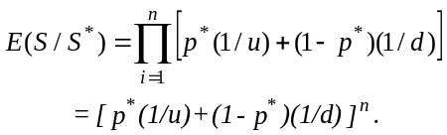

Inverting this gives

Since r^{T} = [p*(1/u) + (1 - p*)(1/d)]^{-n}, then r^{T} = E[S/S*]⁻¹ or r^{-T} = E[S/S*]. Therefore,
-T logr = log[E(S/S*)].
So now we are working with log[E(S/S*)]. Since S*/S is lognormally distributed, it will also be true that the inverse of a lognormal distribution is lognormally distributed.^{[5]} Thus, S/S* is lognormally distributed. For any random variable x that is lognormally distributed, it will be the case that log[E(x)] = E[logx] + Var[logx]/2. This result may not look correct, but follows from a widely used result in options: The log return is defined as S*/S = e^{x} so log(S*/S) = x. It is known that E(x) = exp[μ + σ²/2].^{[6]} Thus, logE[x] = μ + σ²/2, where μ is E[logx] and σ is its standard deviation.
Since -T logr = log[E(S/S*)], then
-T logr = E[log(S/S*)] + Var[log(S/S*)]/2.
= E[-log(S*/S)] + Var[-log(S*/S)]/2
= -E[log(S*/S) + Var[log(S*/S)]/2.
Note where these results come from. E[log(S/S*)] = E[-log(S/S*)] = -E[log(S/S*)], since you can always pull a minus sign out from inside an expectations operator. Also, Var[log(S/S*)] = Var[-log(S*/S)] = Var[log(S*/S)], since you can pull the constant (-1) out in front of the variance operator by squaring it, thereby obtaining plus one times the variance.
Now what we have is
E[log(S*/S)] = T logr + Var[log(S*/S)]/2.

Now recall that we know that Var[log(S*/S)] is σ²T. Thus, we have
E[log(S*/S)] = (logr + σ²/2)T.
Since logr = r_{c}, this is the result we want for B₁ to converge to N(d₁).
For B₂ to converge to N(d₂), recall the definition p = (r₀ - d)/(u - d). Then r₀ = (pu + (1 - p)d). Since S_{i} = S_{i-1}u with probability p and S_{i} = S_{i-1}d with probability 1 - p, then E(S_{i}/S_{i-1}) = pu + (1 - p)d = r. Since,
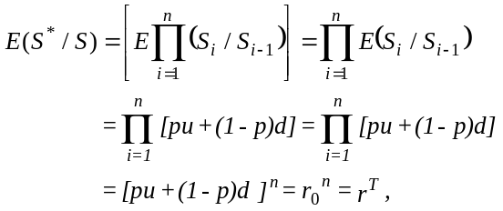

it follows that
log[E(S*/S)] = T log r.
Again, substituting the result that log[E(S*/S)] = E[log(S*/S)] + Var[log(S*/S)]/2, we have E[log(S*/S)] = T logr - Var[log(S*/S)]/2. Recalling that Var[log(S*/S)] = σ²T, we have
E[log(S*/S)] = (logr - σ²/2)T.
Because logr = r_{c}, this is the result we needed to obtain convergence of B₂ to N(d₂).
Thus, the binomial model converges to the Black-Scholes.^{[7]} We made no assumptions regarding what the probabilities were, and we did not have to specify a particular formula for u and d. Hsia=s proof requires only the condition of the DeMoivre-LaPlace limit theorem, which is that np 6 4 as n 6 4. This condition will not be met only if the probability per period approaches zero. This is clearly not the case. If the probability of an up move approached zero, then the probability of a down move would approach one. The model would then be meaningless as it would have no uncertainty. In fact, it is well known that the probability value converges to 1/2.^{[8]}
Source: www.fenews.com 15 May 03

References
The key articles cited here are

Cox, J. C., S. A. Ross and M. Rubinstein. AOption Pricing: A Simplified Approach.@ Journal of Financial Economics 7 (1979), 229-263.

Hsia, C-C. AOn Binomial Option Pricing.@ The Journal of Financial Research 6 (1983), 41-46.

Jarrow, R. and A. Rudd. Option Pricing (Homewood, Illinois: Irwin (1983).

Rendlemen, R. and B. Bartter. ATwo State Option Pricing.@ The Journal of Finance 34 (1979), 1093-1110.

For other noteworthy research, see
Amin, K. I. AOn the Computations of Continuous Time Option Prices Using Discrete Approxmations.@ Journal of Financial and Quantitative Analysis 26 (1991), 477-496.

Barone-Adesi, G., E. Dinenis and G. Sorwar. AA Note on the Convergence of Binomial Approximations for Interest Rate Models.@ Journal of Financial Engineering 6 (1997), 71-77.

Cutland, N. J., E. Kopp and W. Willinger. AFrom Discrete to Continuous Financial Models: New Convergence Results.@ Mathematical Finance 3 (1993), 101-123.

Duffie, D. and P. Protter. AFrom Discrete- to Continuous-Time Finance: Weak Convergence of the Financial Gain Process.@ Mathematical Finance 2 (1992), 1-15.

He, H. AConvergence from Discrete- to Continuous-Time Contingent Claims Prices.@ Review of Financial Studies 3 (1990), 523-546.

Leisen, D. P. J. and M. Reimer. ABinomial Models for Option Valuation - Examining and Improving Convergence.@ Applied Mathematical Finance 3 (1996), 319-346.

Nelson, D. B. and K. Ramaswamy. ASimple Binomial Processes as Diffusion Approximations in Financial Models.@ Review of Financial Studies 3 (1990), 393-430.

^{[1]}An alternative approach is provided by Jarrow and Rudd (1983), who obtain different values for the up and down factors, which hold for any number of time steps, not just in the limit. They then provide a general sketch of how the binomial model converges to the Black-Scholes model.
^{[2]}Do not confuse the integrating term dz with the variable d, which equals (j E(j))/σ_{j}.
^{[3]}We are not introducing a new probability q. We are just using a general specification to illustrate a point that applies to any binomial distribution. In our specific cases, q will become p and p*.
^{[4]}Although it is not particularly important, note that r₀ is the harmonic mean return on the stock when the probability is p*.
^{[5]}Let x be distributed lognormally meaning that log x is distributed normally. Let y = 1/x. Then is logy distributed normally? Logy = log1 - log x = -log x. Given that logx is distributed normally, changing its sign will not change its status as a normal distributed variable. It simply changes all positive outcomes to negative and vice versa. This does not change the normal distribution to some other type of distribution.
^{[6]}This result is obtained by evaluating the integral of the normally distributed random variable x using the normal desnity function.
^{[7]}Another convergence result is provided in the Rendlemen and Bartter (1979) version of the model. Their proof seems considerably more complex than the Cox-Ross-Rubinstein proof and requires the condition that the probabilities converge to 1/2. While this condition is met, nonetheless, it is not necessary to impose it to obtain the proof.
^{[8]}For the Jarrow and Rudd proof, they simply set the probability to 2 and then do not alter it as time steps are added (p. 188). In other applications of the binomial model, such as elsewhere in the Jarrow-Rudd book, the probability is not arbitrarily set to 2, but simulations would show that it converges to 2 , given their formulas for u and d, as the number of time steps increases.

BinomialBlackScholes.doc

