1. **Constant scale “S” (Original size) and number of lines “N” are varied:**

**Case1: With N = 16, as we have enough samples, the image won’t be distorted. Hence we can see a crisp image**

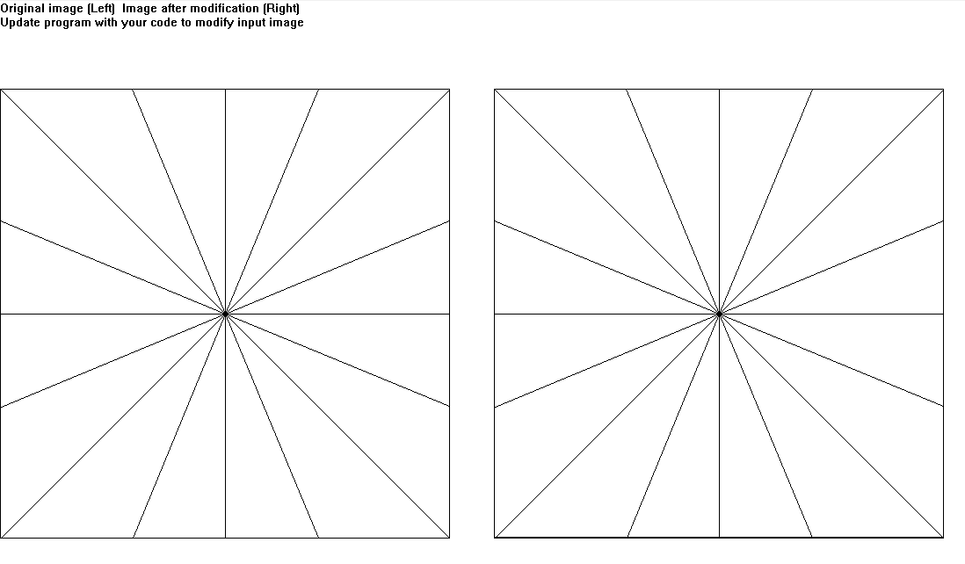

**CASE 2: With N = 128, we can see that lines are getting distorted. Because we don’t have enough pixels to differentiate between lines, and it looks like all the lines have been merged in the center.**

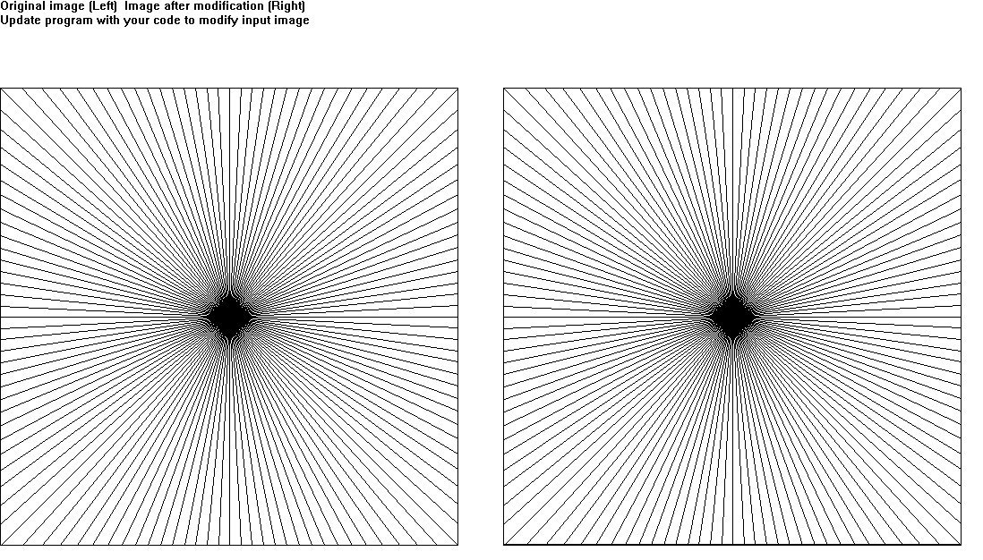

**CASE 3: With N = 360, we can see that almost all the lines are merged, as we can see “Moire” pattern.**

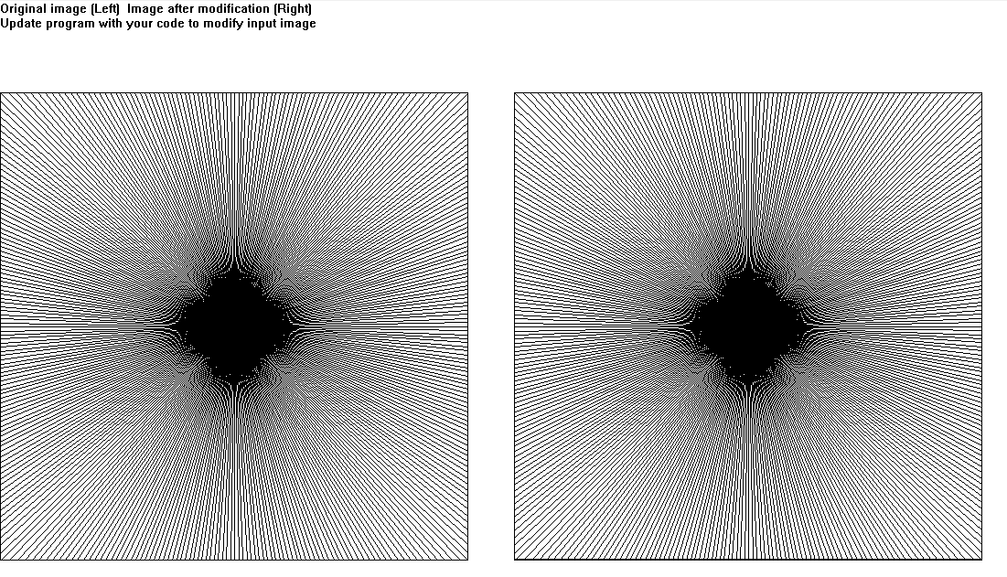

1. **Constant Line “N” and size “S” is varied:**

**CASE1: With scale = 2, we can make out clearly the reduced image, and each line is visible clearly**.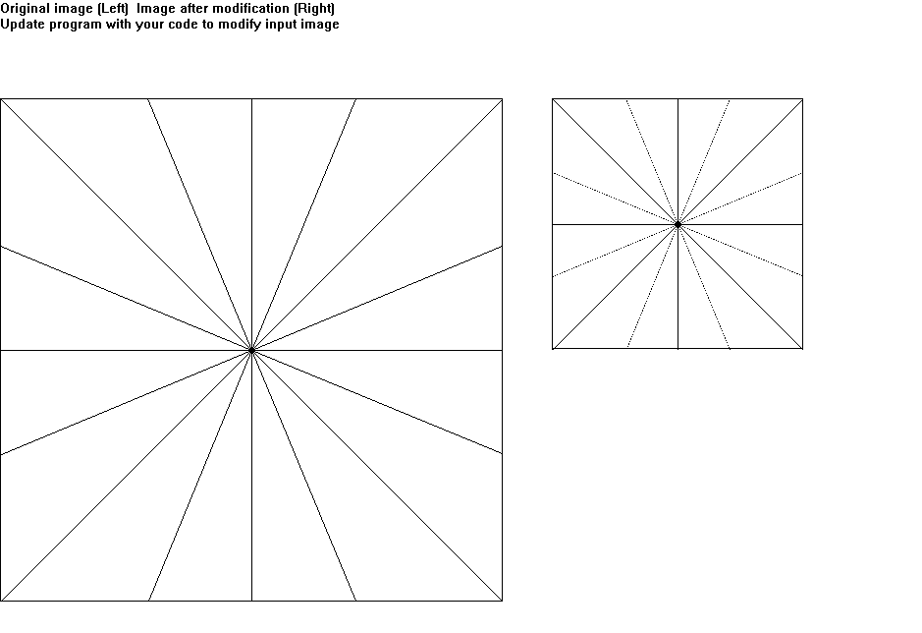

**CASE2:** **With scale = 4, some of the data is being lost. This can be improved using anti-aliasing as shown**



**CASE3:** **With scale = 8, we can see that some of that most of data is being lost.** 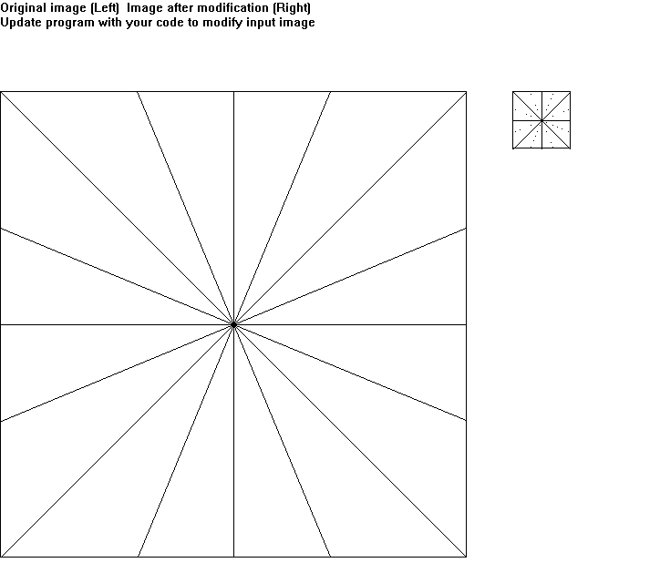

**CASE4:** **With scale = 8, and with anti-aliasing turned on:**

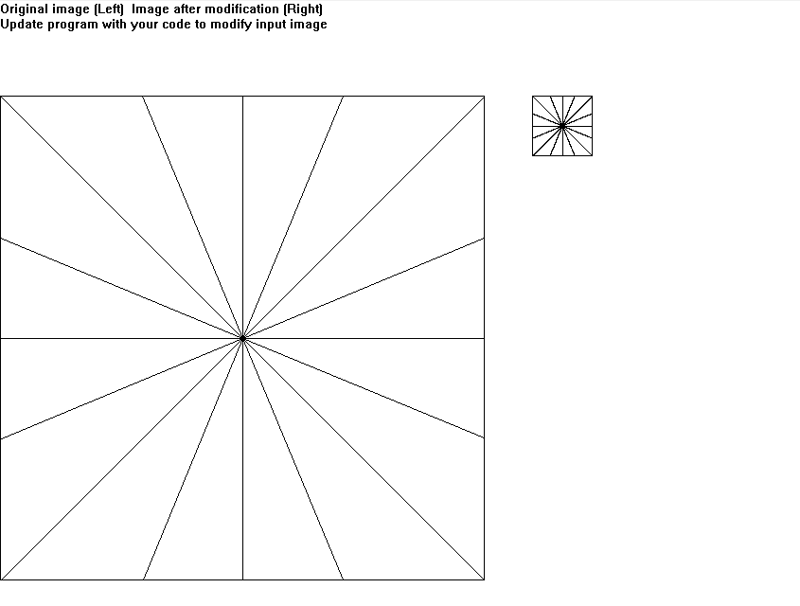

**General Observation:**

1) When Scale is constant, and number of lines are varied: Lines can be easily differentiable up to a certain density. Once we reach a threshold density point, we basically can’t tell which pixel is representation which line, we start to see “Moire” pattern.

2) When number of lines is kept constant, and scale is varied: For few initial scale factor we don’t see any loss of information, after a certain scale we start seeing loss of information, which can be reduced using anti-aliasing turned on.